Additional Reading Material Available for Unit 22
of Certificate III in Theological Studies

All these folders and titles (e-books) are available to the student upon request via email up to 1 folder and 5 titles at a time, unlimited lend.

Main Folders:
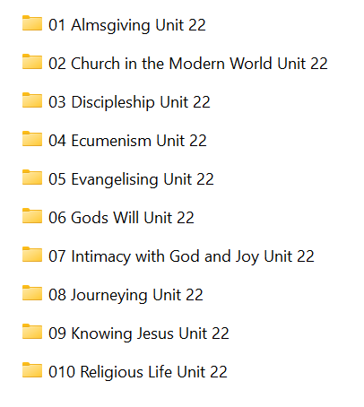

- Almsgiving has:

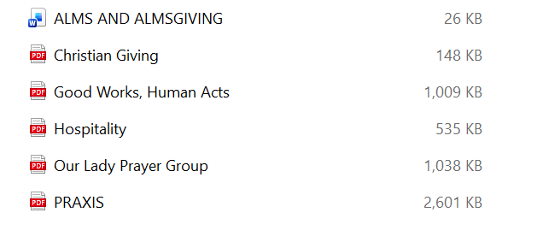

- Church in the Modern World folder contains:

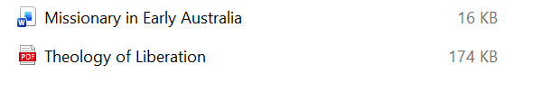

- Discipleship folder contains these articles:

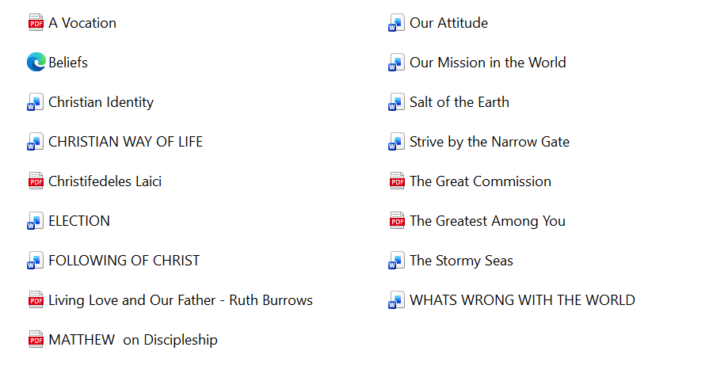

- Ecumenism has:
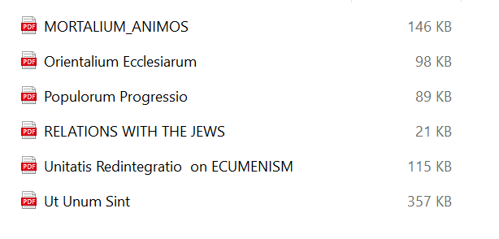

- Evangelising folder has these e-books:

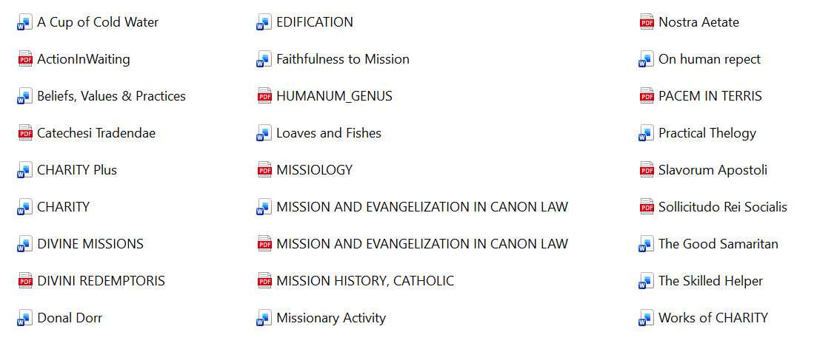

- God’s Will folder has:

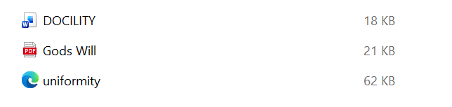

- Intimacy with God and Joy has:

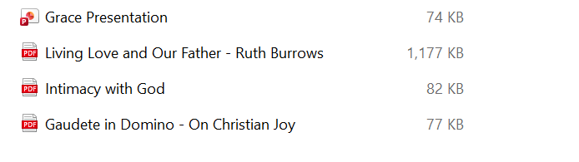

- Journeying folder contains:

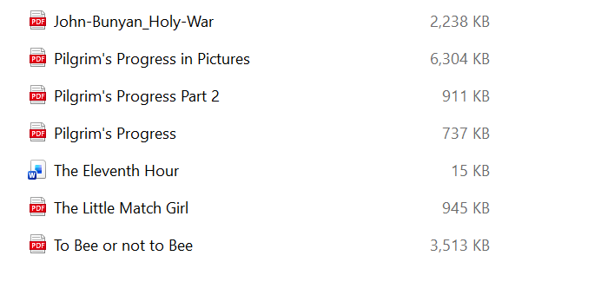

- Knowing Jesus folder contains:

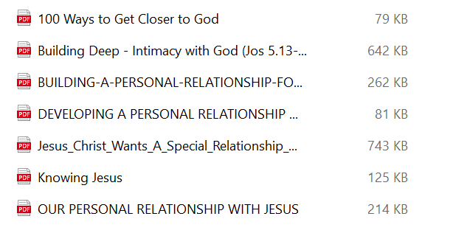

- Religious Life folder has these items:

