Additional Reading Material Available for Unit 13
of Certificate III in Theological Studies

All these folders and titles (e-books) are available to the student upon request via email up to 1 folder and 5 titles at a time, unlimited lend.

Main Folders:
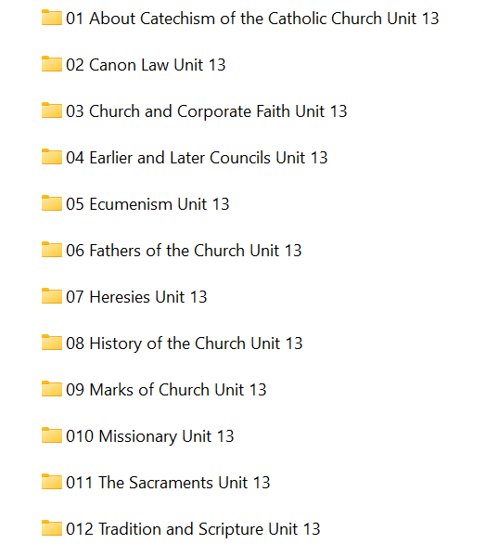

- About Catechism of the Catholic Church

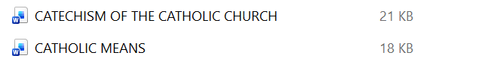

- Canon Law

- Church and Corporate faith has over 25 e-books:

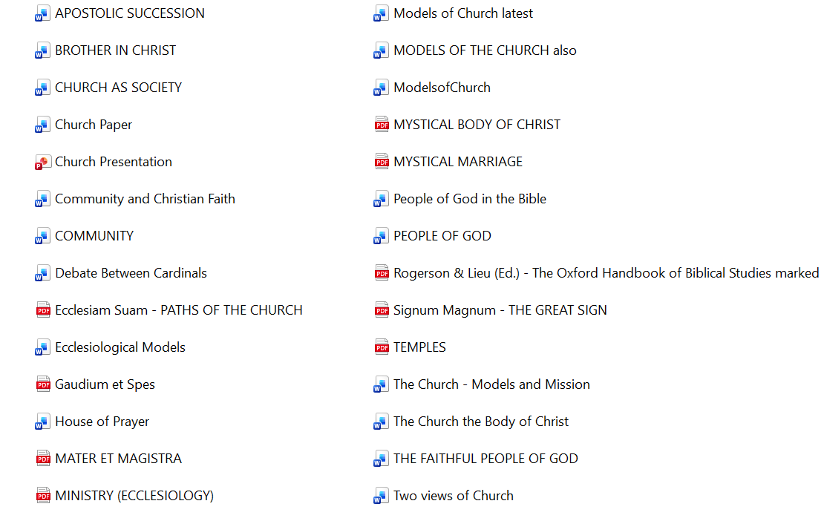

- Earlier and later Councils has these 12 sub-folders:

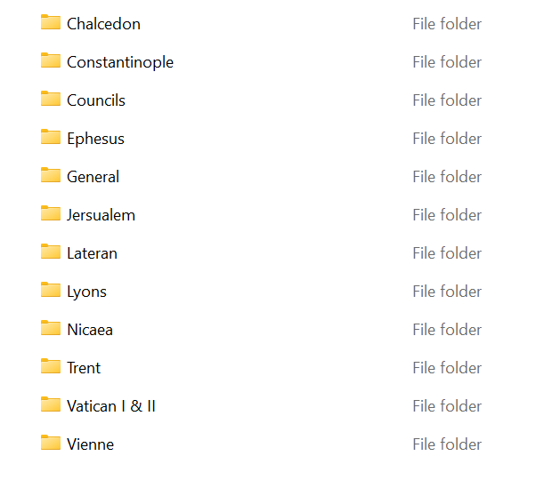

- Ecumenism has these 9 sub-folders:

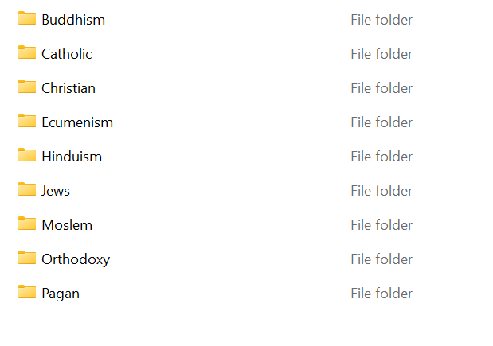

- Fathers of the Church folder has 8 sub-folders:

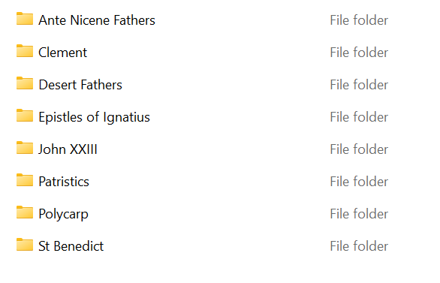

- Heresies has 3 files:

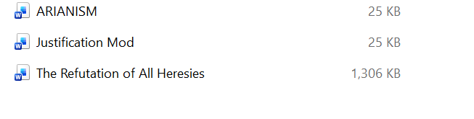
- History of the Church contains 7 sub-folders:

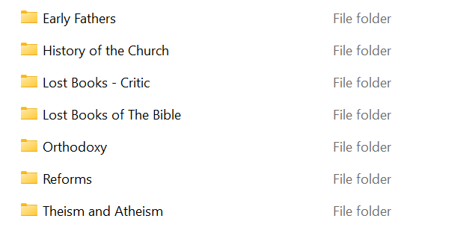

- Marks of the Church has 9 e-books:

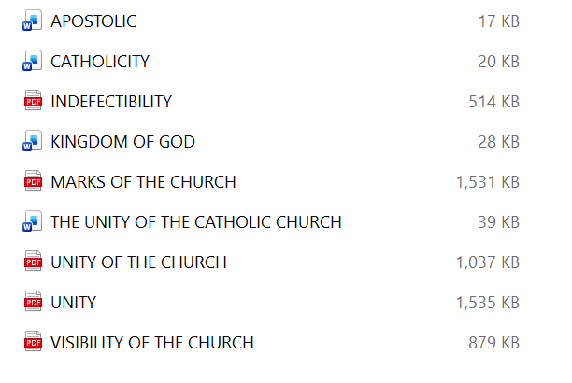
- Missionary folder has 4 articles:
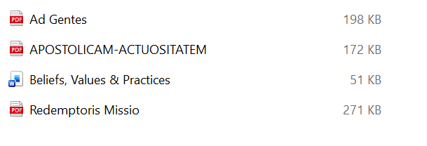

- The Sacraments has these e-books:

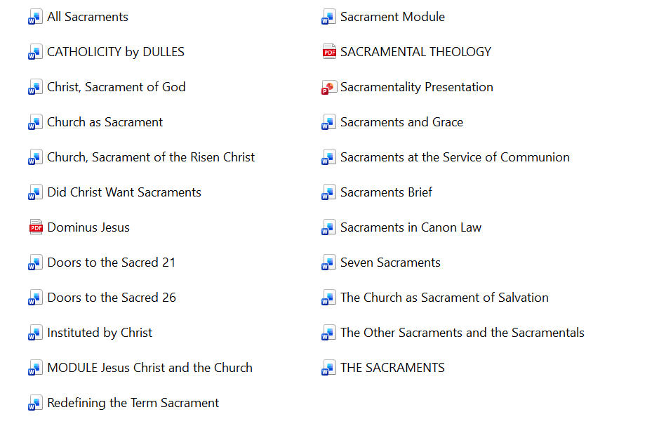

- Tradition and Scripture folder contains these e-books:

