Faith & the Holy Bible

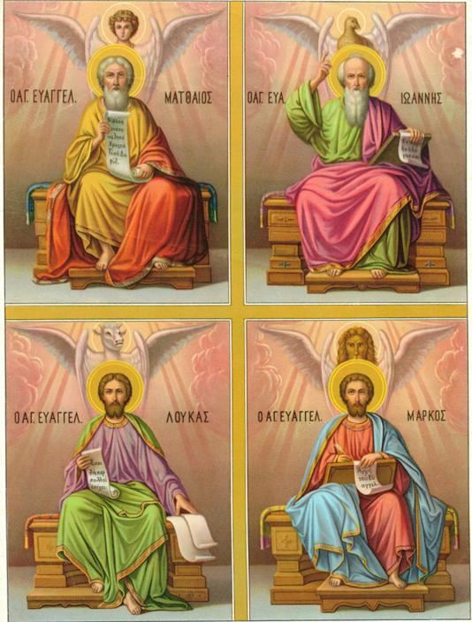
Figure 1- The four writers of the Gospel symbolically depicted

  - Unit One

Table of Contents
(Ctrl and Click mouse on headings to go to each section)

- 1. Faith – What is Faith?
- 1a. Type of faith required
- 1c. People of faith
- 1d. What does “unbelief” lead to?
- 2. Science and Reason
- 3. Apostles’ & Nicaean Creeds
- 3a. Apostles’ Creed
- 3b. Nicene Creed
- 4. Holy Bible
- 4a. Books of the Bible — Old Testament
- 4b. Books of the Bible — New Testament
- 5. Apocrypha
- 6. Main Parts of the Bible
- 6a. Further Points about the Holy Bible
- 6b. What can be said about the Bible?
- 6c. Understanding discrepancies in the Bible
- Apostle’s Creed addend
- 7. Essential Reading Material
- 8. Unit One Exam

“For those who believe, no explanation is necessary, and for those who do not believe, no explanation is possible” (Anonymous).

“When the Son of Man comes back will he find any faith on the earth?” (Luke 18:8).

“True science is in Christ and in his teachings, and man’s highest wisdom is in obeying him” (Valtorta).

1. Faith
Ctrl and Click mouse on the title name to go
back to the top.

1.What is faith?
Ctrl and Click mouse on the title name
to go back to the top.

- “Faith is the assent given by our intellect to what cannot be seen or proven but is taken on the word and authority of another” (Thomas Aquinas, 13th Century). This definition highlights the essence of faith as a conscious choice made by an individual, rooted in trust and reliance on the testimony of others. It acknowledges that faith often extends beyond empirical evidence, positioning it as a crucial element of belief systems that are not solely dependent on observable phenomena. This assertion emphasises that faith encompasses a profound personal commitment to truths that may not be immediately verifiable. Ultimately, Aquinas' perspective reveals the intersection between intellect and spiritual conviction, illustrating how faith serves as a bridge between the known and the unknown.

- Faith is a supernatural virtue that instils courage within individuals, enabling them to endure life's challenges even when answers may not be readily apparent. It is a deeply personal act, one that is embraced freely without coercion. This aspect of faith encourages believers to navigate uncertainty with resilience, reinforcing the idea that faith is not merely about having all the answers but about trusting in a higher power. By embodying faith, individuals cultivate a sense of hope and strength that transcends their immediate circumstances. Thus, faith becomes a source of empowerment, guiding believers through trials with the assurance that they are not alone.

- Faith represents the accumulation of the truths that God reveals to humanity—specifically, the supernatural truths essential for salvation that cannot be fully grasped through the lenses of science or philosophy. This understanding positions faith as an indispensable component of the spiritual journey, as it invites individuals to embrace divine revelations that surpass human comprehension. The truths of faith are not arbitrary; they are rooted in the belief that God communicates vital knowledge necessary for the well-being of the soul. Therefore, faith serves as a conduit through which believers can access the deeper mysteries of existence, nurturing their relationship with the divine. By recognising these truths, individuals are encouraged to seek a deeper understanding of their faith and its implications for their lives.

- Faith is the capacity to hope and believe beyond all limits and apparent realities that may contradict such belief. It embodies a commitment to trust in God's goodness and promises, even when circumstances seem contrary. This aspect of faith requires not only a belief in God's existence but also a profound love for Him above all things. It is about maintaining hope in the face of adversity and trusting that God's plans are ultimately for our benefit. Thus, true faith is characterised by a steadfast assurance that, despite life's challenges, one can rely on God's unwavering support and love.

- “Faith is the assurance of things hoped for, the conviction of things not seen” (Hebrews 11:1; cf., 6:11). This biblical passage encapsulates the dual nature of faith, emphasising both assurance and conviction as fundamental components of a believer's experience. Assurance speaks to the confidence that what one hopes for is attainable, while conviction reinforces the belief in the existence of the unseen spiritual realm. Together, these elements form a comprehensive understanding of faith that empowers believers to navigate their spiritual journey with certainty. This conviction often leads to a deeper exploration of spiritual truths and a more profound connection to the divine.

- In our current state, we live by faith in God, navigating this in-between time guided by the Holy Spirit until our faith is fully realised and fulfilled (cf., Romans 1:16). This transitional period underscores the importance of faith as a dynamic experience that evolves as individuals grow in their spiritual lives. It highlights the role of the Holy Spirit as a companion and guide, leading believers toward a greater understanding of their faith. This acknowledgment of the "in-between" time encourages believers to remain steadfast, even when they cannot see the final outcome of their faith journey. Ultimately, this period of waiting is not passive; it is an active engagement with faith that prepares individuals for the fulfillment of God's promises.

- In Matthew 8:5-13, we find a compelling example of faith in the Roman Centurion, who demonstrated great belief in Jesus' authority. His faith was greatly endorsed by Jesus, who marvelled at the Centurion's understanding that a mere word from God would suffice to heal his servant. This encounter illustrates that faith is not merely a matter of belief but also encompasses trust in God's promises. By believing that God would fulfill His word, the Centurion exemplifies the essence of true faith, which is characterised by reliance on divine providence. Therefore, his story serves as a powerful reminder that faith is about trusting in God's ability to act according to His will.

- “Religion is the opium (drug) of the people” (K. Marx). Contrary to Marx's assertion, faith is not simply a positive mental state or an irrational belief in the impossible; it encompasses a rich tapestry of understanding and responsibility. Faith is not rooted in superstition or mere intellectual exercise; rather, it involves a profound commitment to the truths revealed by God through Sacred Scripture and Sacred Tradition. This perspective challenges the notion that faith is without merit or substance, underscoring the importance of engaging with the teachings and revelations that form the foundation of belief. Ultimately, faith demands a responsible engagement with the divine, inviting believers to explore and deepen their understanding of God's revelations.

- Faith invariably leads to results or rewards, as God is generous in giving and rarely takes away without cause. When God does allow for loss, it is often for our own good, teaching us valuable lessons in the process. This intrinsic relationship between faith and reward underscores the notion that God desires to bless His followers abundantly. Faith, therefore, not only serves as a means of connection to the divine but also promises a return that enriches the believer's life. In this way, faith becomes a source of hope and encouragement, reminding individuals that their trust in God will yield positive outcomes.

- Faith must be integrated into every aspect of life, encompassing various dimensions such as political, personal, and familial contexts. This holistic approach to faith emphasises that belief should not be confined to religious practices alone but should permeate all areas of existence. By integrating faith into daily life, individuals can navigate challenges and decision-making processes with a spiritual lens, allowing their beliefs to guide their actions. This integration fosters a sense of purpose and direction, as faith informs one's choices and interactions with others. Ultimately, a life lived in accordance with faith reflects a commitment to embodying spiritual principles in every facet of life.

- God entrusts us with the great treasure of faith, and we will be held accountable for how we use it. This accountability involves reflecting on whether we have led others toward good or evil through our actions and beliefs. The question arises: Have we utilised our faith to draw others closer to God and facilitate their sanctification? This consideration encourages believers to evaluate their influence on those around them and recognise the potential impact of their faith on the broader community. In doing so, individuals are called to be stewards of their faith, using it as a means to uplift and inspire others on their spiritual journeys.
- The meaning of faith according to the letters of Paul means a trust in the person of Jesus Christ, a belief in his doctrinal teachings and a full acknowledgement of his redemptive work accomplished at Calvary. This leads to following him and his teachings in total submission, believing him to be the eternal Son of God and Son of Man (the God-man), the second Adam, who died for us making it possible to be reconciled and justified with God leading to adoption into the family of God, sanctification and ultimately glorification with him. In other words, believing in the words of the Apostles’ Creed leading to a total commitment. Not to make a decisive response to God’s offer in Christ leads to an individual remaining in sin and darkness.

- The purpose of faith is:

- to help us gain a better understanding of God and to grow
in truth (John 8:31ff; 1 John 2:5);

- to grow in the grace of the Lord (Acts 2:42-47;
Ephesians 4:15);

- to help us rejoice (Romans 5:2-5; Philippians 2:17-18);

- to strengthen and encourage us (Romans 6:12-14;
1 Corinthians 9:27);

- to transform us into the image of Christ (Romans 8:29;
1 Corinthians 15:49);

- to help in times of affliction (Job 13:15ff);

- to obtain divine guidance (Psalm 25:12) and mercy
(Psalm 32:10);
- to be in the divine presence (Matthew 28:10; John 14:17, 23);

- to lead to a heavenly reward (2 Timothy 4:8; James 1:12;
2 Peter 1:11);

- to obtain eternal life (Matthew 19:29; 25:46; John 3:15,
36) and union with God (1 John 3:24).

1a. Type of faith required:

- Faith is essential to please God, as stated in Hebrews 11:6, and believers are encouraged to continually seek an increase in their faith (Luke 17:5). This highlights the notion that faith is not static; it is a dynamic journey that requires ongoing growth and development. The desire for greater faith reflects an understanding of its importance in deepening one's relationship with God. By actively seeking to strengthen their faith, individuals demonstrate a commitment to spiritual growth and a desire to align more closely with God's will. This pursuit of faith not only enhances one's personal spirituality but also enriches the broader community of believers.

- During the time of Christ, His works often spoke louder than His words, but it is an extraordinary blessing to possess the ability to believe without requiring tangible proof. God, in His wisdom, allows believers to witness and experience wonders as a means to fortify their faith. However, it is vital that believers do not wait for miraculous occurrences to validate their beliefs. Instead, genuine faith thrives on trust and conviction, independent of visible signs. This understanding encourages individuals to embrace faith as a personal commitment rather than a response to external evidence.

- There are many over the centuries who have accepted the words of Christ’s disciples and accepted him as really being the Son of God, Saviour and Truth. These have believed in him even without knowing him physically. Though these will die without seeing him, they will love him without ever knowing him personally. Those who believe in someone’s word or the Word of God, show a greater faith than those who need to see to believe (John 20:29). This great faith has with it the hope of eternal life and the immediate possession of God after a life lived justly. If we really knew God, nothing would ever make us doubt again. His material absence should not impair our faith (cf., Matthew 8:10, 21:21).

- God desires absolute faith from His followers, which means believing in Him regardless of the circumstances or consequences. This unwavering faith requires trusting in God against all adversity, embodying hope beyond hope, and placing complete reliance on Him alone. The essence of faith lies in trusting God and Jesus in every aspect of life, without exception. Such an approach to faith nurtures a deep-rooted relationship with the divine, allowing believers to experience peace and security amidst life's uncertainties. Ultimately, this commitment to absolute faith fosters a resilient spirit that can withstand the trials of life.

- Faith witnesses to the love of God (cf., Galatians 6:6). Faith is not only a wreath of flowers but it also contains thorns. The person who continues to believe both in the hours of joy and in the hours of tragedy, and continues to love God whether he covers one with flowers or lays one with thorns, displays faith that is true. Those who believe with true faith will continue to believe, with greater peace, but not always with greater conviction as they already really believe.

- Faith is instrumental in producing good works, as noted in 1 Thessalonians 1:3; 2 Thessalonians 1:11. This connection between faith and action underscores the transformative power of belief in a believer's life. When faith is genuine, it naturally manifests in actions that reflect God's love and goodness. Therefore, a life rooted in faith is characterised by a commitment to serving and uplifting others, aligning one's actions with the principles of faith. This dynamic relationship between faith and good works serves as a testament to the authenticity of one's belief.

- Those who do not possess true faith may remain in doubt, unable to be convinced of the truths of God. The incredulous world often dismisses the wonders of God as mere frenzy or falsehood. Even miraculous events occurring in modern times may fail to convince a skeptical audience. This highlights the challenge that believers face in a world increasingly distanced from faith. It serves as a reminder that faith requires a willingness to embrace the unseen and trust in God's work, regardless of external skepticism.

- It is easier for humans to believe in people whom they see than to believe in God, whom they do not see, so much have they fallen away from God. That is why proofs are often required by those who are uncertain and need evidence of his power. Proofs are required today because vices, irreligiousness, politics and many worldly things dim souls to such an extent they no longer see anything clearly. No miracle is granted where there is no faith nor the will to have it. Miracles and signs do not change unjust people but believers are able to obtain grace and miracles from God.

- In the Gospel, we see that many unbelievers did not accept Jesus’ words or miracles, nor did they believe in the miraculous resurrection of Lazarus. Instead, these events only intensified the animosity towards Jesus (Luke 22:2). Following the Resurrection, the hostility of the Jewish leaders grew even stronger (Matthew 28:11-15). This highlights a critical principle: as Abraham pointed out in the parable of Dives, “If they do not listen to Moses and the prophets, neither will they be convinced even if someone rises from the dead” (Luke 16:31). This indicates that tangible proof can often become a source of further disbelief for those opposed to God, illustrating the complex relationship between faith and evidence.

1b. People of faith in the Bible:

- Abel, Enoch (Hebrews 11:4, 5)
- Noah and his family (Genesis 6-9)
- Abraham and Sarah (Genesis 12-15)
- Moses and the Israelites (cf., Exodus 3:13ff)
- Shadrach, Meshach and Abednego
(Daniel 3:17ff)
- Job (Job 1:1)
- Mother Mary (Luke 1:38)
- John the Baptist (Matthew 3:1ff)
- Mary Magdalene (Matthew 28:1ff)



1c What does “unbelief” lead to?:

- atheism – for arguments against see Job 12:7-25;
Romans 1:19-20;

- spiritual blindness (John 14:17);

- hardening of the heart (Psalm 95:8ff; Acts 19:9);

- a rejection of Christ and of the gospel (Matthew 22:2-6;
Mark 6:3, 6; John 1:11; 5:38, 40, 44, 46-47; 10:25-26;
12:38);

- being carnal in mind and actions (Romans 8:5, 7-8; 9:8);

- difficulty to convince against a stubborn heart (Luke
16:31; 22:67; John 4:48; 12:37ff);

- displeasing God (Psalm 78:19-22; Hebrews 11:6);

- being children and instrument of the devil (John 8:44;
Acts 13:10; 1 John 3:10);

- being contentious and corrupt (Psalm 53:1; Isaiah 59:3;
Romans 2:8)
- being destitute of the love for God (John 5:42);

- not altering God’s faithfulness for the unbeliever
(Romans 3:3-4);

- being only understood by those in darkness (John 1:5);

- causing God to extend his mercy (Romans 11:20, 30-32);

- defeat and destruction (Isaiah 7:9; Romans 11:20);

- condemnation and rejection (Romans 14:23; 1 Peter
2:7ff) and will one day be destroyed (Jeremiah 5:12ff;
Matthew 10:14ff; Acts 13:41; 1 Corinthians 1:18;
2 Thessalonians 2:11ff; Jude 5-7; Revelation 21:8);

- being finally rejected by the Lord (Matthew 7:23;
John 8:21);

- being excluded from the Kingdom of God (1 Corinthians
6:9-10; Galatians 5:19-21; Revelation 21:27; 22:19);

- being blotted from God’s book (Exodus 32:33);

- everlasting sorrow and destruction (2 Thessalonians 1:9;
Isaiah 50:11);
- the second death (Revelation 21:8);

- condemnation to hell and the outer darkness (Matthew
22:13; 23:13, 25:30).

Please read the short paper on ‘Classical Theism’ by F. Joshua Marion.

2. Science and Reason
“Jesus answered them, “You are wrong, because you know neither the scriptures nor the power of God” (Matthew 22:29).

“But grow in the grace and knowledge of our Lord and Saviour Jesus Christ. To him be the glory both now and to the day of eternity. Amen” (2 Peter 3:18).

- A Christian understanding of the world puts God/Christ at the centre of everything, the beginning and the end of everything – the supreme authority. It acknowledges that God created reason and therefore objective truths and facts do exist beyond a personal understanding of them. This means there are absolute values and truths based on God’s natural ordered laws existing independent of one’s circumstances. Therefore, it acknowledges that God created a physical world of laws and systems that keep it running.

- Science and reason should not be viewed as adversaries to faith; rather, they should work in harmony in the pursuit of truth. The greatest mistake made by those who do not believe is their over-reliance on reason as the sole measure of truth, which often blinds them to the possibility of God's omnipotence. Thus, faith and reason are complementary, each enhancing the understanding of the other. Recognising the limitations of human understanding encourages individuals to approach both faith and science with humility. This cooperative relationship allows for a more comprehensive exploration of existence and truth.

- Humanity approaches God not through scientific inquiry, power, or any other means, but through love and the pursuit of goodness. Faith must exist independently of empirical evidence; thus, the greater one’s reliance on scientific proof, the lesser their faith may become. Every person, regardless of their level of education or intellect, can engage in simple, sound faith that believes through the strength of love. This understanding fosters a universal approach to faith, inviting everyone to partake in the journey of belief based on love and sincerity rather than mere rationality. Ultimately, it reinforces the idea that love is the most profound pathway to understanding the divine.

- Many individuals search for truth throughout their lives, yet they often fall short of finding it. They resemble those who wish to see yet choose to wear blinders, searching but moving further away from the light. To discover the truth, one must combine intellect with love and pursue it with good intentions and an open heart. A humble and loving disposition will always lead to a path that unveils the truth. This realisation emphasises that the pursuit of understanding requires both intellectual effort and a sincere heart, reinforcing the connection between love and truth.

- While science may support our understanding of the world, it is limited by human perception, which can be imperfect and subject to change. True wisdom, however, is obtained through faith and divine insight, leading one towards heavenly truths. Science, though valuable, can be marred by errors and superficiality. Instead, one should aspire to clothe themselves in the enduring garment of wisdom, which is rooted in divine knowledge. The contrast between the fleeting nature of scientific inquiry and the steadfastness of divine wisdom underscores the enduring importance of faith in the quest for understanding.

- Solomon wisely noted, “Vanities of vanities. All is vanity” (Ecclesiastes 1:2). Human science can become a source of vanity if its primary goal is merely to expand knowledge without purpose. Such knowledge can lead to anxiety and spiritual anguish, where the pursuit of understanding becomes burdensome. However, when human sciences are guided and supported by supernatural wisdom and the love of God, they gain true significance. This perspective encourages individuals to seek knowledge that uplifts rather than oppresses, aligning their pursuits with divine wisdom.

- If science is not rooted in God, it risks becoming misguided and fails to elevate the truth. Knowledge centered on God enriches understanding and fosters a conscious awareness of one's dignity before the divine and the eternal future. Those who anchor their knowledge in God are less likely to falter, as they discern their identity and purpose in alignment with divine intelligence. This understanding encourages believers to seek the real God and His truth, avoiding the pitfalls of false knowledge that lead to spiritual ignorance. Ultimately, the pursuit of authentic knowledge should be guided by the principles of faith and divine revelation.

- While many pursuits may seem vain, it is the fear of God and adherence to His commandments that hold true significance. The essence of real wisdom transcends material and visible matters, focusing instead on our spiritual nature. Those who reason in this way and strive to understand higher truths can break free from the confines of mere materialism, moving closer to the Son of God. The allure of worldly vanities may seem enticing, but they ultimately lead to misery and darkness. The goal is to attain spiritual maturity and perfection in our willingness to embrace God's will.

- The most recent discoveries made by humanity are illuminated by the light of God. All knowledge that we gain is ultimately derived from divine wisdom, as God guides our understanding. Conversely, any knowledge or discoveries that stem from darkness—such as the creation of destructive weapons—come from the forces of evil. This dichotomy underscores the importance of seeking knowledge that aligns with God's will and purposes. Ultimately, true understanding is rooted in a relationship with God, guiding humanity toward meaningful discovery and advancement.

Please read the Encyclical Letter on ‘Faith and Reason’ (FIDES ET RATIO) by JOHN PAUL II.

3. The Apostles’ and Nicean Creeds

He gave us the truth through his teachings which can be summarised in the two commandments of love, the ten commandments and in the Apostles’ Creed. An important and continuing part of the belief of the early Church and of Sacred Scripture is the Creed of which the most ancient is the one put together in the first century attributed to the 12 apostles. This statement of belief of the Church is a summary of the truths important for all members of the Church to adhere to with loyalty and allegiance. The Apostles’ Creed was later expanded at the Council of Nicaea convened in the year 325 A.D to further clarify the statements in the Apostles’ Creed and to condemn the heresy of Arianism (which denied the divine nature of Christ as equal to God the Father) that was growing quickly at that time. What is contained in both Creeds is the Church’s Profession of Faith that summarises what is considered divinely revealed truths.

Please read sections of THE NICENE CREED from the Ecumenical Councils.

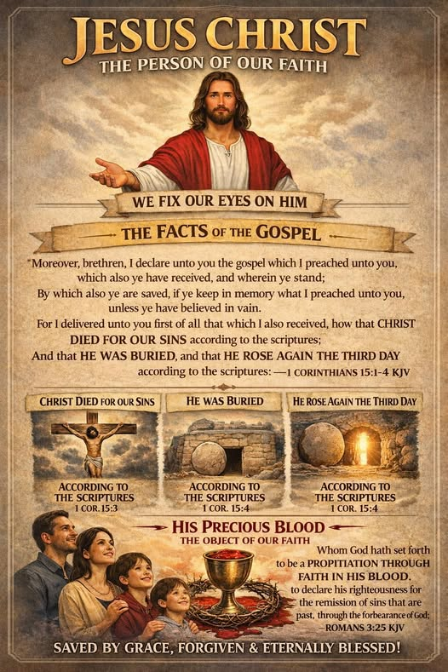
3a. The Apostles’ Creed

I believe in God, the Father Almighty, the Creator of heaven and earth, and in Jesus Christ, his only Son, our Lord: who was conceived by the Holy Spirit, born of the Virgin Mary, suffered under Pontius Pilate, was crucified, died, and was buried.

He descended into hell. On the third day he rose again from the dead. He ascended into heaven and is seated at the right hand of God the Father Almighty; from there he will come to judge the living and the dead.

I believe in the Holy Spirit, the holy Catholic (universal) Church, the communion of saints, the forgiveness of sins, the resurrection of the body, and life everlasting. Amen.

3b. The Nicene Creed

The ancient Nicene Creed has been taught for over two thousand years through Sacred Tradition and Sacred Scripture. It is the faith of Christians that should be believed without question. It is more detailed than the apostles’ creed and begins as follows:

I believe in God, the Father Almighty, the maker of heaven and earth, of all things visible and invisible.

- This statement affirms the belief in a real, living God who is the Father of all humanity. The Father is the first person of the Most Holy Trinity, and He is the Creator of both the visible and invisible realms, shaping everything from nothing. This declaration underscores the foundational belief in God as the ultimate source of existence, emphasising His role as the Creator. Recognising God as the maker of all that exists fosters a deep sense of reverence and gratitude among believers, as it highlights the relationship between the Creator and creation.

I believe in one Lord Jesus Christ, the Only-Begotten Son of God, born of the Father before all ages. God from God, Light from Light, true God from true God, begotten, not made, consubstantiation* with the Father; through him all things were made.

- This statement affirms that Jesus is the only Son of God, recognised as the Christ (the promised Messiah) and also as Lord, sharing the same divine nature as God the Father. This declaration serves to clarify the unique and essential relationship between the Father and the Son, emphasising that Jesus is not merely an angel or a prophet but fully divine. By affirming Jesus' identity as the Only-Begotten Son, believers are reminded of the significance of His role in salvation history and the divine plan for humanity. This foundational belief fosters a deeper understanding of the Trinity and the interrelationship between its persons.
- The term ‘consubstantiation’ succinctly encapsulates the belief that Jesus Christ shares the same substance and essence as God the Father, distinguishing Him from angels and other created beings.

For us men and for our salvation he came down from heaven, and by the Holy Spirit was incarnate of the Virgin Mary, and became man.

- This statement reveals God's intention for humanity through the sending of His Son, who became incarnate in Jesus. This profound mystery illustrates how God took on human flesh, being conceived in the womb of Mary. It emphasises that Mary not only gave birth to Jesus but also bestowed upon Him His human nature. The incarnation signifies the active participation of the Father, Son, and Holy Spirit in salvation history, highlighting the unity of the Trinity in the mission to redeem humanity. By understanding the significance of the incarnation, believers can appreciate the depth of God's love and commitment to humanity.

For our sake he was crucified under Pontius Pilate, he suffered death and was buried, and rose again on the third day in accordance with the Scriptures.

- This statement indicates that Jesus truly suffered and died as a human being, affirming His full humanity alongside His divinity—two natures in one person. Mentioning the Roman Procurator, Pontius Pilate, places Christ's suffering within a historical context, situating it around 29 A.D. This historical reference adds depth to the understanding of Jesus' crucifixion and resurrection, underscoring the reality of His sacrifice. The resurrection signifies His triumph over death, accomplished through His divine power, and serves as a cornerstone of Christian faith, affirming the hope of eternal life for believers.

He ascended into heaven and is seated at the right hand of the Father.

- After forty days following His glorious resurrection, Jesus ascended into heaven in the presence of many disciples, encompassing both His human and divine natures, body and soul. This event embodies the hope that the faithful hold for their own ascension, which will occur on the Last Day, when body and soul will be reunited. Jesus’ ascension serves as a promise of what is to come for believers, reinforcing the assurance that they will one day share in His glory.

He will come again in glory to judge the living and the dead and his kingdom will have no end.

- This statement affirms the belief in the Second Coming of Christ, which is anticipated to occur at the end of the world. On this momentous day, Christ will serve as the divine judge for all individuals who have ever lived, including those who are still alive at that time. This event is known as the General Judgement, where God's judgement is revealed, reflecting the judgement each person has already received during their private judgement after death. It is crucial to understand that this event does not offer a second chance for redemption; rather, it culminates the life choices made by individuals during their earthly existence. Currently, upon death, individuals face their particular judgement before Christ, evaluated on how they expressed love and lived their lives. According to Catholic belief, the soul is then assigned to either heaven, purgatory, or hell, awaiting the return of Jesus Christ.

I believe in the Holy Spirit, the Lord, the giver of life, who proceeds from the Father and the Son, who with the Father and the Son is adored and glorified, who has spoken through the prophets.

- The above statement affirms the existence of God in three divine persons, collectively known as the Holy Trinity. Each person of the Trinity—the Father, the Son, and the Holy Spirit—is equally adored and glorified, emphasising their unified nature. In the current era, we inhabit a transitional period between the first and second comings of Christ. This phase is characterised by the active presence of the Holy Spirit, who continues to work within the hearts of believers, guiding and inspiring them in their daily lives. The belief in the Holy Spirit's ongoing influence serves as a source of strength and comfort for those who follow the teachings of Christ.

I believe in one, holy, catholic and apostolic Church.

- The statement regarding faith in one, holy, catholic, and apostolic Church asserts the foundational role of the Church instituted by Christ as documented in Matthew 16. This Church is understood to be the universal ‘Body of Christ,’ which has a vital mission to teach, sanctify through sacraments, and govern its members through appointed authorities and leaders. These functions are crucial indicators that the Church is fulfilling God's divine mandate. As the body of believers, the Church serves as a community where individuals can grow in faith, receive sacraments, and participate in the collective worship of God. Ultimately, the Church stands as a testament to the continuity of Christ's presence and his teachings throughout history.

I confess one baptism for the forgiveness of sins and I look forward to the resurrection of the dead and the life of the world to come. Amen.

- The declaration of belief in one baptism for the forgiveness of sins highlights the significance of baptism in the Christian faith. Christ entered the world with the paramount purpose of forgiving sins, which includes both Original Sin and personal sins committed by individuals. Baptism, described as being ‘born of water and the Spirit’ (John 3:5), serves not only as the initiation into the Church but also as the means of receiving forgiveness for one's sins. Following death, the body and soul are separated temporarily until the Day of the Lord arrives, when all the dead will be resurrected. On that day, both body and soul will be subject to eternal reward or punishment, leading to either everlasting life in heaven or eternal separation in hell. This belief underscores that earthly existence is merely the beginning of the soul's journey toward its ultimate destiny.
Creed - “I believe”

The Creed is a statement of belief of a religion
that is essential and necessary for all members
requiring loyalty and allegiance to the
truths contained in it.

Apostles’ Creed Nicene Creed

· Oldest Creed 1st Century A.D. · Council of Nicaea 325 A.D.

· Attributed to the 12 Apostles · To affirm the divinity of Christ

· To condemn heresy of Arianism

The Communion of Saints includes:

- The living baptised on earth

- The saints already in heaven

- The souls in purgatory

At the Resurrection of the dead, also known as the
General Judgement:

- There will be the reuniting of the separated body and soul.

- All will know the revealed judgements of God.

- All will know who is in heaven and who is in hell and the
reasons for this.

- It is not a second chance because God’s judgements are
infallible.

    - The just will spend all eternity in heaven with both body
and soul.

- The damned will be cast body and soul forever in hell, a
place where punishments for unrepentant sins are perfect.

- The body as well as the soul are to be rewarded or punished
for all eternity.

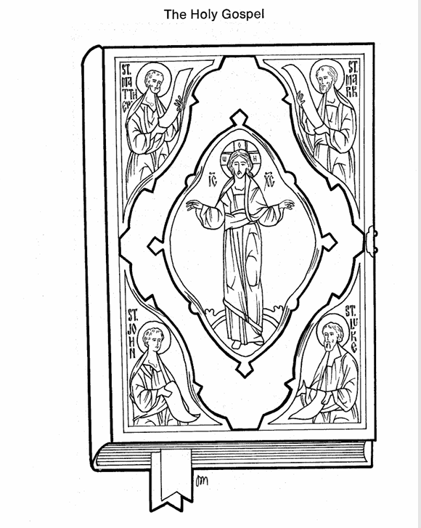

4. The Holy Bible

“All Scripture is inspired. The special gift of the Holy Spirit is given to the sacred authors who wrote Sacred Scripture (the Bible), so that only the things God wanted were written down. Matthew, Mark, Luke and John wrote their Gospels with the inspiration and help of the Holy Spirit appropriate for their communities at that time that have a lasting effect on us today” (Anonymous).

4a. Books of the Bible — Old Testament:

- The Old Testament is composed of books authored by writers who were inspired under God’s covenant with Israel. In contrast, the New Testament consists of writings from the apostles of Christ. The Old Testament contains 39 books that were written approximately 300 to 1500 years before the birth of Christ. Some versions of the Bible include a number of Apocrypha, or “hidden” books, which were composed between 200 B.C. and 70 A.D. Most Old Testament texts were written in Hebrew, the language spoken by the Israelites in Canaan prior to the Babylonian captivity. Following the exile, Aramaic, a dialect closely related to Hebrew, became the prevalent language in Southwest Asia. The ancient Hebrew text originally contained only consonants; the system of written vowels was developed much later. Historical evidence, including the recently discovered Dead Sea Scrolls, indicates that Jewish scribes meticulously copied these texts.

The Unity of the Bible
- Despite comprising many different books written over an extensive period by numerous authors, the Bible exhibits a remarkable organic unity. This coherence can be understood by accepting the claims made by its writers, who assert that they were inspired by the Holy Spirit to convey God's word to humanity regarding redemption. The Old Testament outlines the origins of humanity's sin and the divine preparation made to address this issue through the Messiah—God's own Son. Meanwhile, the New Testament fulfills God's redemptive plan by detailing the Messiah's arrival, the establishment and growth of the Church as described in the Acts, and the theological implications of the Incarnation as found in the Epistles. Ultimately, the Bible reveals that all of human history will reach its culmination in Jesus Christ, connecting the two testaments into a single, cohesive narrative.

The two testaments form two large volumes of the one complete work. It is always best to interpret the O.T. in the light of the N.T. The O.T. is incomplete without the N.T., and the N.T. cannot be understood without the O.T. Together they help show God’s revelation to humanity of his provision for its salvation.

Structure of the Old Testament
The Old Testament includes:

- The Pentateuch (“five”) or Torah (“The Law”):

(5 books)

- Genesis
- Exodus
- Leviticus
- Numbers
- Deuteronomy

B) History of Israel books -

These books depict a recurrent pattern of Israelite history: i) A new generation of Israelites neglects and disobeys God, worshipping other deities; ii) God punishes them through foreign oppression; iii) The people repent and beseech God for salvation; iv) God delivers them militarily through a judge and renews their commitment to Him.
This section comprises 12 books:

- Joshua
- Judges
- Ruth
- 1 Samuel
- 2 Samuel
- 1 Kings
- 2 Kings
- 1 Chronicles
- 2 Chronicles
- Ezra
- Nehemiah
- Esther

- Poetry &Wisdom Literature of Solomon and David:

(5 books)

- Job
- Psalms
- Proverbs
- Ecclesiastes
- Song of Songs

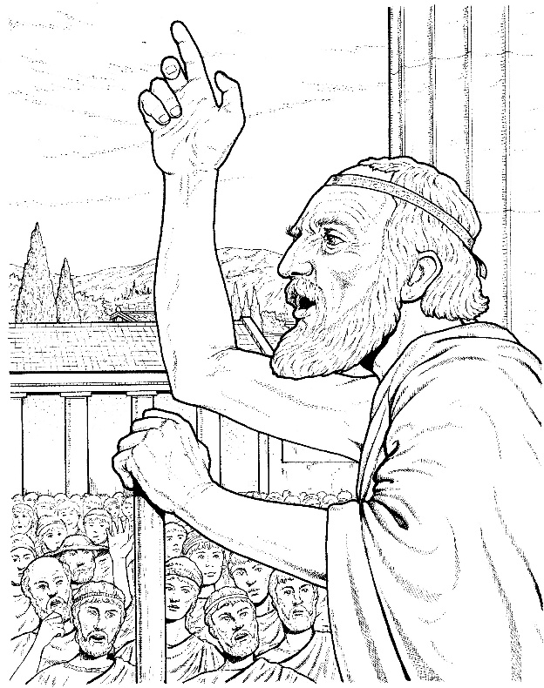

- The Major Prophets who were big influencers of the Hebrew nation. There is disobedience and the call for renewal intermingled with a book about suffering (Lamentations):

(5 books)

- Isaiah
- Jeremiah
- Lamentations
- Ezekiel
- Daniel

- The Minor Prophets the smaller influencers:

(12 books)

- Hosea
- Joel
- Amos
- Obadiah
- Jonah
- Micah
- Nahum
- Habakkuk
- Zephaniah
- Haggai
- Zechariah
- Malachi

**Email us if you would like to learn about the Book of Genesis in 27 lessons as an extra course of study.
Or maybe you prefer to study 12 lessons on Theology (the Study of God) instead. There are plenty of these short courses available check our web site for details. A small collection of these courses is listed below. All you need do is let us know via email which course you would like to attempt and we will send the link out to you.

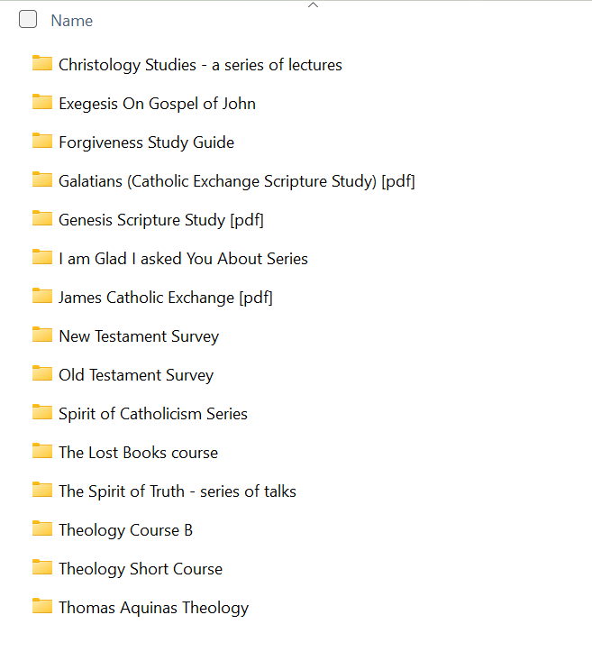

For each unit there are many additional reading materials upon request via email on our web site; just let us know which folder or file you would like and we will send you a link. In each unit there are many folders with sub-folders relating to particular areas of the topic. Check some of these below!

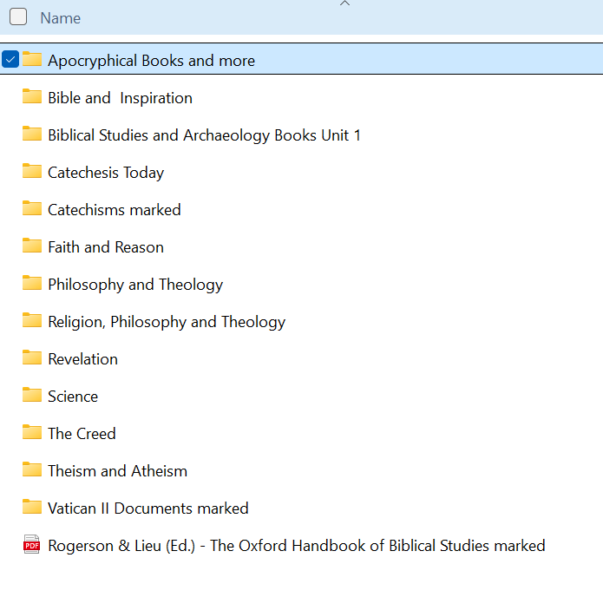



4b. Books of the Bible — New Testament:

The New Testament comprises 27 books that were penned approximately 20 or more years after the earthly life of Christ. These writings, composed in Greek, contain the teachings and actions of Jesus Christ, as well as the formation and expansion of the early Church. Greek was the predominant language in the Hellenistic world during the first century A.D., making it accessible to a wide audience. All the New Testament books were written during the apostolic period, either by the apostles themselves or by individuals closely associated with them.
The key components of the New Testament include:

- The Gospels which contain the life, works, death and resurrection of Christ:

- books)

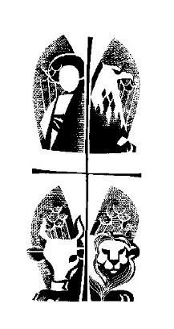
- Matthew
- Mark
- Luke
- John

- The history of early Christians and the early Church:

- book)

- Acts

- Paul’s Letters to the different communities he visited leaving his footprints. They were either written by him, or dictated to others or written by others on his behalf. These highlight the significance of the work and person of Jesus Christ and leave rules for the growing Church:

(13 books)

- Romans
- 1 Corinthians
- 2 Corinthians
- Galatians
- Ephesians
- Philippians
- Colossians
- 1 Thessalonians
- 2 Thessalonians
- 1 Timothy
- 2 Timothy
- Titus
- Philemon

- A number of General Letters:

(8 books)

- Hebrews (written from a Jewish
believers’ perspective)
- James (brother of the Lord, of Alphaeus,
the brother of Joseph.
Head of the Church in Jerusalem)
- 1, 2 Peter (Head of the Apostles)
- 1, 2 & 3 John (The favourite Apostle)
- Jude (brother of the Lord & son of Alphaeus)

- Prophecy written by John the disciple after having an apocalyptic vision while in exile on the Island of Patmos after escaping the severe Roman persecution. This tells of the consummation of all things eventually in Jesus Christ, the worthy Lamb:

(1 book)

- Revelation

The total number of books in the Bible is 66 plus there is the Apocrypha books (14 to 17 books depending on the Bible used).

5. The Apocrypha
Please read the New Catholic Encyclopedia’s information about the Apocrypha.

These books include: (14 to 17)

- Tobit
- Judith
- Wisdom of Solomon
- Ecclesiasticus
- Baruch
- Letter to Jeremiah
- Prayer of Azariah & Song of the Three Jews
- Susanna
- Bel & the Dragon
- 1 Maccabees
- 2 Maccabees
- 1 Esdras
- 2 Esdras
- Prayer of Manasseh
The Orthodox Christians also include:
- 3 & 4 Maccabees
- Psalm 151
These Apocryphal texts, influenced by Hellenistic culture, were written in Greek and can be found in both the Greek and Latin versions of the Bible.
Please read “Lost Books of the Bible for Dummies” which looks at the lost books in ancient and Christian times in some detail.

Reasons to include the Apocrypha in the New Testament Canon:

- The New Testament refers to the Apocryphal books.
- The early Church leaders quoted from them.
- St. Augustine claimed them to be authoritative.
- Early Greek translations of the Old Testament
contained the Apocrypha.

Reasons against:

- Jesus never quotes or alludes to any of these books.
- The Jews never considered them as part of their Old Testament Canon.
- None of the early Church Fathers before Augustine treated them as inspired.
- They were not included for theological reasons i.e. they include praying for the dead.
- Core Christian beliefs and teachings are not contained in any of these books.

6. Summary of the main parts of the Bible

- The Primeval History, which encompasses Creation, Adam and Eve, Cain and Abel, and Adam’s descendants (Genesis 2:4 – 5:32). [Undated]

- The narrative of Noah and the Ark, detailing the flood, the repopulation of the earth, and the story of the Tower of Babel (Genesis 6:1 – 11:32). [Undated]

- The Patriarchs, including the account of Abraham, where God promises a nation to Abram, the stories of Abram and Lot, the destruction of Sodom and Gomorrah, the near sacrifice of Isaac, Isaac and Rebekah, and the death of Abraham (Genesis 12:1 – 25:18). [2166 B.C.]

- The story of Isaac, detailing his sons Jacob and Esau, Isaac and Abimelek, and the blessing of Jacob by Isaac (Genesis 25:19 – 28:9). [2066 B.C.]

- The narrative of Jacob, which chronicles the start of his family and his eventual return home (Genesis 28:10 – 36:43). [2006 B.C.]

- The account of Joseph, illustrating his journey from being sold into slavery and imprisoned to becoming a significant leader in Egypt, as well as the eventual relocation of Jacob’s family to Egypt (Genesis 37:1 – 50:26). [1915 B.C.]

- The period of Israelite slavery in Egypt, including the story of Moses, the ten plagues, the Passover, the Exodus, the crossing of the Red Sea, and Israel’s experiences in the wilderness, culminating in the giving of the Ten Commandments and the establishment of the Ark of the Covenant (Exodus to Deuteronomy). [1526 – 1406 B.C.]

- The time of the Judges, where Joshua leads the Israelites into the Promised Land, including the crossing of the Jordan River and the military and moral challenges faced by Israel, as well as their eventual rescue by judges (Joshua, Judges, and Ruth). [1375 – 1105 B.C.]

- The united/divided Jewish Monarchy period, which includes narratives about Samuel, conflicts with the Philistines, King Saul’s rejection by God, the anointing of David, the confrontation with Goliath, and the complexities of David’s kingship, including his failures and victories (1 Samuel, 2 Samuel, and Chronicles). [1105 – 1000 B.C.]

- The exilic and post-exilic periods of Israel, featuring King Solomon’s wisdom, his downfall, the construction of the Temple in Jerusalem, the revolt of the northern tribes, the division of the Kingdom of Israel, the ministry of Elisha, Israel's exile to Assyria, Judah’s exile to Babylon, and the eventual return of Jewish exiles and the completion of the new Temple in 515 B.C. (Kings, Chronicles, Ezra, and Esther). [970 – 400 B.C.]

- Great expectations for the coming of the Messiah, as illustrated by the lives of Elijah, Elisha, Jonah, Hosea, Isaiah, Hezekiah, Jeremiah, Daniel, and Malachi (The Prophets). [900 – 300 B.C.]

- The intertestamental period, characterized by the transition from the Old to the New Testament and the different world that emerged after the conclusion of Malachi, the last book of the Old Testament.

- The reign of Herod the Great, who was appointed king of Judea by the Romans, and the political landscape shaped under Julius Caesar. Mary, the mother of Jesus, was born around 20 B.C., during this period when Herod began remodelling the Temple in Jerusalem.

- The beginning of the New Testament chronicles the birth, preparation, life, ministry, teachings, and works of Jesus Christ, the promised Messiah. The suffering, death, and resurrection of Jesus, who is regarded as the Son of God, Servant King, and Savior, are meticulously recorded in the four Gospels: Matthew, Mark, Luke, and John. Jesus initiated his three-year ministry at approximately 30 years of age between 24 and 26 A.D. [4-6 B.C. - 29 A.D.].

- The establishment and growth of the early Church is detailed, beginning in Jerusalem and expanding outward, featuring the ministry of the Apostle Peter (Acts 1:1 – 12:24) and the missionary journeys of Paul, culminating in his trial and martyrdom (Acts 12:25 – 28:31). [29 A.D. - 67 A.D.]

- Paul authored the book of Romans while imprisoned in Caesarea in 57 A.D., followed by his final voyage to Rome, during which he wrote the ‘prison letters’ in 62 A.D. to the communities he previously visited. His other letters were composed between 49 A.D. and 67 A.D. (Romans to Titus).

- The destruction of Jerusalem, including the Temple, by the Romans occurred in 70 A.D.

- Various General Letters were written by different authors between 49 A.D. and 95 A.D. (Hebrews to Jude).

- The closing of the biblical narrative is marked by the Apostle John’s writing of Revelation in 95 A.D., offering a prophetic vision of the end times.

6a. Some further points about the Holy Bible:

- The Bible does not have any first editions available; rather, it is a compilation of texts that have been handed down through generations. These texts were originally inscribed on papyrus, a material derived from a tall water plant that was commonly used in ancient times. The absence of modern technologies, such as photocopying, meant that both the Old and New Testament texts needed to be meticulously copied by hand to ensure their preservation. This labour-intensive process led to the creation of thousands of handwritten manuscripts, each contributing to the rich tapestry of biblical history. As a result, the Bible has evolved into a collection of diverse writings, each manuscript representing a unique facet of the ancient world.

- The Old Testament texts were composed over a vast span of time, approximately between 300 to 1500 years before the birth of Christ. In contrast, the New Testament texts began to emerge around 20 years after the death of Jesus, with the earliest writings dating back to approximately 45 A.D. This timeline highlights the significant historical context in which these scriptures were developed, reflecting the beliefs and experiences of the communities that produced them. The Bible, therefore, serves as both a religious document and a historical record, encapsulating the faith journey of its authors and their followers over centuries. Understanding this chronology is essential for grasping the theological and cultural implications of the biblical narrative.

- The Bible is a remarkable compilation of texts that spans over a period of approximately 1,200 years, created by a multitude of authors, editors, and copyists. These individuals wrote in three primary languages: Hebrew, Greek, and Latin, each language contributing its unique nuances to the text. The diversity of voices and perspectives within the Bible enriches its content, allowing for a multifaceted exploration of themes such as faith, morality, and human experience. Furthermore, this linguistic variety serves as a testament to the Bible's widespread influence across different cultures and epochs. The interplay between these languages enhances our understanding of the original messages and the contexts in which they were articulated.

- The Bible plays a foundational role in the traditions of three major world religions: Judaism, Christianity, and Islam. Each of these faiths draws upon the scriptures to shape their beliefs, practices, and moral teachings. The interconnectedness of these religions reflects a shared heritage that underscores the Bible's significance beyond its literary and historical value. It addresses profound themes that resonate with humanity, such as creation, redemption, and the nature of God. By engaging with the teachings of the Bible, adherents of these faiths find guidance and inspiration in their spiritual journeys.

- The Bible encompasses a vast narrative that begins with the creation of the world and extends to the culmination of human history. This sweeping storyline captures the essence of existence, exploring the relationship between God and humanity throughout the ages. The text is rich with diverse literary forms, including narratives, hymns, poems, prose, historical accounts, stories, and parables, each contributing to the overarching message of the scriptures. The integration of these various forms allows for a dynamic exploration of theological themes, making the Bible a profound source of wisdom and insight. Its narrative continuity invites readers to reflect on their own lives within the broader context of divine creation and purpose.

- The Bible can be approached from multiple interpretative angles, allowing for both literal and figurative readings. This duality invites readers to engage with the text on different levels, uncovering deeper meanings that may not be immediately apparent. A literal interpretation focuses on the explicit words and historical context, while a figurative reading seeks to uncover the symbolic or metaphorical significance behind the narratives. This flexibility in interpretation enriches the reader's experience and fosters a more profound understanding of the text's implications for both personal and communal faith. Consequently, the Bible remains a living document, continually relevant across time and cultures.

- Geographically, the Bible spans three continents: Asia, Africa, and Europe, with ancient Israel serving as the central stage for many of its narratives. The diverse locations featured in the biblical texts reflect the historical and cultural contexts in which the events unfolded. This geographical expanse enhances our understanding of the interactions between different peoples and cultures throughout biblical history. The significance of Israel as a focal point highlights the region's role in the unfolding story of God's relationship with humanity. By recognising the geographical context, readers can better appreciate the complexities and richness of the biblical narrative.

- The Bible must be understood as a continuous narrative, a cohesive work that weaves together various threads of storytelling, doctrine, and prophecy. Despite its diverse authorship and the span of time over which it was written, the text possesses a coherent plot that centers on the life and actions of God, particularly in relation to humankind. This storyline emphasises God's enduring relationship with His creation, focusing on themes of disobedience, grace, and redemption. This narrative coherence invites readers to view the Bible as a unified testimony to God's character and purpose throughout history. In doing so, it reinforces the idea that the scriptures are not merely isolated texts but rather parts of a grand divine narrative.

- From the beginning to the end of the New Testament, the entire text speaks of the Lord and presents Him as the long-awaited Savior. It is essential to interpret the Old Testament in light of the New Testament, particularly regarding the coming of God's promised Messiah. This interpretative lens allows for a deeper understanding of the continuity between the two testaments and the unfolding plan of salvation. By recognising the connections between the Old and New Testaments, readers can appreciate the richness of biblical prophecy and fulfillment. Ultimately, this perspective enhances the reader's comprehension of God's overarching narrative throughout the scriptures.

- In the Bible, every word serves as a lesson, reflecting the timeless wisdom embedded within its pages. Although the Holy Spirit inspired its writing for the context of its time, the messages contained within can also resonate with future events and circumstances. This dynamic quality underscores the Bible's relevance across generations, as its teachings continue to speak to the human experience. Believers are encouraged to engage with the text actively, seeking to apply its lessons to their lives. The enduring nature of biblical wisdom invites ongoing exploration and application in contemporary contexts.

- In these challenging times, the Gospel serves as a guiding compass for believers, offering a sense of direction and purpose. Within its teachings lie the concepts of 'Life' and 'Safety,' encompassing everything one requires for salvation. The Gospel articulates essential truths that address the myriad circumstances faced by individuals and communities alike. Each article of this holy code provides answers that can bring solace and clarity to the complexities of life. It is vital for believers to remain steadfast in their commitment to the Gospel, nurturing their faith and dispelling doubts that may arise.

- The works of the Holy Trinity—comprising the Father, the Son, and the Holy Spirit—are abundantly manifested throughout the Bible. The Gospel itself embodies the essence of God and represents His profound love for humanity. Understanding the significance of Jesus' words is crucial, as they impart life and wisdom essential for spiritual growth. Believers are encouraged to cultivate a deep love for the Gospel, recognising that the Kingdom of God is present in every aspect of His teachings. This connection to the Trinity fosters a sense of belonging and purpose within the faith community.

- Those who do not accept the Word of the Father find themselves disconnected from the Trinity and unable to participate fully in the one-fold of faith. This separation can be likened to a branch that is no longer connected to the vine; without this vital connection, believers cannot thrive or produce spiritual fruit. Rejecting any part of God's Word leads to a state of spiritual stagnation, where the nourishing sap of divine truth ceases to flow. Consequently, it is imperative for individuals to embrace the entirety of the scriptures, fostering unity and growth within their faith. A holistic approach to the Word ensures that believers remain vibrant and fruitful in their spiritual journey, allowing them to experience the fullness of life that God intends.

6b. What can be said about the Bible?:

- The Bible is the book of the ages (Psalm 119:89; Matthew 5:18);

- Is food for the soul (Deuteronomy 8:3; 1 Peter 2:2);

- Is divinely inspired (Acts 1:16);

- Its precepts are written on one’s heart (Deuteronomy 6:6; Colossians 3:16);

- Is light and life for all who embrace it (Psalm 19:8; 2 Peter 1:19);

- Is loved by those being saved (Psalm 119:47; Jeremiah 15:16);

- Has a saving power (Romans 1:16);

- Is a powerful double-edged sword (Ephesians 6:17);

- Contains blessings (Luke 11:28);

- Is most sacred (Revelation 22:19);

- Is absolutely trustworthy (Ezekiel 12:25; Luke 21:33);

- Is profitable for instruction (Deuteronomy 4:10; Isaiah 2:3).

Please go to the Salvation History Chart.docx for a summary of salvation history from the beginning of time.

6c. Principles for understanding apparent discrepancies in the Bible:

- The unexplained in not necessarily unexplainable.

- Fallible interpretations do not mean fallible revelation.

- One must understand the context of the passage.

- Interpret difficult passages in the light of clearer ones.

- Don’t base your teachings on obscure passages.

- The Bible is a book written by humans with human characteristics.

- Just because a report is incomplete does not mean it is false.

- New Testament citations of the Old Testament need not always be exact.

- The Bible uses non-technical, everyday language.

- The Bible may use round numbers as well as exact numbers.

- Note that the Bible uses many different literary devices.

- An error in a copy does not equate to an error in the original.

- General statements do not necessarily mean universal promises.

- Later revelation superseded previous revelation.

For further details see McDowell, Josh., The New Evidence That Demands a Verdict. Thomas Nelson Publishing Co. Nashville, 1999, p.47.

Apostle’s Creed
Father, Creator of Heaven and Earth
One God His Only-Begotten Son, Redeemer & Our Lord } The Trinity all play a (divinity) part in salvation history
Holy Spirit, the Sanctifier

Christ (Messiah) Incarnation Pontius Pilate
Jesus (God saves) Birth in flesh by Roman Governor Death of his flesh
______________ Holy Spirit conceived Historical person Good Friday
Fully human through Virgin Mary, 6 B.C. - 29 A.D.
Fully divine no human father and beyond
2 natures in one

Abraham’s Bosom
(not hell of the damned
but abode of the just dead)

Resurrection
By his own power
Glorified & Risen body

Ascension body & soul Seated at Right Hand
into heaven with the souls of the Father
in Abraham’s Bosom

Second Coming
of Jesus with the angels,
to judge living & dead,
end of world

General Judgement Goats Sheep
of living & dead, Damnation Bodily resurrection

Doomsday Revealing of God’s judgements on all,
FOREVER not a 2nd chance

11. Essential Reading Material

Please read the essential marked documents listed below for UNIT ONE. A link to these was sent out to your email when you received your course material. Only read the documents and chapters relevant to this unit:

Catechism of the Catholic Church - Essential Read.pdf

Documents of Vatican II - Constitutions Essential Read.pdf

The Catechism of the Council of Trent Essential Read.pdf

Catholic Bible Dictionary Essential Read.pdf

These texts are suggested reading only:

Dei Verbum.pdf

First Book of Adam and Eve.docx

Second Book of Adam & Eve.docx

The following marked texts and folders can be read as well to further improve your understanding of the overall subject area. Only read the areas suitable for this unit. They are accessed by the link sent to you with your original course material or by the folders sent to you in your unit’s course package:

Dictionary of Dogmatic Theology - Parente et al Essential Read.pdf

A Concise Encyclopedia of the Philosophy of Religion Essential Read.pdf

The marked “Catechism” folder

The marked “Vatican II Documents” folder

8. Unit One Exam
The exam for unit 1 is provided with the course material. You can print it out and write your answers on the space provided or you can type directly onto the Word document.

EXAM Unit 1.docx.

Good Luck!

Back to Table of Contents

