Additional Reading Material Available for Unit 1
of Certificate II in Theological Studies

All these folders and titles (e-books) are available to the student upon request via email up to 1 folder and 5 titles at a time, unlimited lend.

Main Folders:

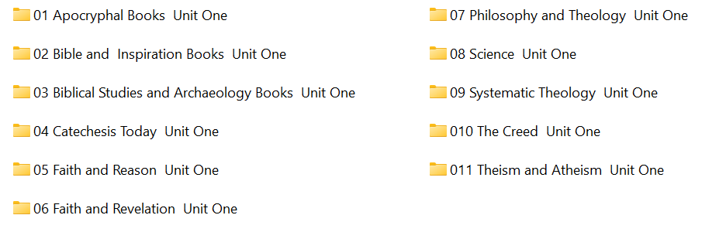
Sub-Folders:
- ‘Apocryphal Books’ has these 6 sub-folders:

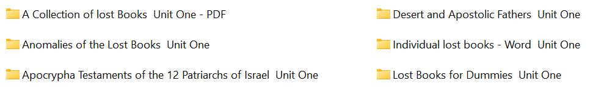

- ‘Bible and Inspiration’ folder has these 5 sub-folders:
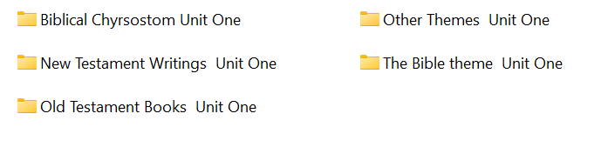

- ‘Biblical Studies and Archaeology’ has 14 books:

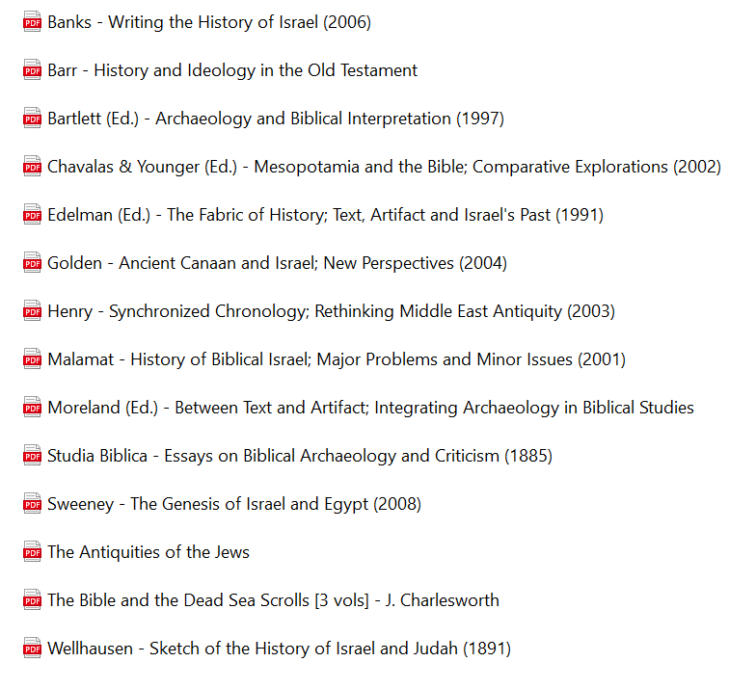

- ‘Catechsis Today’ has 2 Books:

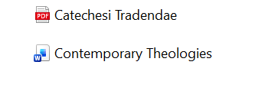

- ‘Faith and Reason’ has 39 books:

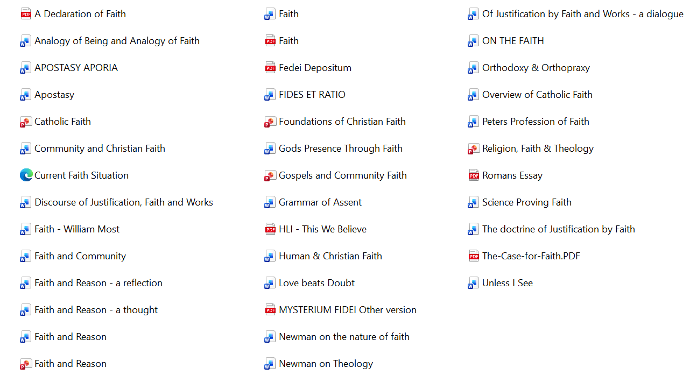

- ‘Faith and Revelation’ has 3 titles:

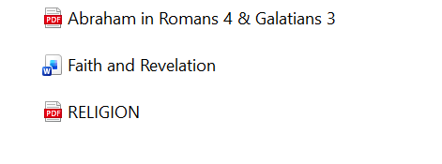

- ‘Philosophy and Theology’ has 21 e-books:

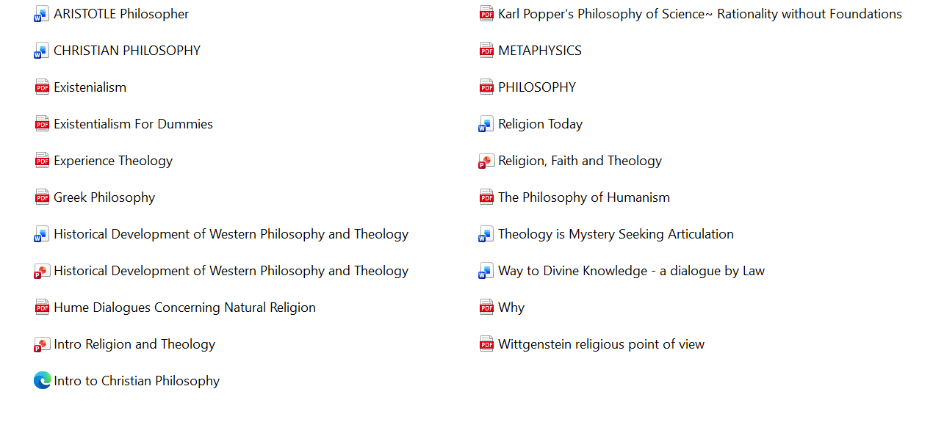

- ‘Science’ has 2 titles:

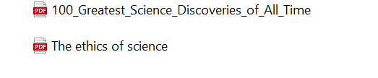

- ‘Systematic Theology’ has 2 volumes:

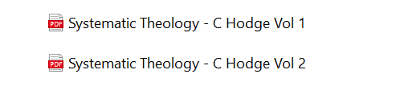

- ‘The Creed’ folder has 10 titles:

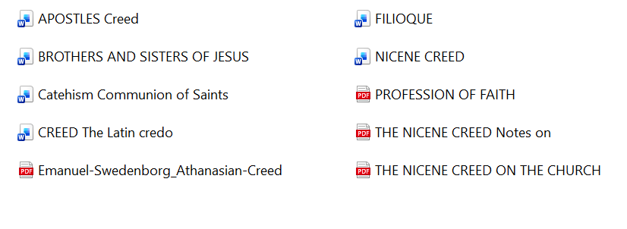
- ‘Theism and Atheism’ has 13 e-books:

