Additional Reading Material Available for Unit 21
of Certificate III in Theological Studies

All these folders and titles (e-books) are available to the student upon request via email up to 1 folder and 5 titles at a time, unlimited lend.

Main Folders:

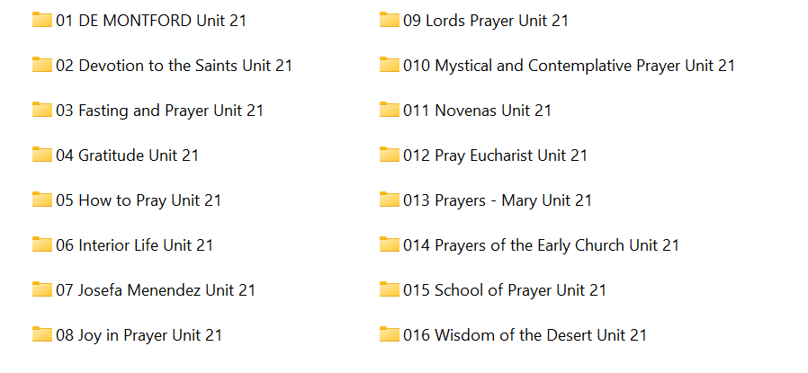1. De Montford folder:

2. Devotion to the Saints has:
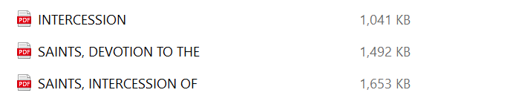

3. Fasting and Prayer has:
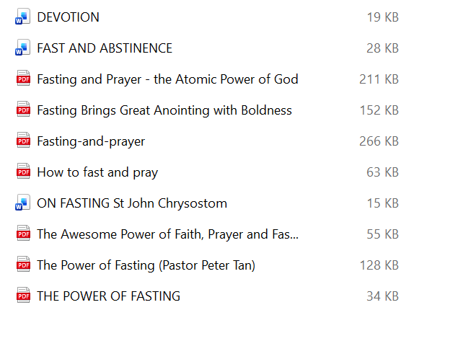
4. Gratitude folder has:

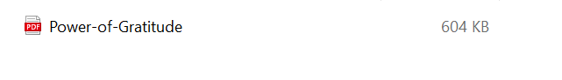
5. How to Pray has these e-books available:

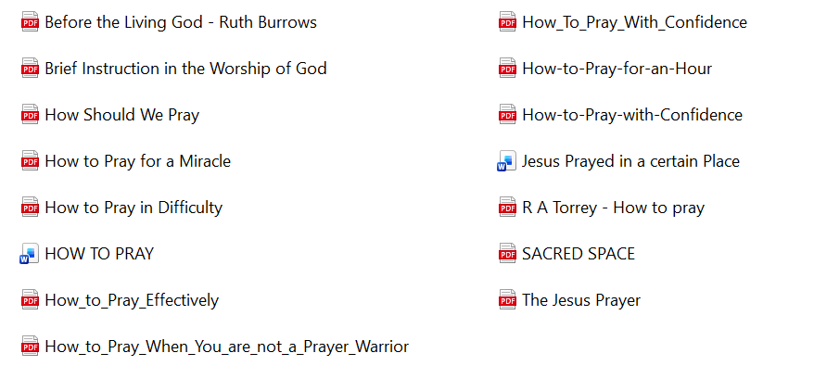

6. Interior Life folder contains this material:

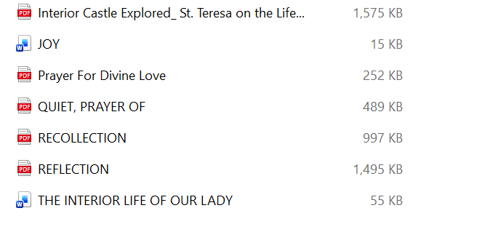

7. Josefa Menendez has:



8. Joy in Prayer contains these items:

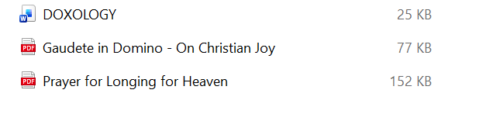

9. Lord’s Prayer folder has:

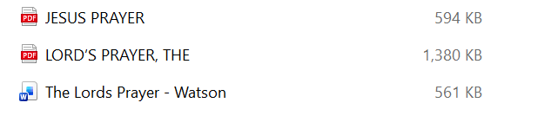

10. Mystical and Contemplative Prayer contains:

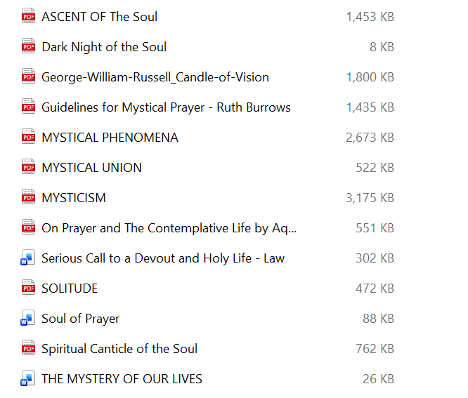

11. Novenas folder has these items:

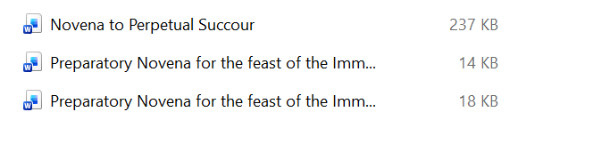

12. Pray Eucharist folder has:

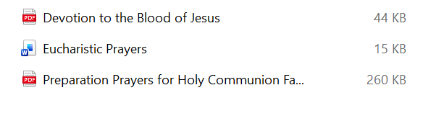

13. Prayers – Mary folder has 1 sub-folder and 14 articles:

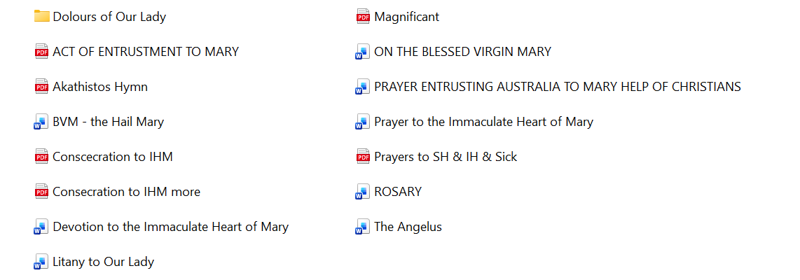

14. Prayers of the Early Church:



15. School of prayer has these e-books:

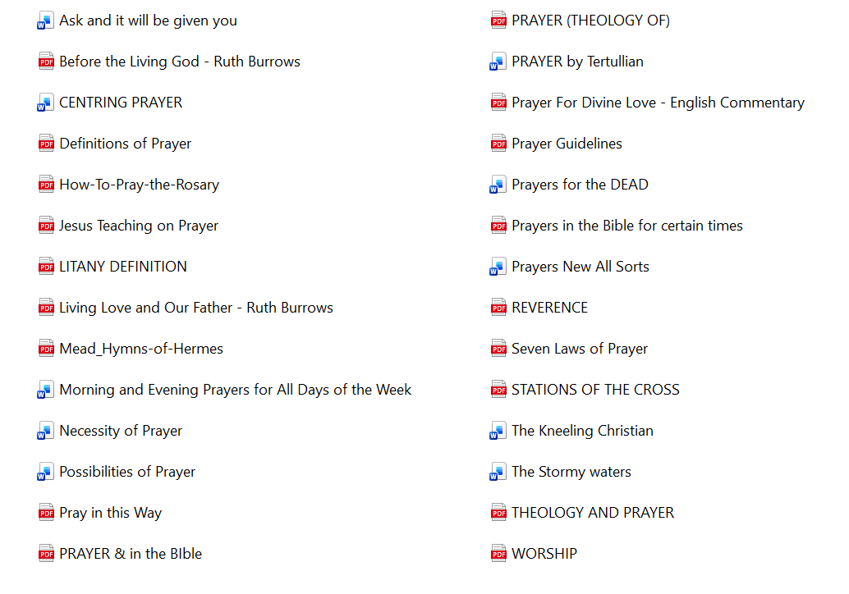

16. Wisdom of the Desert folder has:

