Additional Reading Material Available for Unit 6
of Certificate II in Theological Studies

All these folders and titles (e-books) are available to the student upon request via email up to 1 folder and 5 titles at a time, unlimited lend.

Main Folders:

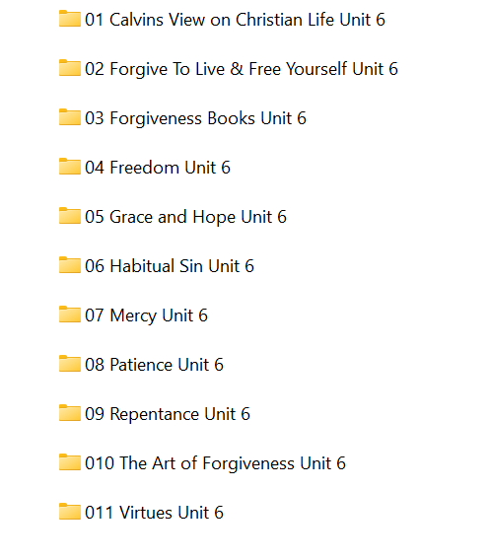

- ‘Calvin’s View’ folder has this book:
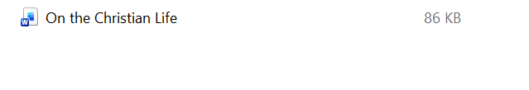

- ‘Forgive to Live and Free Yourself’ folder has these 26 books for loan:

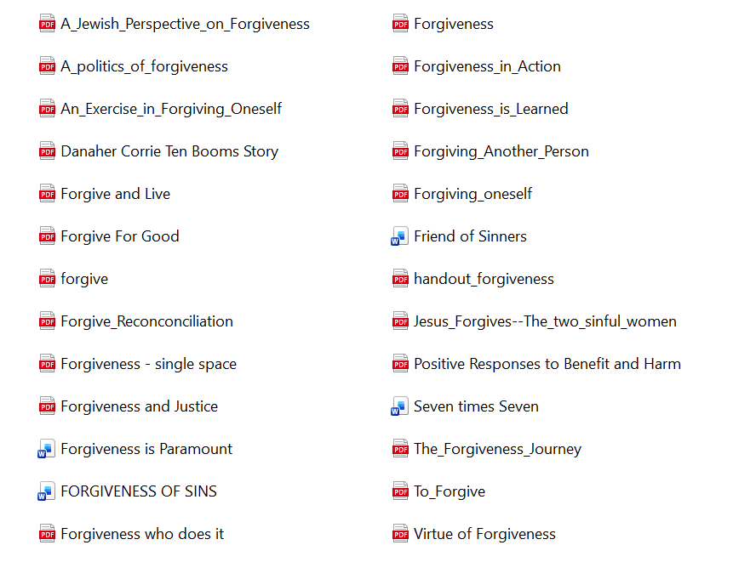

- ‘Forgiveness Books’ folder contains these:

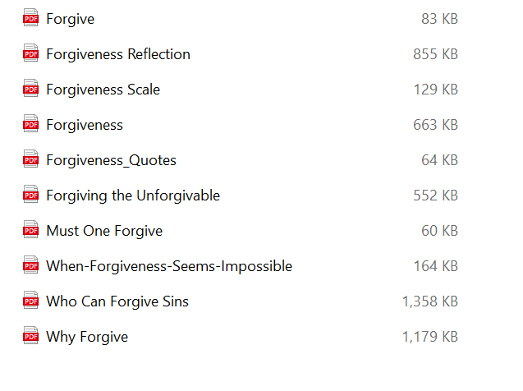

- ‘Freedom’ folder has these:

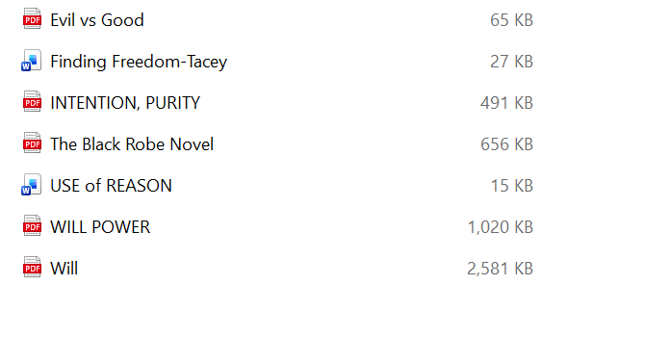

- ‘Grace and Hope’ folder contains these articles:

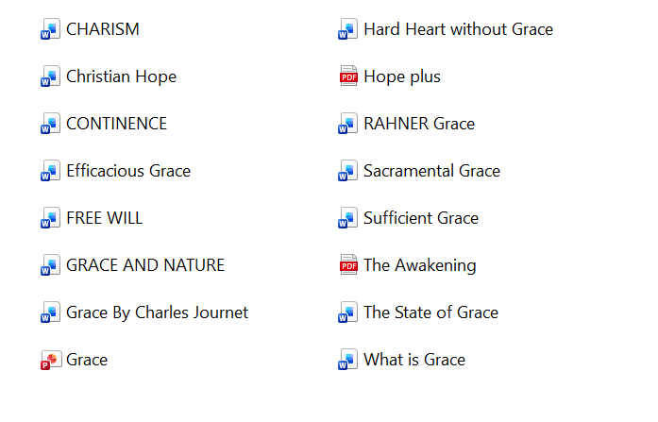

- ‘Habitual Sin’ has these two e-books:

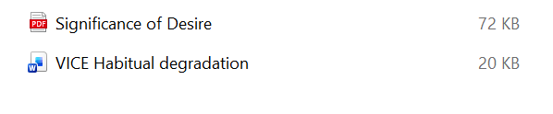

- ‘Mercy’ folder has these:

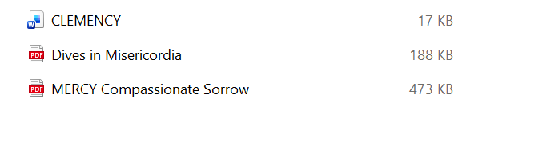

- ‘Patience’ has 2 available books:

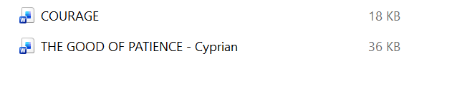

- ‘Repentance’ folder has these 8 e-books available:

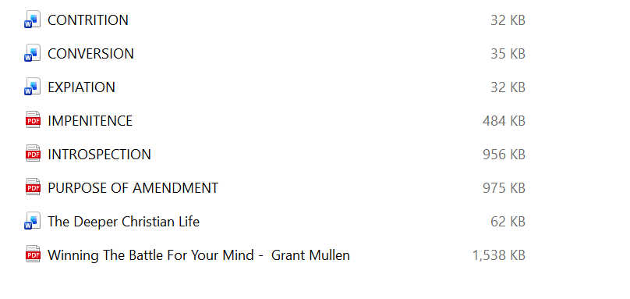

- ‘The Art of Forgiveness” contains these articles:

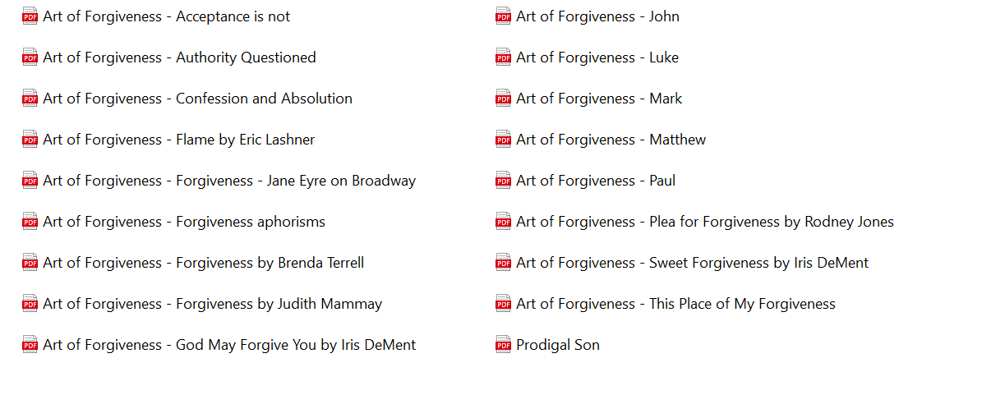

- ‘Virtues’ folder has at least 25 e-books for the student to loan:

