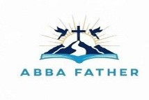
ABBA FATHER

Correspondence Course

Additional Reading Material Available for Unit 10
of Certificate II in Theological Studies

All these folders and titles (e-books) are available to the student upon request via email up to 1 folder and 5 titles at a time, unlimited lend.

Main Folders:

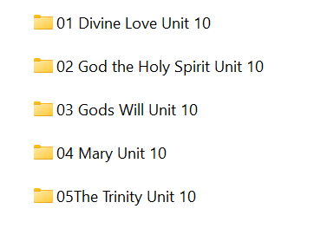

- Divine Love has this one special book:

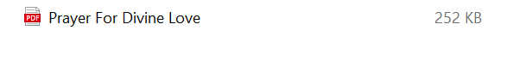

- God the Holy Spirit folder has these:

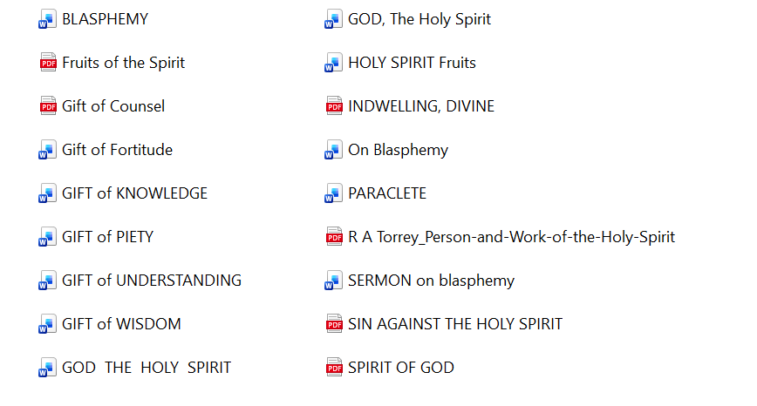

- God’s Will contains 3 e-books:

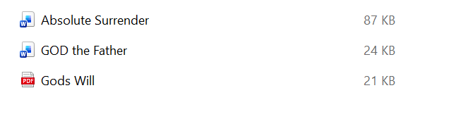

- Mary folder has many articles and e-books on this topic area:
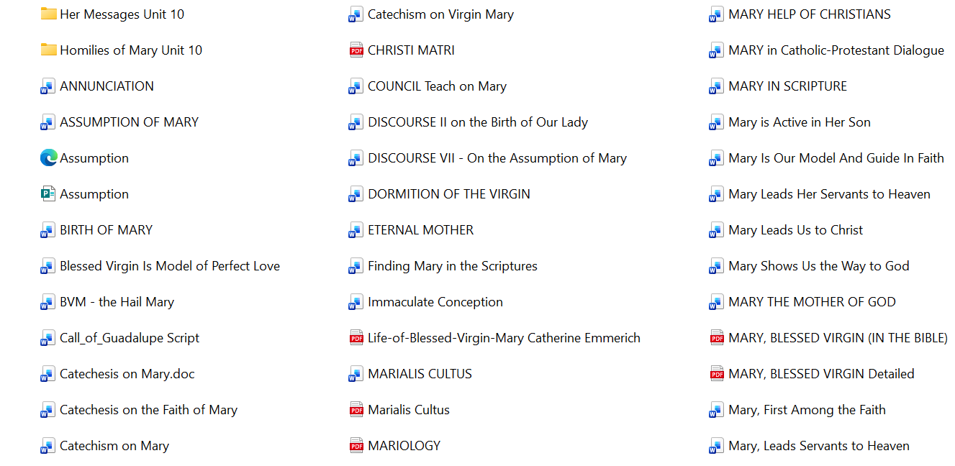

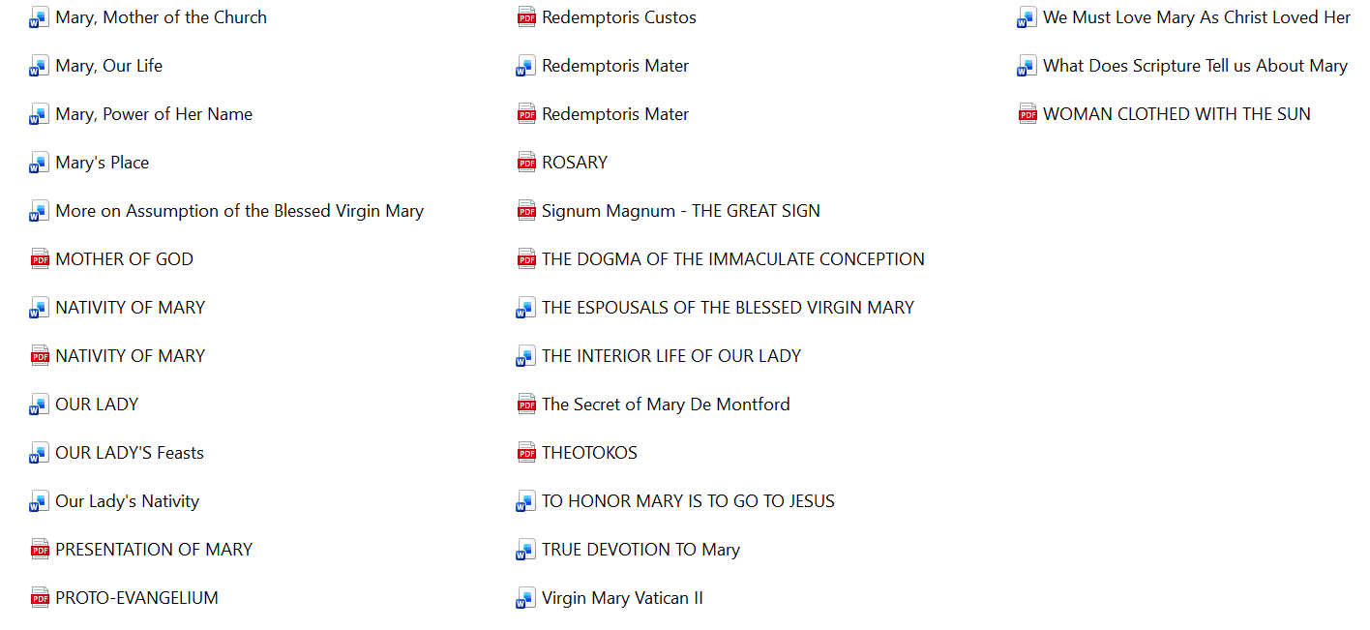

- The Trinity folder contains these for the student to use:

