Additional Reading Material Available for Unit 20
of Certificate III in Theological Studies

All these folders and titles (e-books) are available to the student upon request via email up to 1 folder and 5 titles at a time, unlimited lend.

Main Folders:

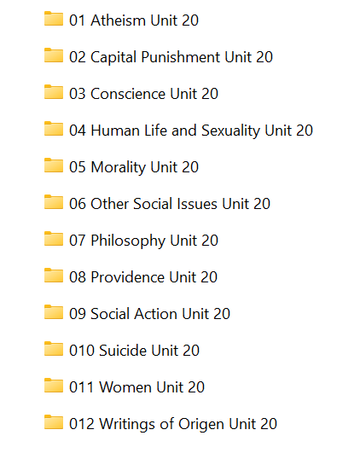

- Atheism folder contains these:

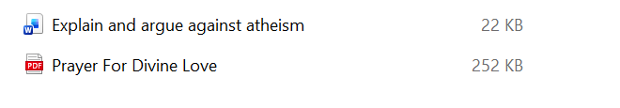
- Capital Punishment folder has:

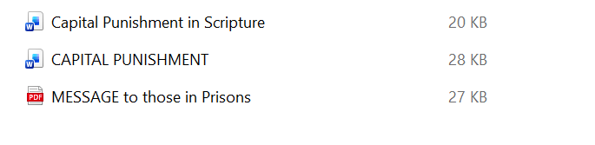

- Conscience folder contains:

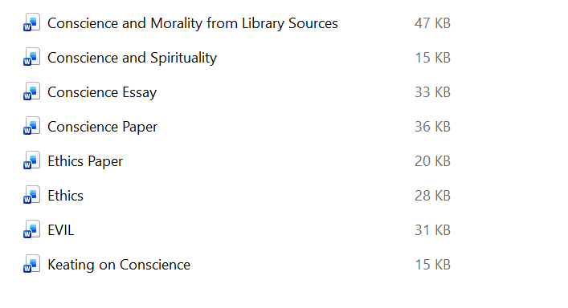

- Human Life and Sexuality contains:

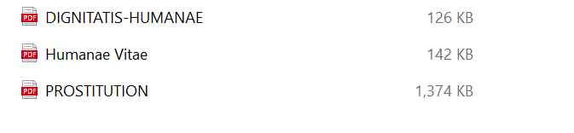

- Morality folder has:

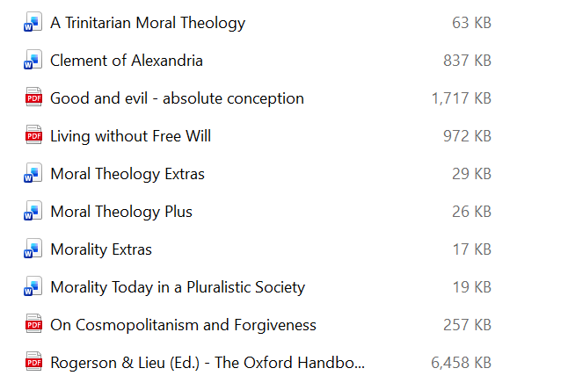

- Other Social Issues folder has these e-books:

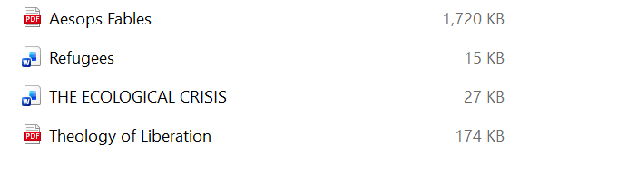

- Philosophy older has:

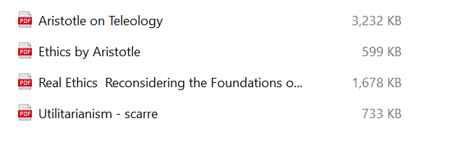

- Providence folder contains these e-books for the student to use:

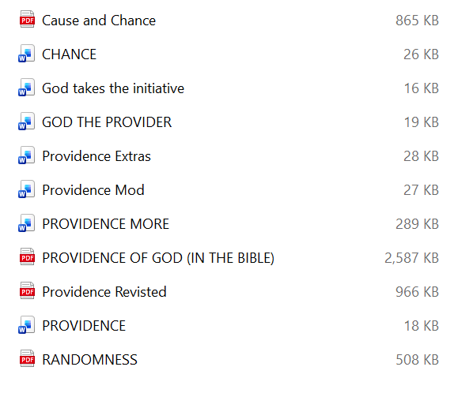

- Social Action folder has:

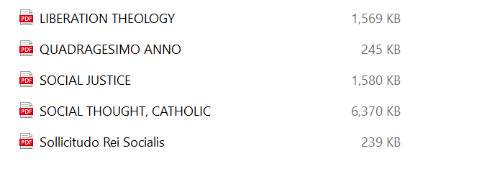

- Suicide folder contains these:

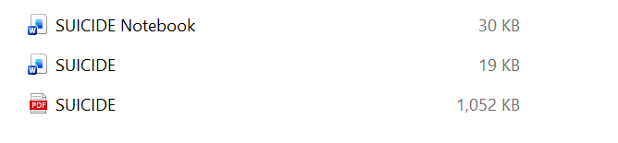

- Women folder contains these articles:

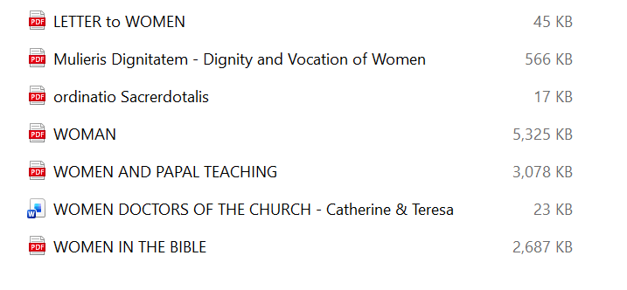

- Writings of Origen has:

