Additional Reading Material Available for Unit 7
of Certificate II in Theological Studies

All these folders and titles (e-books) are available to the student upon request via email up to 1 folder and 5 titles at a time, unlimited lend.

Main Folders:

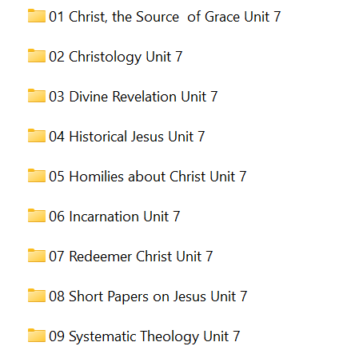

- ‘Christ the Source of Grace’ contains 6 e-books:

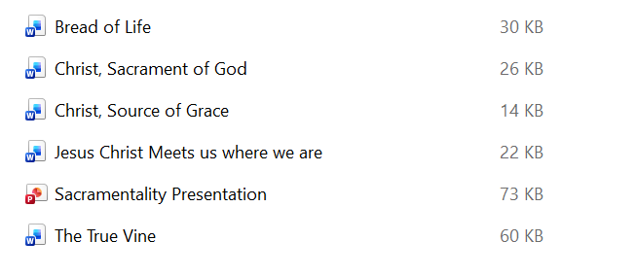
- Christology has these books:

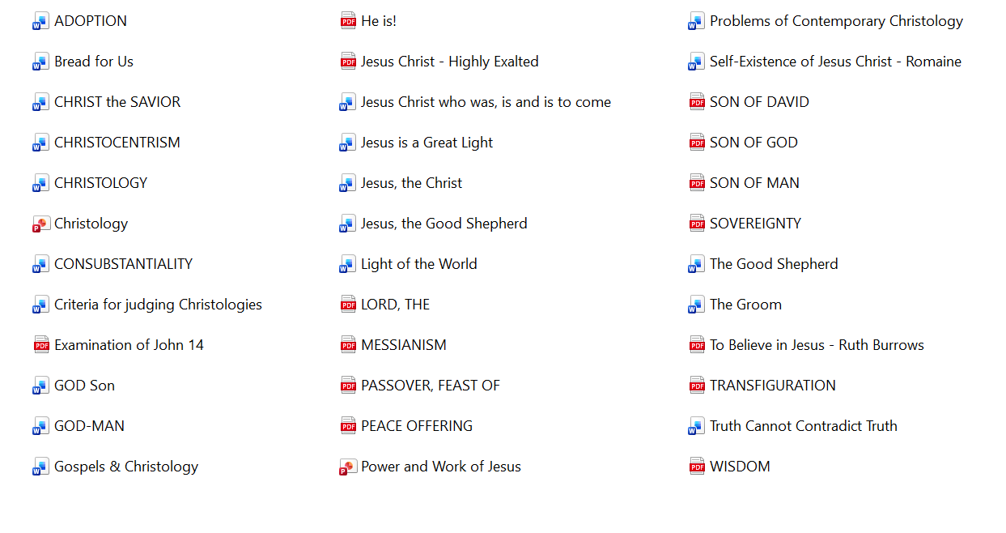

- Divine Revelation folder contains these:

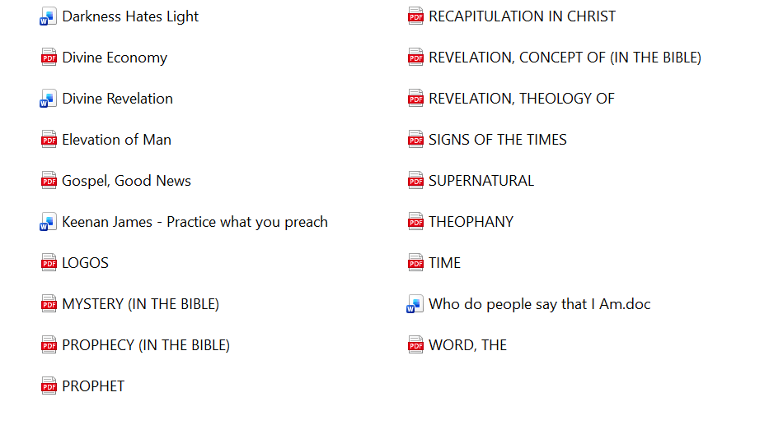

- Historical Jesus has a large number of excellent articles to read:

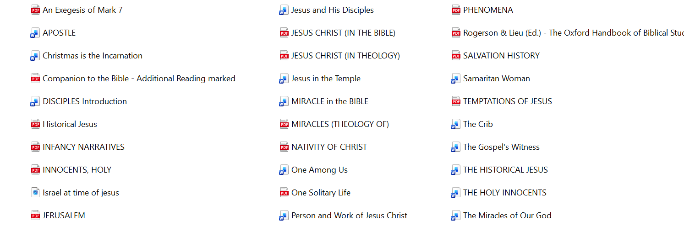
- Homilies about Christ

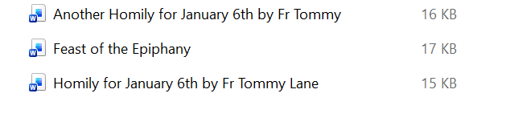

- Incarnation folder contains these:

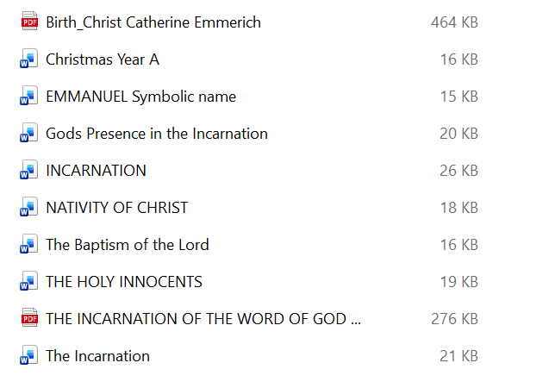

- Redeemer Christ folder has about 29 e-books to loan:

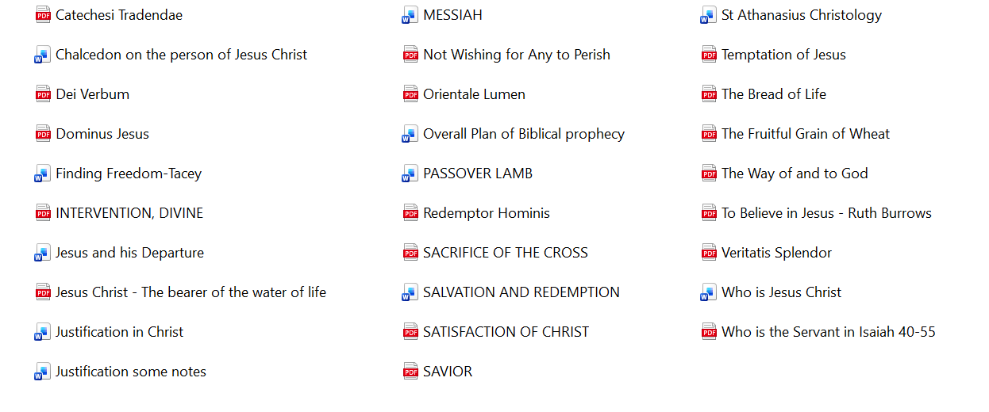

- Short Papers on Jesus contains 3 articles:
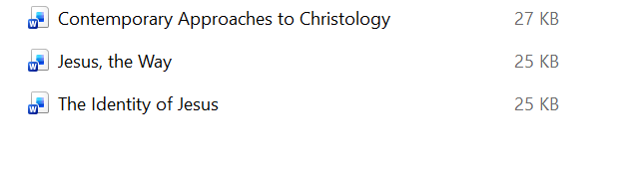

- Systematic Theology folder has these 2 volumes:

