Additional Reading Material Available for Unit 3
of Certificate II in Theological Studies

All these folders and titles (e-books) are available to the student upon request via email up to 1 folder and 5 titles at a time, unlimited lend.

Main Folders:
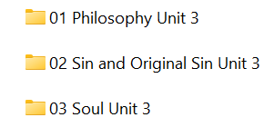

- ‘Philosophy’ folder contains 6 titles for the student to engage in:

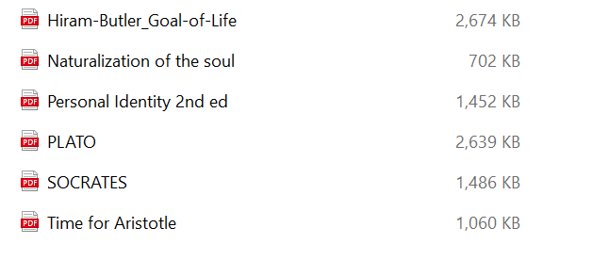

- ‘Sin and Original Sin’ has the following 8 e-books:

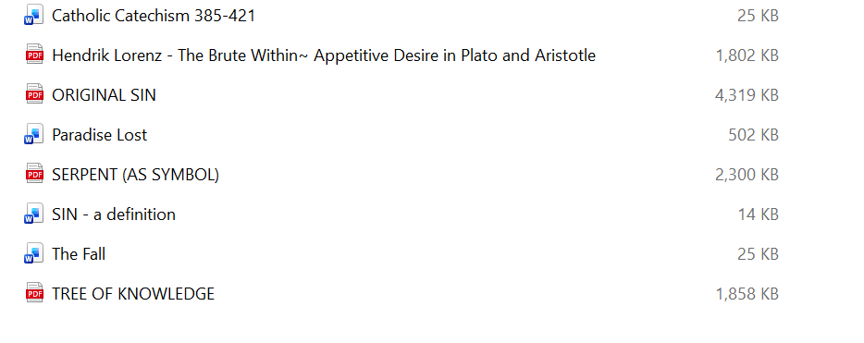

- ‘Soul’ folder contains 10 titles:

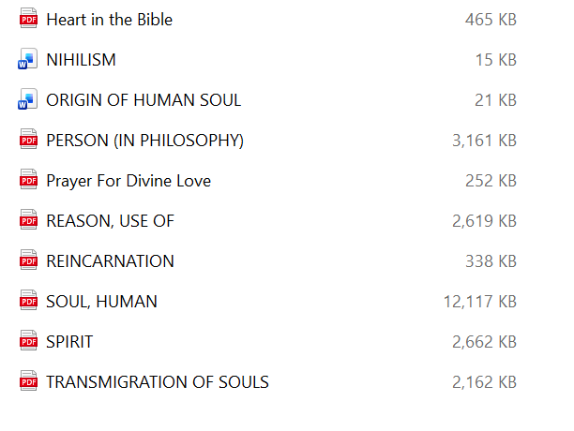

Additional Reading Material Available for Unit 4
of Certificate II in Theological Studies

All these folders and titles (e-books) are available to the student upon request via email up to 1 folder and 5 titles at a time, unlimited lend.

Main Folders:
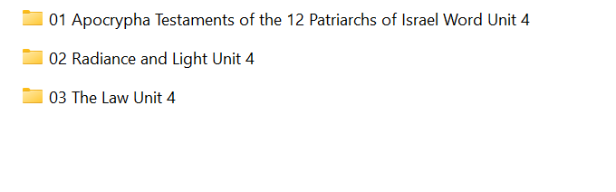
- ‘Apocrypha Testaments’ 12 e-books:

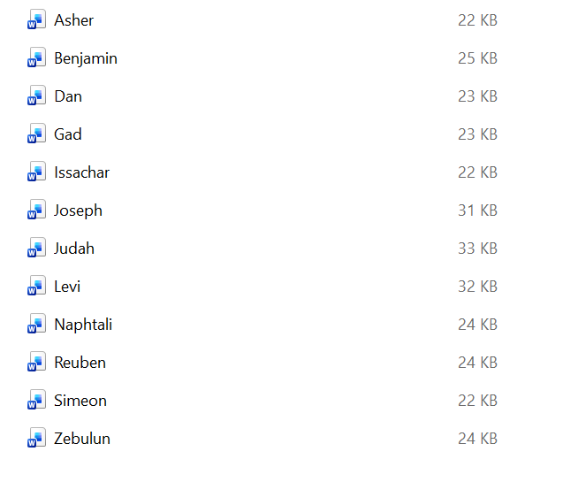

- ‘Radiance and Light’

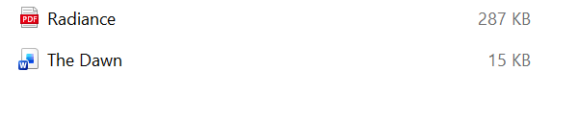

- ‘The Law’ has the following articles for the student:

