Additional Reading Material Available for Unit 14
of Certificate III in Theological Studies

All these folders and titles (e-books) are available to the student upon request via email up to 1 folder and 5 titles at a time, unlimited lend.

Main Folders:
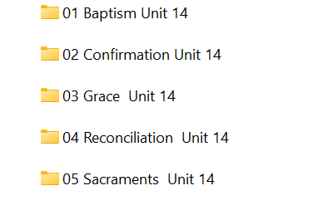

- Baptism folder has 1 folder and at least 18 e-books:

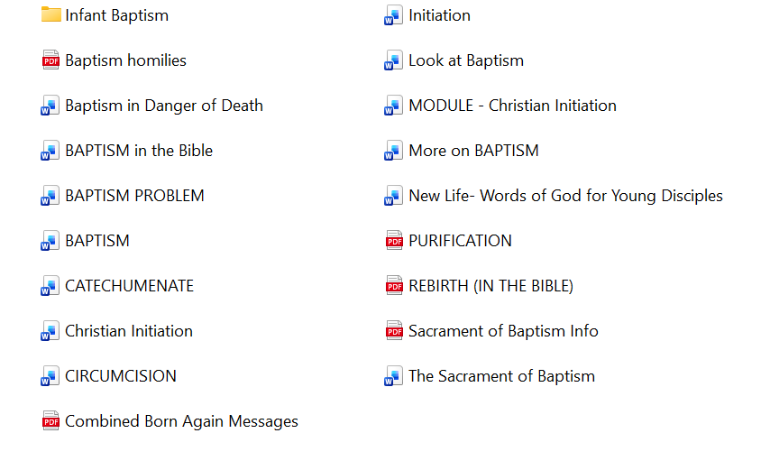

- Confirmation folder has 8 e-books available to the student:

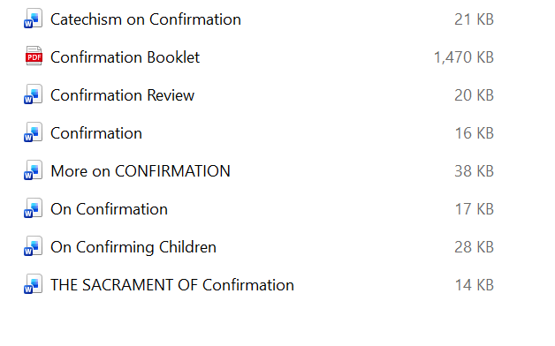

- Grace has these:

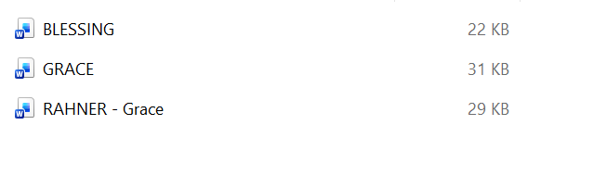
- Reconciliation

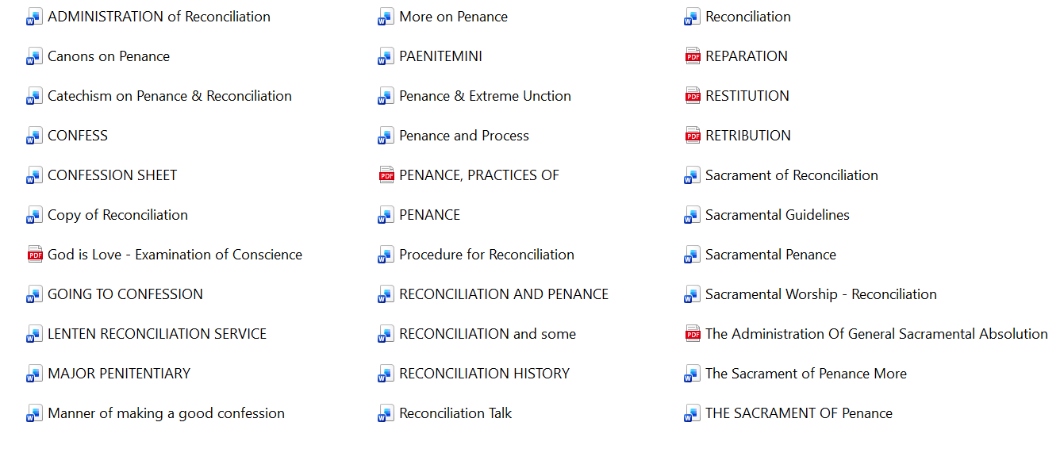

- Sacraments

