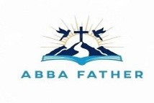
ABBA FATHER

Correspondence Course

Additional Reading Material Available for Unit 8
of Certificate II in Theological Studies

All these folders and titles (e-books) are available to the student upon request via email up to 1 folder and 5 titles at a time, unlimited lend.

Main Folders:

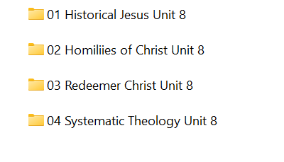

- Historical Jesus folder contains these e-books:

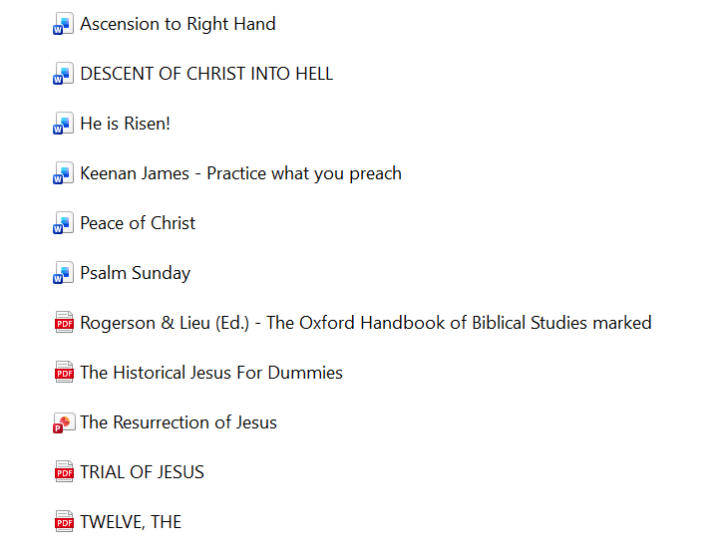

- Homilies of Christ:

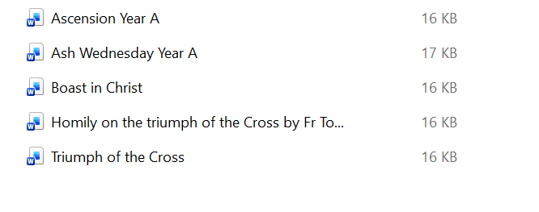

- Redeemer Christ has many e-books for loan:

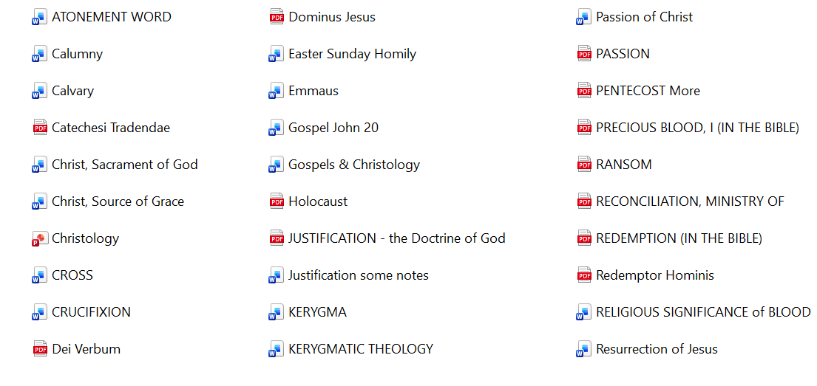

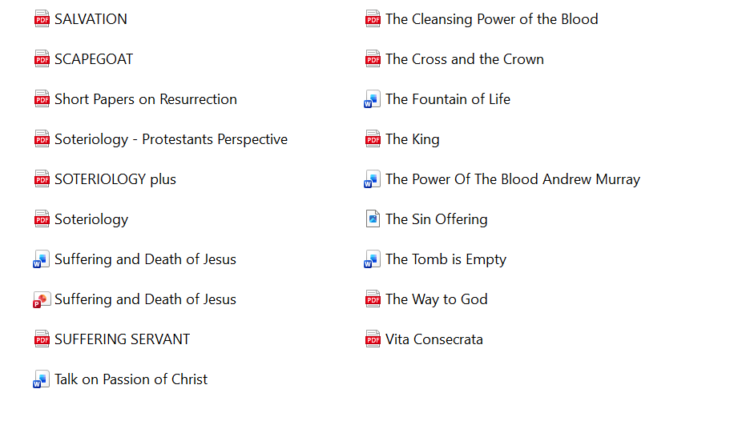

- Systematic Theology folder contains these 2 volumes:
