Additional Reading Material Available for Unit 2
of Certificate II in Theological Studies

All these folders and titles (e-books) are available to the student upon request via email up to 1 folder and 5 titles at a time, unlimited lend.

Main Folders:

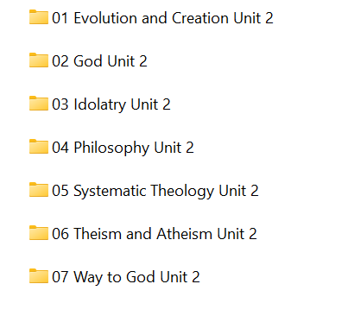

- ‘Evolution and Creation’ folder has 25 books for loan by the enrolled student:

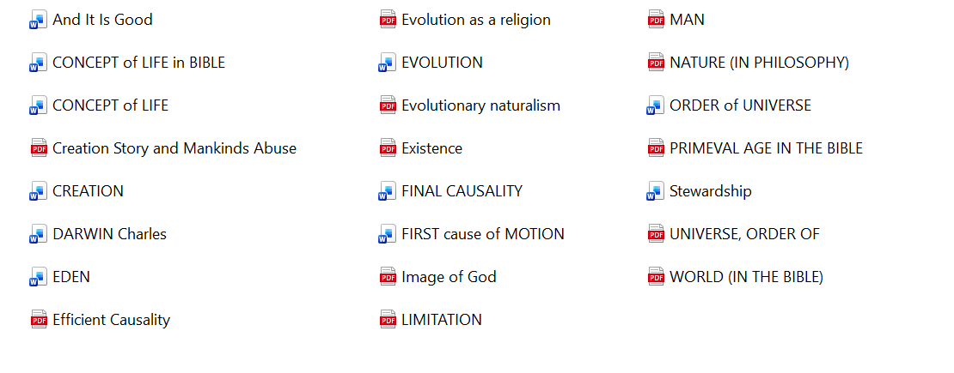
- ‘God’ folder has at least 42 e-books available to the student:

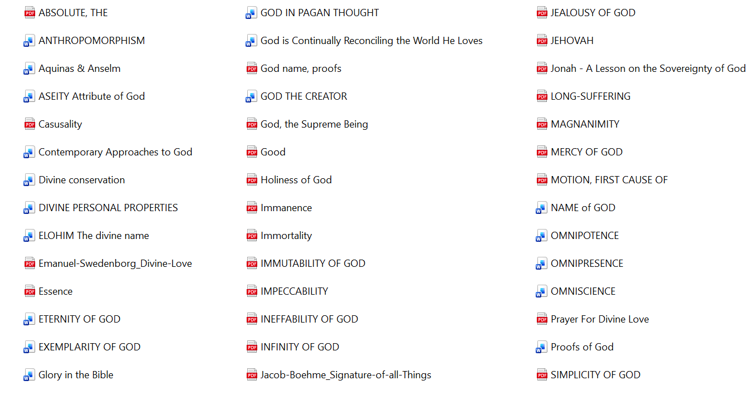

- ‘Idolatry’ has 3 titles:

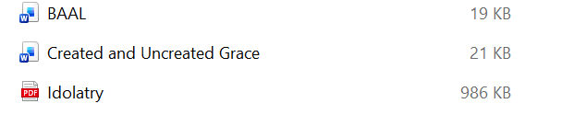

- ‘Philosophy’ has 7 titles for this unit:

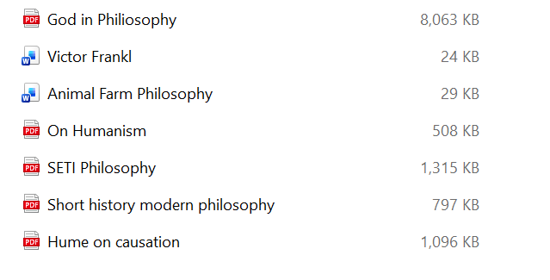

- ‘Systematic Theology’ folder has 2 volumes:

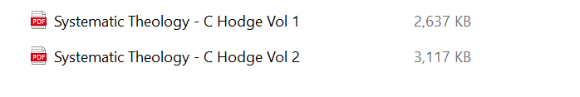

- ‘Theism and Atheism’ folder contains 22 titles:

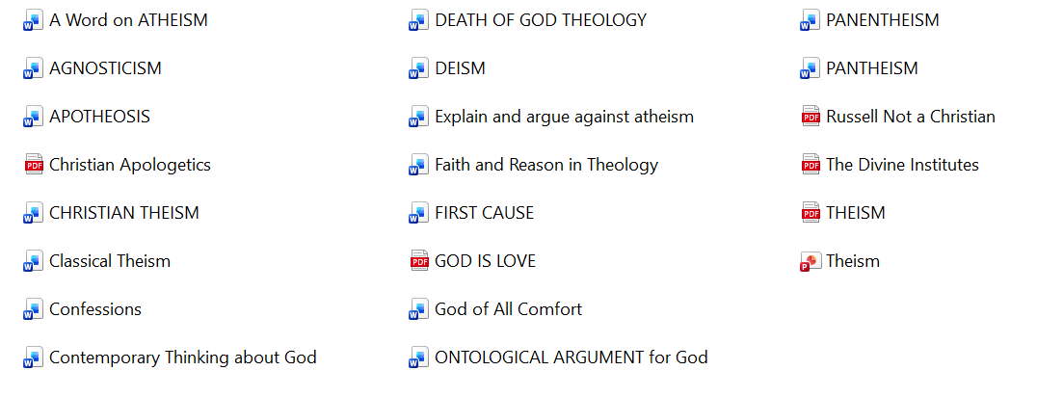

- The ‘Way to God’ folder has these 2 books:

