Additional Reading Material Available for Unit 15
of Certificate III in Theological Studies

All these folders and titles (e-books) are available to the student upon request via email up to 1 folder and 5 titles at a time, unlimited lend.

Main Folders:
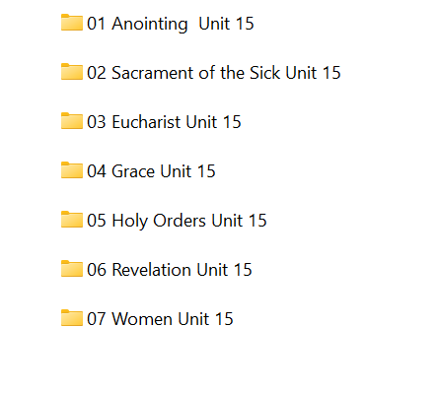

- Anointing folder contains:

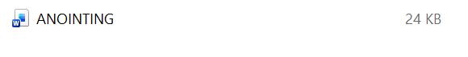

- Sacrament of the Sick folder contains 20 e-books:

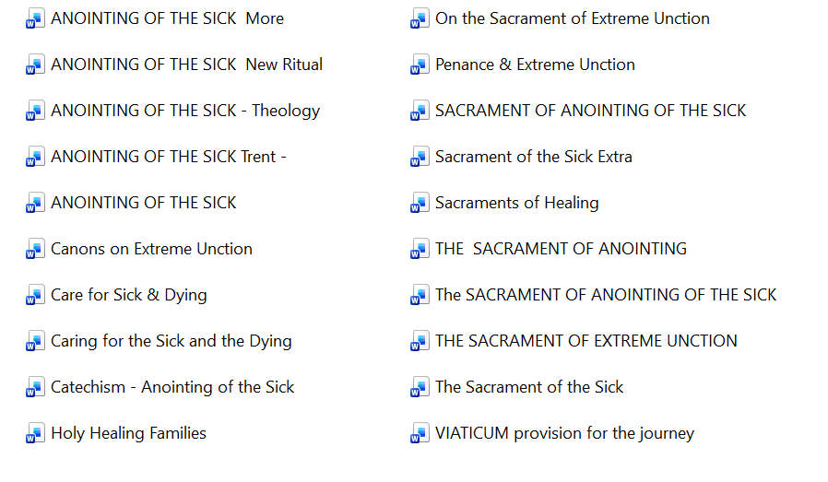

- Eucharist has well over 70 e-books to choose from:

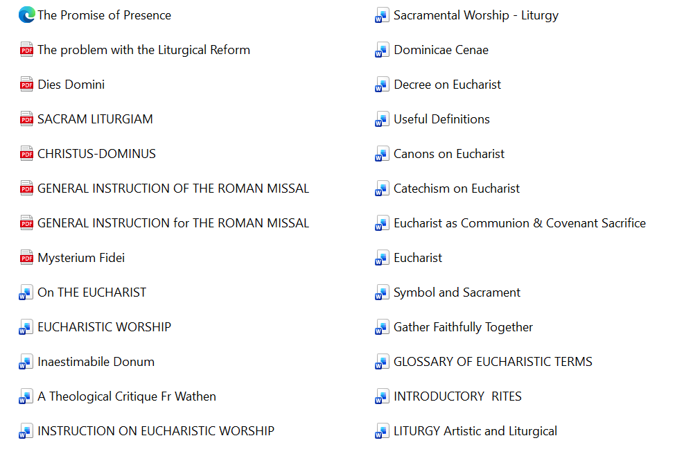
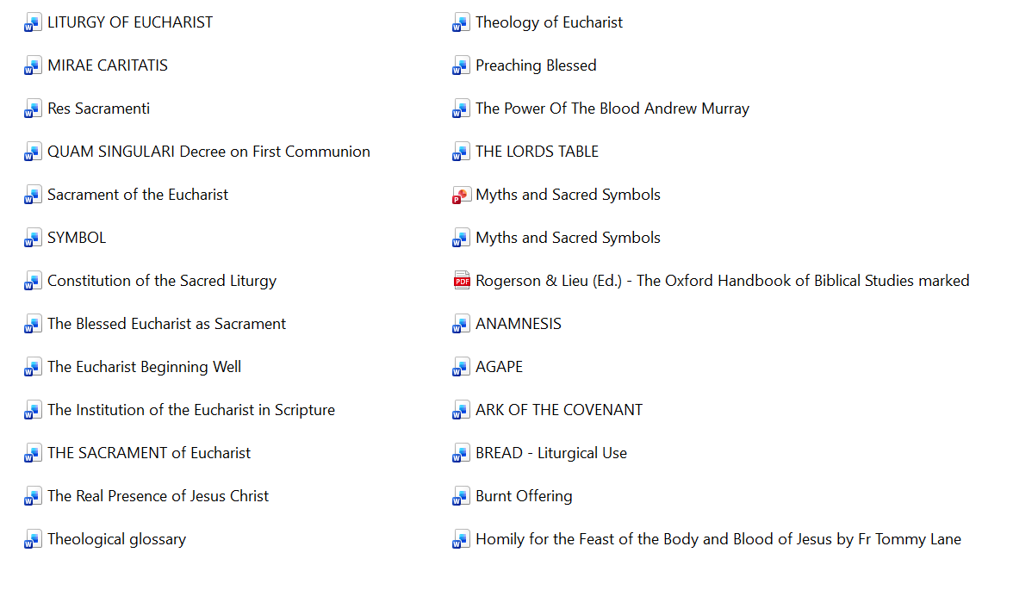

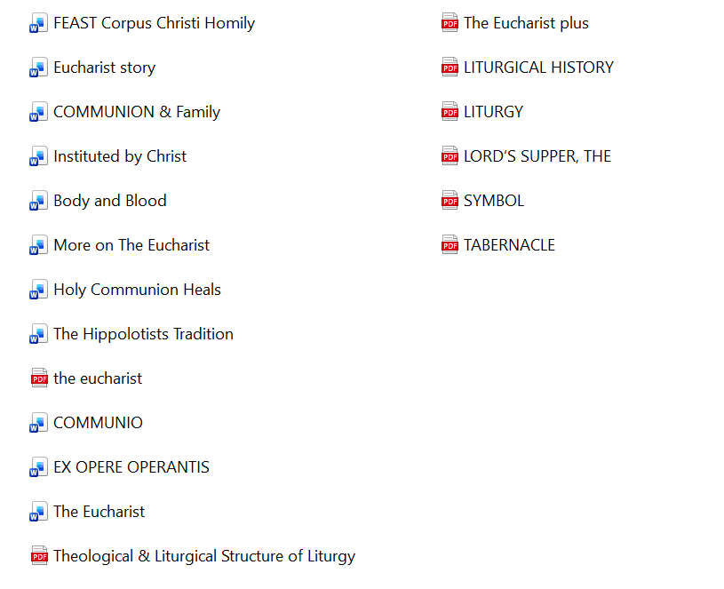

- Grace
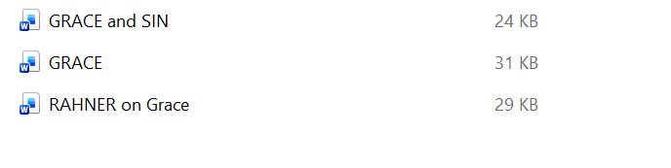

- Holy Orders has these:

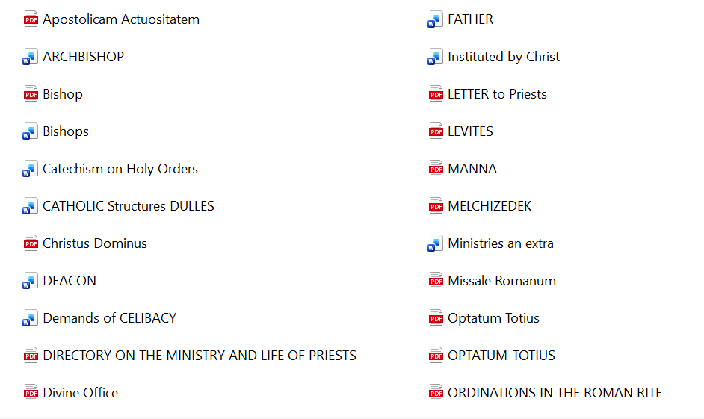

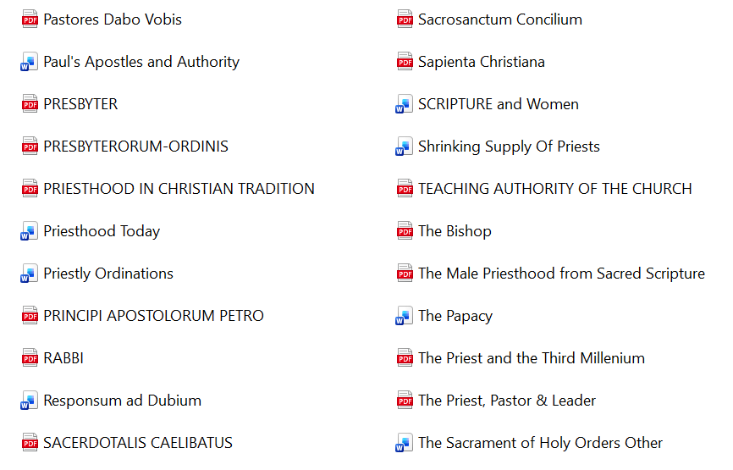

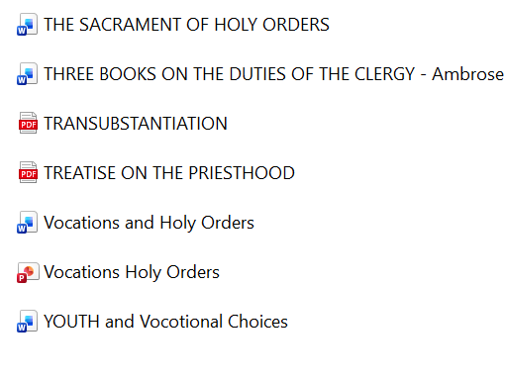

- Revelation has:


- Women folder contains 11 e-books:

