  Creation, Attributes of God & Idolatry | Unit Two  Did this beautiful scene of mountains, ice and colourful variety of flowers create itself or was there a divine hand involved in it? How you decide will influence your life’s decisions.

Table of Contents
Ctrl and Click mouse on heading to go to each section.

- 1. Mystery of Creation
- 2. Variety of Species
- 3. Gradation of Existence & Being
- 4. Stewardship
- 5. Earth is an Altar
- 6. God’s Attributes
- 6a. God is
- 6b. How God can be Known
- 6c. Thomas Aquinas’ Philosophical Proofs
for God
- 6d. Anthropomorphisms
- 7. Idolatry and Other Religions
- 8. Salvation of Others
- 9. Non-Christians and Unbelievers
- 10. Conclusion
- 11. Essential Reading Material
- 12. Unit 2 Exam

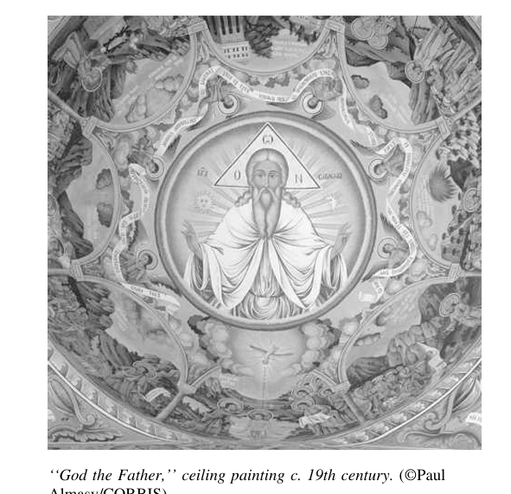

“Our Creator is our origin and our destination.”

“By faith we understand that the worlds were prepare by the word of God, so that what is seen was made from things that are not visible” (Hebrews 11:3).

1. The Mystery of Creation:
Ctrl and Click mouse on the title name
to go back to the top.

- Many individuals hold the belief that the world is relatively young, estimating its age to be around 10,000 years. According to this perspective, God created the entire universe during a literal six-day period, after which He rested on the seventh day, as described in the biblical texts. This interpretation emphasises a straightforward reading of religious texts, suggesting a direct and immediate creation by divine will. Advocates of this view often reject scientific findings that indicate the Earth is millions of years old, positing that faith in God's creative power supersedes scientific exploration. Thus, this belief system forms a foundational aspect of their worldview, shaping their understanding of existence and the divine.

- Conversely, some individuals choose to overlook scientific claims that the Earth is millions of years old. Others propose that creation unfolded over an extended period, possibly spanning eons, rather than adhering to a strict six-day framework. This perspective allows for the possibility that God intervenes in nature at various points throughout history, creating new species and guiding evolution. Consequently, proponents of this view believe that God's creative activity is ongoing, continuing even in the present day. This could also explain why new species are being found daily on the surface of the earth and in the depths of the seas. As scientists explore previously uncharted territories, they continue to find evidence of life forms that were previously unknown, suggesting that the process of creation is dynamic and ever-evolving. This view has God as an active participant in the world, continually shaping and renewing creation. It invites believers to engage with both their faith and the scientific inquiry, fostering a sense of wonder about the complexities of life. This interpretation provides a bridge between traditional religious beliefs and contemporary scientific understandings of the natural world.

Please view the outline of the six days of Creation.

- Yet others subscribe to the proving that an intelligent designer created the world as more important irrespective of the earth’s age and when it was created (Catholic view).

- Others try to combine creation with Darwin’s theory of Evolution (“The Origin of Species”, 1859) suggesting God created the world but used natural selection (survival of the fittest) as the means to continue creating.

- Many Christians reject the notion that life emerged solely through self-creation, chance, or randomness guiding the universe. For them, faith in God is entirely compatible with a thoughtful and open-minded approach to science, one that seeks to uncover the truths of the universe without bias or preconceived notions. This allows for a blending of supernatural and natural explanations, providing a holistic understanding of existence. By recognising both divine intervention and scientific principles, these individuals find harmony between their spiritual beliefs and scientific exploration. This integration encourages believers to view scientific discoveries as a means to deepen their understanding of God's creation.

- The prevalent Christian view is understood to be that God made everything from nothing, from a black void. This notion encapsulates the idea that God initiated the transformation of potential into reality, the moving of a potential thing into actuality; from ex nihilo—out of nothing to something. This process is vastly different from human creativity, which always involves using pre-existing materials. This, in effect, shows God’s omnipotence and sovereignty over the universe. This belief not only shapes the understanding of God's nature but also invites believers to contemplate the profound implications of creation. It emphasises that the universe's existence is a direct result of divine will and intention.

The universe was initially barren, devoid of shape and life, shrouded in darkness, devoid of stars and lifeless. To bring forth order and beauty, the Spirit of God moved over the waters, declaring, “Let there be light,” and light came into existence. This light was deemed good, beneficial, illuminating the day and dimming during the night, while also giving rise to countless stars, planets, seas, forests, plants, flowers, animals, insects, and humans to remain until the end of time. This narrative from Genesis 1:2-5 illustrates the divine intention behind creation, portraying it as a purposeful act aimed at bringing forth life and harmony. The unfolding of creation reflects God's desire for a vibrant and interconnected world (eco-systems) where every element plays a significant role.

Please read a short paper on “adaption not evolution”.

- The Bible articulates that the universe and all matter came into existence through the will of the eternal God, as seen in Genesis 1:2ff; John 1:1-3; Hebrews 11:3; and Revelation 4:11. This foundational belief asserts that God created from nothing, without any pre-existing materials, emphasising His role as the sole creator of the universe. It highlights God's unique ability to bring existence into being, setting Him apart from all other entities. In this understanding, God is portrayed as the ultimate source of all that is, encouraging believers to recognise the magnitude of His creative power. To understand God as Creator of the universe compare Genesis 1:1; Nehemiah 9:6; Job 26:7; Psalm 102:25 and Acts 14:15.

- The biblical view of the earth was that it:

- is created by God (Genesis1:1; Job 38:4; Psalm 90:2; Isaiah 37:16; Jeremiah 10:12; Acts 14:15; 2 Peter 3:5; Revelation 10:6; 14:7);

- came into being through Christ (John 1:3, 10);

- was created from nothing (Genesis 1:2);

- was created to be populated (Isaiah 45:18);

- is made by design (45:18);

- belongs to the Lord (Exodus 9:29; Deuteronomy 10:14; 1 Samuel 2:8; Psalm 24:1; Isaiah 66:1;
1 Corinthians 10:26);

- is controlled by God (Job 9:6; Revelation 7:1);

- is God’s footstool (Isaiah 66:1; Matthew 5:35; Acts 7:49);

- will be judged by God (1 Samuel 2:10; Psalm 96:13; 98:9);

- will be destroyed (Isaiah 24;19ff; Matthew 5:17ff; 24:3ff; 2 Peter 3:10ff; Revelation 20:11; 21:1);

- is destined to be new again (Isaiah 65:17; 66:22;
2 Peter 3:13; Revelation 21:1).

The mysteries of creation can only be found in the One who made creation. No one can understand these mysteries without understanding God’s purpose for human beings and their eternal destiny, and of their human and immortal natures.

God has a divine purpose for creating the world and the universe and he designed it in a precise physical order. For example, he made ordered natural laws in physics, chemistry and biology to govern the solar system and the world. He made gravity just right; he made the earth exactly the right distance from the sun to support life; he made planets to rotate around the sun and to follow predictable patterns and orbits that determine their length of days, seasons and years; and he made the earth to have all the necessary elements to support life – water, air, food and an atmosphere.

Please view the summary chart of salvation history.

God could have made the whole universe and humankind in successive phases or he could have made everything in an instant of time. Either way, God did not do things in a disorderly way. God is order and patience. The universe was in chaos before the Creator decided to order the elements and to arrange them into a wonderful association. He ordered the firmament with stars and planets. Nothing existed before this. God made it all and ordered it all. So God designed and directed creation however long he took and through whatever process he used.

The harmony and order of the universe is evidence of God’s power, and no human power or natural settlement of elements can possibly repeat such a wonder, not even in a small way. The probability would be too great.

Four things in creation speak entirely as a witness
of his power:

- the inexhaustible mystery of light everywhere
(in space there is only complete darkness);

- the foundation of the universe with its resplendent heavens with millions of stars, planets and galaxies;

- the sea and how it maintains its boundaries, firm limits, its motion and its voice, and

d) the earth with its countless creatures on the land, under the sea and in the air such as in the birds of the air, the creeping things on the ground, and the legion of fishes in the sea.

We should all bow before the works of the Creator in humility, even if it is a set of clouds or a flock of birds. He is the Master Craftsman. Creation has within itself the indelible reflection of its Creator; the universe and everything in it (in the smallest and largest things) speaks of “God” - there is the imprint of the Creator in creation everywhere. The Creator is visible in all his works, in the most beautiful things created. These are the most visible signs of him who created them all by an act of his will and of his supreme intelligence.

There is not a small drop, no matter how small and insignificant, which does not have a good reason for existing in the plans of God. Likewise, there is no huge mountain or volcano or cyclone which does not have a good reason for being.

Everything God created serves a purpose. Nothing in creation is useless or entirely harmful to the soul except noxious evil. God’s power to create is seen in the verdant flowery earth, the fruit swelling in trees, the winds blowing the clouds, the sun that for centuries and millennia has risen without fail. Everything speaks of God; everything explains God and his love and good will for us. Everything reveals and has the discovery of God in it.

Look at the simple flower. Through its beauty, scent and shape it is different from any other flower. The perfume of the flower speaks of God’s humility and his grandeur at the same time.

Always simple in its complexity. God made everything well, useful and varied. Herbs, animals and nature are a living book. We have the foundations of faith right in front of us. Genesis lives right in front us, if one knows how to see and how to listen. So how can a flower with its sweet scent, beautiful stems and corollas make itself from itself? How can a red breasted Robin make itself with its red markings? And how have butterflies found the gems and ribbons for their wings? And a water stream where does its source come from (cf., Job 38, 39)? To look carefully is to believe, if one knows how to look. The living Genesis is in front of us. So why do we rely too heavily on science and too little on the love of the Creator and his enormous creativity?


2. Variety of Species:
Rain and sunshine, warm and cold, light and darkness alternate as part of God’s plan because it is not possible to have the same situation on the earth all the time. Life would come to an end on earth. If all the stars were like the sun in size and warmth, the earth would be on fire all the time with so much heat leaving no wood to light fires, build houses or make tools. All birds are not eagles; animals are not all the same. The earth needs such varieties as created by God to give human beings all the possible help for a good purpose. And as all kinds of animals, vegetables, stars are all different, can we expect that all humans should be alike? Each person has their mission, their personalities, their looks and their individual temperaments and their strengths and weaknesses. The infinite variety of species is a great sign of the power of God as one species helps enhance the other. Each of us, like all the species with each other, has its part to play in the cycle of life and death.

From God’s ocean of wonders, from the very throne of God, from his very bosom, God draws his most beautiful gem, that is, the creation of human beings from the dust breathing his Spirit to make it a living flesh (Genesis 2:7). For God, humans are the most perfect creature, more perfect than the sun, because only humans are endowed with a soul as well as with matter, with intelligence as well as with instinct, with freedom as well as with rules. Humans are similar to God as regards to their spirit, similar to animals as regards to their bodies. They are destined to become gods by the grace of God and of their own free will so that he may rejoice in them and they in him. The human being, who can transform to be like an angel saint, is the most beloved being of sensible creation, for whom, although God knew would be a prolific sinner even before time existed, prepared the Saviour Victim, his beloved Son, for whom everything was made. The Most High has given everything to him, his Son in whom he is well pleased from eternity wanting Jesus to be the first in everything (cf., Matthew 3:17, Philippians 2:9-11).

But human beings are the work of patient progress, and they will continue to progress in knowledge and in power, which may be good or bad according to their will. Humans have learnt many things slowly and progressively after their expulsion from the Garden of Eden, and have had many failures before their successes. The more the spirit of humankind grows, the more they will truly evolve. This is the real evolution of the species, where the animal-man becomes the supernatural-man, from passing from the state of physical beings to that of saved spirits, from animals in nature to kings in heaven, from mortal beings to immortal gods. That’s the real evolution God wants human beings to possess. The more their spirits are evolved, the more they know and become like God.

3. Gradation of Existence and Being:
“For God’s foolishness is wiser than human wisdom, and God’s weakness is stronger than human strength” (1 Corinthians 1:25).

By the order of his thought God created the heavens and the earth – the incorporeal (spiritual) and the corporeal (physical).

In creation he ordered a gradation of being. This includes all inanimate matter, plants and vegetation, animals and human beings as well as the angels. Genetic scientists have discovered that all human beings can be genetically traced to one human female DNA.

According to biblical accounts, the first man, Adam, was formed from the dust of the earth and infused with the breath of God, as described in Genesis 2:7. This act of creation signifies the intimate connection between humanity and the divine, highlighting the unique status of humans among God's creations. Adam's formation from earthly materials underscores the belief that humans are part of the created order, yet distinct due to their relationship with God. This narrative sets the foundation for understanding human dignity and purpose, establishing a framework for the relationship between humanity and the divine. Furthermore, it serves as a reminder of the sacredness of life and the divine breath that animates human existence.

The first woman was created from Adam’s rib, rather than through the breath of God, as noted in Genesis 2:21. This detail emphasises the interconnectedness of man and woman, reinforcing the idea that they are designed to complement one another. The creation of Eve from Adam signifies a deep bond and shared humanity, establishing the foundation for relationships and community. It highlights the significance of companionship and partnership in the divine plan. This narrative serves to illustrate the value of both genders within the created order, accentuating their equality and unique roles in fulfilling God's purpose.

All subsequent human births occur through conception following sexual intercourse, as outlined in Genesis 4:1. This process positions human beings within the created order as a single species, while also distinguishing them from the animal world due to their special relationship with God. Created in His image and likeness, as stated in Genesis 1:26, humans embody a unique spiritual essence (the soul) that sets them apart from other creatures. This belief stresses the inherent dignity of all human life, and showcases the importance of respecting and honoring each individual. It also invites reflection on the responsibilities humans have in relation to each other, the whole of creation and to their Creator.

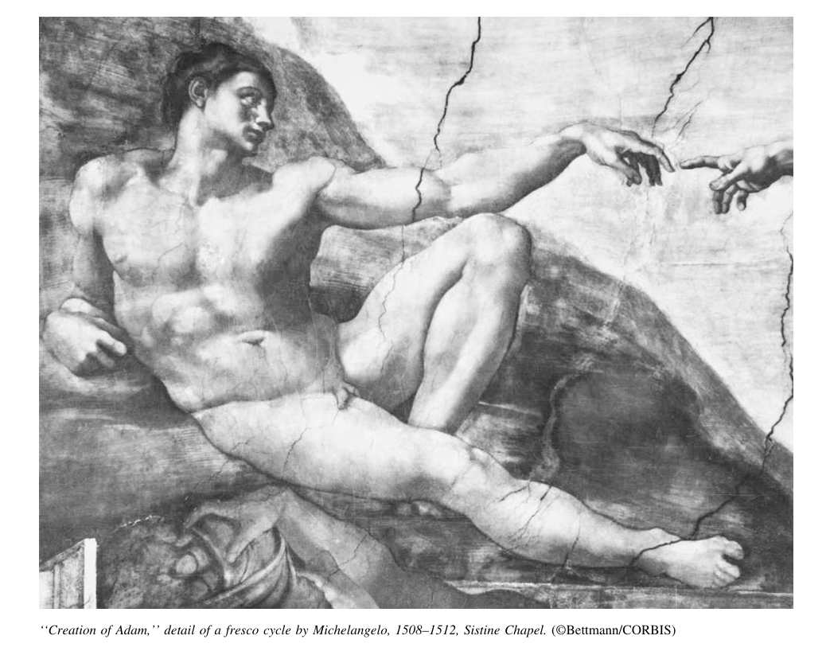

The Creation Hierarchy from Lowest to Highest:

- Inanimate matter – rocks, dirt etc.

- Plant life and Vegetation – these can reproduce.

- Animal life – can reproduce and have sensory knowledge.

- Human life – can do all that the animal life can do but also has reason, free will, moral conscience, self-knowledge and the capacity for spiritual communion with the Creator (Psalm 8:5).

- Angelic or Pure beings – pure spirits without bodies, superior to humans in abilities and knowledge. They suffer no pain, sickness nor have material needs. They are immortal and have power over the material world.

- Supreme Pure Being – ultimate existence with no beginning or end. Purest Spirit with infinite power, knowledge and presence.

4. Stewardship:

Everything made by the Creator is useful to human beings, including the animals and plants. They are a gift of his love and patrimony (that which is inherited from one’s father) and care for them, so that they may use them with profit and gratitude to the giver of all providence (Genesis 1:18, 28). Therefore, all things are to be loved and treated with proper care by the faithful stewards of God’s creation (1 Corinthians 4:1-2; Titus 1:7; 1 Peter 4:10; cp., Luke 12:35-38, 42). The unfaithful steward is described in Luke 16:1-8. It is worth examining the parable of the minas in Luke 19:11-27 and the parable of the talents in Matthew 25:14-30.

Humans must take care of what God, with providential love, has placed at their disposal. This care does not mean making idols of things or other people including the immoderate (excessive) affection for animals or plants or possessions or anything else. Care means having a feeling of compassion and gratitude for these earthly things that serve humans and of being sensitive to them and their needs.

Often animals serve humans better than humans do. Animals, plants, minerals and the elements exceed humans in passively following and obeying the laws of creation, or by actively following the instinct instilled in them by the Creator, or by surrendering for the purpose for which they were created. Humans, in remembrance of God the Father who gave all things to make their exile on earth less difficult, must be humane towards animals, their inferior servants and to the whole of creation. They are all given by God, and as such, they should be loved from beyond the finite things to the infinite being who created them.

Nothing in the universe was made without a good purpose; God does not waste His perfect power on useless things. For example, a blade of grass is not less useful than the mighty house one lives in. A drop of dew, this little pearl of frost, is just as significant as the vastness of the ocean. The tiniest gnat insect is just as useful as the mighty elephant, and the humble worm that lives in the mud is not less useful than a majestic whale. Each element of creation serves a purpose, crafted from God's love and intention for humanity. This understanding invites reflection on the beauty and significance of all creation, encouraging a sense of stewardship and responsibility.

Even mistakes and errors, for those striving towards goodness, can serve as pathways to achieving greater good and personal improvement. When individuals face challenges, they often emerge stronger and more beautiful, akin to a butterfly transforming after a period of struggle. As they navigate through difficulties, they can transition from one virtue to another, drawing closer to perfection. This process illustrates God's continual works of mercy, operating within and around them, guiding their growth and transformation.

When one looks down from the height of a mountain’s summit, they can understand better the shape of the mountain, the existence of woods, rivers, meadows and slopes and can appreciate the beauty of the landscape. In a similar manner, one can more intimately perceive God's works as both wonderful and functional, recognising how each phenomenon serves and completes the other. This perspective reveals the interconnectedness of creation, where every element contributes to the overall beauty and harmony of the world.

If one is the master of a business, it would still not be lawful for them to dispose of it as they please. For the things that belong to us, belong to us because God grants them to us. Although we may hold stewardship over them for a limited time, we must always identify that God is the ultimate master of everything, possessing all without limitation of time or measure. We are merely administrators of the crumbs of the grand Creation and we will be held accountable to God for how we manage these gifts, as noted in Romans 14:12.

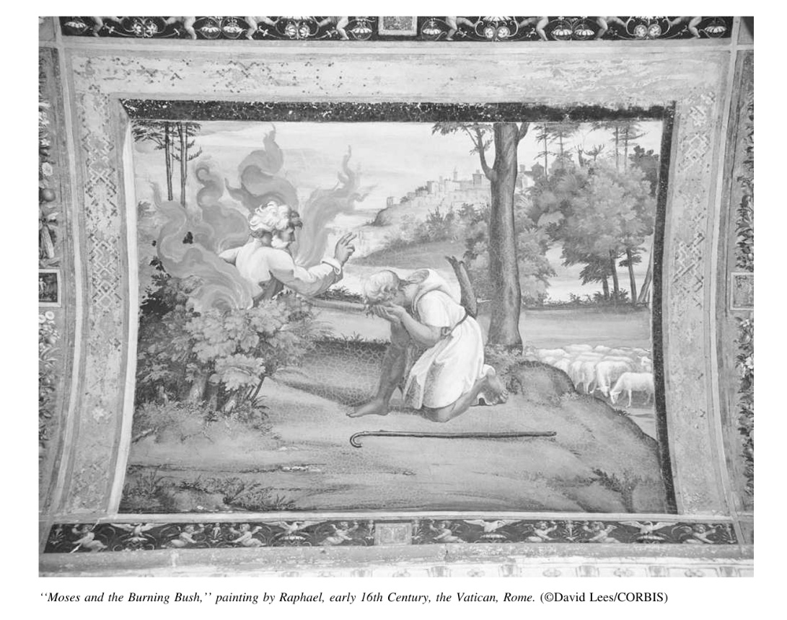

5. Earth is an Altar:

“I saw the Lord standing by the altar..” (Amos 9:1), “I saw under the altar the souls..” (Revelation 6:9), “always giving thanks to God the Father at all times.” (Ephesians 5:20).

“The whole earth is full of his glory” (Isaiah 6:3), “and the knowledge of the Lord shall fill the earth (Habakkuk 2:14).

God’s works (Psalm 77:12; 143:5) are awesome and wonderful (66:3) and require meditation upon and continual praise (72:18; 105:1-2).

The earth serves as a colossal altar, a site of everlasting praise to its Creator. But instead, the earth is full of sin, contrary to the intended purpose of creation. The earth, like the other worlds of creation, ought to sing non-stop psalms to the God who created them. The stars, planets and comets at night sing the praises of God with their voices and their light and motion in the infinite spaces of the firmament. Their song, which rises from the blue fields of the sky of the earth to the heaven of God, has lasted for thousands and thousands of years. The earth, like the sky, unconsciously sings to God with its winds, and the voices of the birds and animals do likewise.

They do what the whole human populace should do, praise the Creator in the unlimited temple. Humans, the synthesis comprising all natures, has a mission that no other creature has as a duty and a joy – to love God intelligently and voluntarily as a way of repaying God for all the love they have received. God requires nothing from creation but love, a love that is free and intelligent. The day that the great altar of the earth should omit the praises and entreaties of love, the earth would cease to exist. Because once love is extinguished all expiation on earth would cease, and the wrath of God would destroy the earth that has become an earthly hell. Thus, for the earth to endure, it must embody a temple of love and prayer, continuously offering praise to the Father of humanity.

In the biblical account of Cain (Genesis 4:1ff), he presented some fruits of the ground as an offering, while his brother Abel brought a sacrifice of animals. Cain's offering was not accepted by God due to his improper disposition towards the divine, which ultimately led him to commit fratricide, revealing his guilt. This narrative serves as a cautionary tale, reminding believers to approach their offerings to God with the right heart and intention. Let us strive to ensure that our offerings to God are sincere and reflective of our love and gratitude!

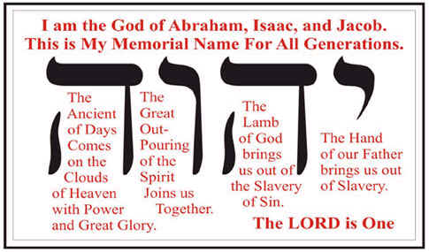

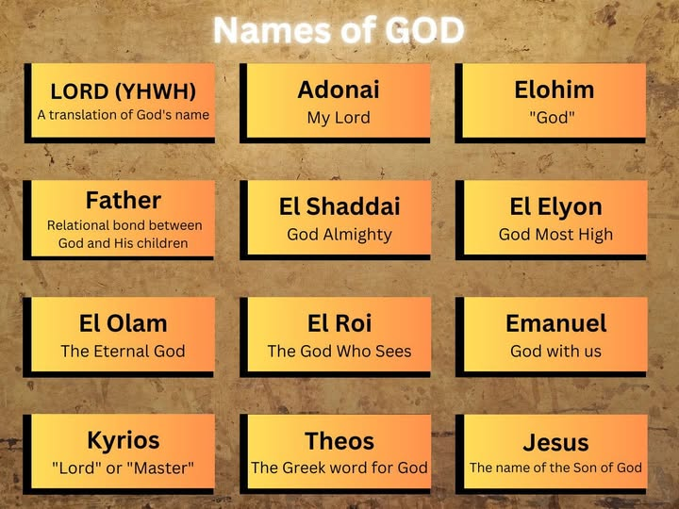

6. God’s Attributes
“No one is good – except God alone” (Matthew 19:17), “For you alone are holy”
(Revelation 15:4).

God is the alpha (the first) and the omega (the last), the beginning and the end (Revelation 1:8), as also is Jesus (21:6; 22:13).

“For my thoughts are not your thoughts, nor your ways my ways, says the Lord” (Isaiah 55:8).

Over the centuries there has been a multitude of ideas about God but he is so difficult to contemplate and capture. It is difficult to use adequate English words to describe his infinite perfections, his love and his goodness. The Apostle Paul notes how it is hard to grasp an understanding of God; he can only be known in a limited way, he is better known for what he is not (cf., Romans 11:33). We must have humility in our approach to the divine contemplation; we must recognise the limitations of human language in expressing the fullness of God's essence. Acknowledging this can lead to a more profound appreciation of the divine mystery.

What we do know is that the true God is not a deity confined to a specific race, an idol, or an imaginary figure. He is the Supreme Reality, the Universal Reality, and the only Supreme Being, responsible for creating all things and creatures. Therefore, he is the God of all. He knows them all even if they do not know him. He loves them, even if they do not love him back or do not know him well, or do not know how to love him. We are simply told to “Love God with all our hearts ….” (Luke 10:27).

God’s paternity does not waver because his sons and daughters are ignorant, foolish or wicked. He continues to teach his children and instruct them out of love. He tries to correct the wrong or wicked ways of his children by applying beneficial punishments and merciful forgiveness. Our Father God, loves all people spread all over the earth and wants their salvation in Christ and does not want one of them to be lost. He is the eternal King of an infinite Kingdom which he created under and for the Kingship of Christ.

Each of us creates an image of God in our minds, shaped by the essential attributes we ascribe to Him. The closer we draw to Him, the clearer our understanding becomes, allowing us to develop a more accurate knowledge of His nature. The more we contemplate God's essence, the more we encounter His real presence within us. Our perception of God significantly influences our attitudes, opinions, and behaviours in the world. If we view Him as a punitive figure, we may live in fear of retribution, whereas seeing Him as a merciful God can lead us to approach life with repentance and the expectation of grace.

Plesae read a short paper on “God’s Existence.”

Please read the paper on “God’s Purpose in Creation.”

“God is Sovereign (Supreme Ruler) (Psalm 135:6); if there was some being higher than him, he would not be God” (St. Anselm).

“God is not subject to any power or any abstract rule or law that could be conceived as superior to or other than himself” (Anonymous).

A simple definition of God is that he

“is a spirit, infinite, eternal and unchangeable, in his being, and is wisdom, power, holiness, justice, goodness and truth. A nonmaterial personal being, self-conscious and self-determining.”

6a. GOD (not god) is:

  - A Pure Spirit and All Holy and Good - “God is Spirit and those who worship him must worship in spirit and truth” (John 4:24; Acts 17:29). He is morally perfect in every way. “Be holy as I am Holy” (Leviticus 11:44; Cf., Isaiah 6:3). God does not commit wicked acts; He is the sole source of goodness. His goodness is revealed through His gracious providence, extending to both the righteous and the unrighteous (Matthew 7:11; Psalm 31:19; Luke 6:35).

  - Unattainable Perfection and Perfect Beauty – God is perfect beauty and to see him face to face is to experience eternal joy thereby enjoying him for all eternity (Beatific Vision). “Be perfect as your heavenly Father is perfect” (Matthew 5:48). God alone, who lacks nothing in terms of excellence, is the one who is truly perfect. Everything he thinks and does has the characteristic of perfection (2 Samuel 22:31; Job 37:16: Psalm 18:30).

  - Incomprehensible Essence (cf., Job 15:8; 37:1-24; Isaiah 40:12-31; 55:8-9; Matthew 11:27; Romans 11:33; 1 Corinthians 2:16). “For nothing is impossible with God” (Luke 1:37). “What is impossible for mortals is possible with God” (Luke 18:27).

  - Omnipotent – God is all-powerful (Psalm 62:11), unlimited (Matthew 28:18) and everlasting (1 Timothy 6:16). God is in control of everything; no human power can resist his will; his will is accomplished in everything (Job 42:2; Psalm 89:5-18). God does not stop operating for one moment, nor does his Son for the welfare of souls (John 5:17). He serves as the source of all strength (Psalm 68:35).

  - Omniscient – God is all-knowing and all-seeing; he has complete knowledge and awareness (Psalm139:1-6). His intelligence knows all events, thoughts and deeds of humankind in all time frames, even the hairs on our head are known to him (Matthew 10:30). He knows us better than we know ourselves. God looks lovingly at us, his eyes are on us and he does not miss the least detail of any of our actions. God’s knowledge is not a step-by-step process; it does not increase or diminish when certain events take place. His knowledge is not acquired through experience; rather it remains constant and unchanging, encompassing all past, present and future events.

  - Impassible – The term "impassible" refers to the divine nature of God as being free from all forms of pain and suffering. This characteristic underline the belief that God exists in a state of perfect peace and tranquillity, unperturbed by the chaos and turmoil of human experience. This notion is integral to understanding the divine nature, as it illustrates the contrast between God's eternal existence and human fragility. The concept of impassibility reassures believers that God is not subject to emotional fluctuations or distress, further highlighting His role as a stable and reliable foundation for faith. This understanding can provide comfort to those who seek solace in the midst of life's challenges.

  - Continuously worshipped and served by the angels as highlighted in the scripture (Revelation 4:8). This depiction serves as a reminder of the heavenly beings' unwavering dedication to glorifying God, reflecting the divine majesty and holiness attributed to Him. The angels, as celestial messengers and servants, play a crucial role in the spiritual realm, demonstrating the importance of worship in heaven. Their eternal praise not only signifies their devotion but also establishes a model for human worship, encouraging believers to emulate this commitment in their own lives.

  - Omnipresent – The attribute of being "omnipresent" signifies that God is everywhere and present at all times, as referenced in Jeremiah 23:23-24 and Psalm 139:1-12. This omnipresence means that no space is unknown to Him, encompassing even our innermost thoughts and feelings. While God is present in everything, it is essential to note that not everything is God; rather, all things are immediately present to Him. This understanding fosters a profound awareness of God's constant presence in our lives, encouraging believers to seek His guidance in every situation. Recognising God's omnipresence can lead to a deeper spiritual connection and a greater sense of accountability in one's actions and thoughts.

  - Transcendent – God is described as "transcendent," existing apart from Creation and outside of human experience, yet simultaneously "immanent," meaning He is actively involved in all of creation. This duality illustrates that God is not a distant observer but rather a real presence who is intimately connected to His creation. As stated in Isaiah 57:15, He is actively involved in our lives, bestowing peace within us and dwelling in the hearts of those who do not, of their own free will, reject or drive Him away (Acts 17:27-28). This relationship between God's transcendence and immanence reveals His desire to engage with humanity, offering comfort and guidance.

  - An Immensity of Being – The concept of "immensity of being" indicates that God fills all things and transcends the limitations of time and space, as referenced in 1 Kings 8:27. This notion emphasises the boundless nature of God, who is not confined by the physical dimensions that govern creation. God's immensity suggests that His presence permeates all aspects of existence, reinforcing the belief that He is always accessible to His creation. This understanding can inspire awe and reverence, encouraging believers to recognise the vastness of God's love and power. Acknowledging God's immensity invites a deeper exploration of the divine and a greater appreciation for the mysteries of faith.

  - An Eternal Now - God embodies "an eternal now," existing without beginning or end, as articulated in Jude 25 and Isaiah 57:15. This timelessness accentuates that God is independent of the constraints of time, perceiving past, present, and future as a singular eternal moment. He is everlasting – he was, is and shall be (immortal). Eternity does not measure time in days, months and years. For God, the concept of time is merely a measure of existence, akin to heartbeats for the Eternal Father. This understanding of God's nature encourages believers to view their own lives through the lens of eternity, stressing the significance of their choices and actions. Recognising that God is everlasting can instil hope and purpose in the hearts of believers, reminding them of the eternal promises that lie ahead.

Given that our souls are immortal, it is essential for us to learn to measure time in a manner that aligns with the Creator's perspective. This challenges believers to reflect on how they utilise their time on Earth, encouraging them to prioritise spiritual growth and meaningful relationships. By seeing time through the lens of eternity, individuals can cultivate a deeper sense of purpose and direction in their lives. This perspective can transform daily routines into opportunities for growth, worship, and service. Ultimately, embracing this view of time can lead to a more fulfilling and spiritually enriched life.

  - Immutable – unchanged and unchanging in regards to his Being and Nature. For example, he continues to love, to forgive, and he never goes back on his promises or changes his mind. His personality is the same today, yesterday and forever (Cf., Hebrews 13:8). If change were possible for God, it would be for better or for worse, but God is already the epitome of absolute perfection leaving no cause for change within Himself or externally. No cause for change in God exists, either in himself or outside of him (cp., Malachi 3:6; Psalm 33:11; 102:26; James 1:17). Despite this, God continues to create and sustain the universe and us. God has emotions and a will, as we do for we are all made in his image. Though there is a timelessness in regard to God he is intimately and actively concerned in all the actions of all his creatures. God as the perfect deity does not change in his essential nature; but because he is in a relationship with human beings who do change, he himself changes his relation and attitude from wrath to mercy or from blessing to judgement as the occasion arises. (cf., Genesis 6:6ff; Exodus 32:14; Jeremiah 15:6; Joel 2:13; Jonah 3:9ff).

  - Self-existent and self-sufficient – God is "self-existent and self-sufficient," meaning He exists in and of Himself, independent of any external influences. God is self-sufficient in Himself and the one and only true, independent Being in the cosmos (John 5:26). He requires nothing from creation to sustain His existence (Acts 17:24ff). God possesses absolute life within Himself, serving as the source of all life (Psalm 36:9; John 1:4; 1 John 1:1-2; 5:20). The entirety of creation does not increase one iota the infinite joy, beauty and power of God. He remains complete and fulfilled in His own essence. He derives no benefit from Creation and would continue to be independent and infinite even if creation never existed. He only has to contemplate Himself to rejoice, to live and to rest. He has no causes or needs. “I am who I am” (Exodus 3:14). He is the first and the last (Isaiah 44:6). Unlike humans and all of creation, they owe their existence and dependence on him for their very survival and life. He is provident and takes care of everything. He created everything to have love and so the earth needs to love in order to continue to exist. Recognising this divine love can inspire gratitude and a sense of responsibility among believers to cherish and protect the world around them. Understanding that love is the foundation of existence encourages believers to live in harmony with creation and with one another.

Please read the article titled: ‘God as an Eternal Now’.

  - Creator – As the "creator" of the universe, God is responsible for the formation of the sky, seas, mountains, forests, plants, animals, and humankind (Psalm 8). This role as Creator positions Him above all other gods, affirming His supremacy in the realm of divinity (cf., Psalm 96). The act of creation itself reflects God's power, creativity, and intentionality, showcasing His desire to bring forth life and beauty. Understanding God as the Creator fosters a sense of wonder and reverence for the natural world, encouraging believers to appreciate the intricate design of life. This acknowledgment can deepen one's faith and inspire a commitment to stewardship of the earth.

  - Infinitely Merciful – wants to shower mercy on all. He is an abyss of mercy which cannot be fully understood (Romans 9:14-16); and Infinitely Just – he cannot ignore evil and punishes disobedience (cf., Psalm 89:14; Deuteronomy 32:4) and rewards goodness. This duality of mercy and justice demonstrates that any punishment from God is intertwined with His desire for restoration and correction (Job 5:17; Hebrews 12:11). Understanding this balance can provide believers with insight into the nature of divine discipline, revealing it as an expression of love rather than mere retribution (2 Samuel 7:14ff; 1 Corinthians 11:32).

Punishment from God can serve various purposes, such as being a blessing or corrective measure (2 Samuel 7:14ff; 1 Corinthians 11:32). It can be a response to sins (Leviticus 26:28; Amos 4:6) or administered out of love to encourage repentance (Hebrews 12:5-10; Revelation 3:19). Ultimately, the weight of our punishment was vicariously borne by Jesus (Isaiah 53:4ff), demonstrating the profound depth of God's love and sacrifice. This understanding invites believers to view divine discipline through the lens of grace and redemption, emphasising the transformative power of God's love. Acknowledging this aspect of God's nature can lead to a more compassionate view of oneself and others in times of difficulty.

  - All-Truth and Immeasurable Wisdom – God embodies "all-truth and immeasurable wisdom," never making rash decisions due to His perfect comprehension of all that is and all that will be (Romans 11:33; Daniel 2:20; cf., Titus 1:2). As the source of all wisdom (Job 28:28; Psalm 111:10), God embodies the principles of logic and mathematics, as well as the laws of reason are not outside of God. This understanding of God's wisdom encourages believers to seek His guidance in all aspects of life, trusting that His knowledge surpasses human understanding. Recognising God's perfect wisdom can provide comfort in times of uncertainty, reminding individuals that they can rely on His insight and to trust him in all life's complexities with faith and assurance.

  - All-Loving – God is characterised as "all-loving," extending selfless love to all His creation (Romans 5:8; 1 John 4:7-10). This love is presented in Scripture as the very essence of God's nature, with the declaration that "God is love" (1 John 4:8, 16). The divine love invites believers to reflect on the depth of God's affection and compassion, encouraging them to embody this selfless love in their interactions with others. The portrayal of God as "slow to anger and abounding in steadfast love" (Nehemiah 9:17) further emphasises His commitment to grace and forgiveness. Embracing this aspect of God's nature can inspire believers to cultivate loving relationships that mirror His divine love.

  - Unsurpassable Bounty – God is described as possessing "unsuspected bounty," being all-giving (cf., Ezekiel 36:26; Matthew 6:11). This attribute reflects God's generous nature, demonstrating His willingness to provide for the needs of His creation. Understanding God as the source of all abundance can encourage believers to trust in His provision, fostering a sense of gratitude and reliance on His goodness. This , in turn, can inspire individuals to share their blessings with others, reflecting God's generosity in their own lives. Embracing this can lead to a more compassionate and giving spirit, as believers recognise the importance of generosity in their faith journey.

  - Patient and Long Suffering – God is characterised as "patient and long-suffering," acting at the perfect time and being slow to anger, providing ample opportunity for people to change (2 Peter 3:9). This attribute of patience illustrates God's desire for repentance and growth within His creation, stressing His mercy and love. God's long-suffering nature can inspire believers to practice patience in their own lives, extending grace to others as they navigate their spiritual journeys. Recognising God's timing in all things encourages individuals to trust in His plan, even during periods of waiting or uncertainty. This helps fosters resilience and hope, as believers learn to rely on God's perfect timing.

  - Faithful – God is "faithful," backing His words with actions (cf., 2 Timothy 2:13). This faithfulness assures believers that God remains true to His promises, providing a solid foundation for their faith. Understanding God's reliability encourages individuals to trust in His character, knowing that He will fulfil His commitments. This attribute can inspire confidence in times of doubt, as believers reflect on God's past faithfulness in their lives. Identifying God's unwavering nature fosters a deeper relationship, as individuals learn to rely on Him in all circumstances.

  - Order not chaos – Deeply rooted in God's nature is His instinct for "order not chaos." This attribute reiterates that God's creation reflects a divine order, highlighting the importance of structure and harmony in all aspects of life. God's penchant for order can inspire believers to seek harmony in their own lives and communities, fostering environments that reflect His character. This can encourage individuals to embrace organisation and purpose, recognising that chaos often leads to confusion and strife. By aligning their lives with God's order, believers can cultivate peace and stability in their personal and communal experiences.

  - Our Father – Jesus taught His followers to refer to God as "Our Father" in the prayer of the ‘Our Father’ (Matthew 6:9ff), illustrating the intimate relationship He desires to have with humanity. Jesus wants us to call him ‘Father’. This title highlights God's nurturing and protective nature, inviting believers to approach Him with confidence and trust. Understanding God as Father fosters a sense of belonging, encouraging individuals to embrace their identity as adopted children of God. This relationship can transform one's prayer life, as believers recognise the depth of love and care that God extends to them. Embracing this can lead to a more personal and meaningful connection with the divine.

  - Fully revealed to us by Christ’s words and actions: God is "fully revealed to us by Christ’s words and actions," as stated, “He who has seen me has seen the Father” (John 14:9). Jesus’ profound union with the Father was such that he was able to completely translate God’s thoughts into words making the divine accessible to humanity. Jesus is often called the Word of the Father and of Truth. Understanding this revelation encourages believers to explore the Gospels, seeking to understand the nature of God through Christ's teachings and actions. This can deepen one's faith, as individuals come to know the significance of Jesus as the embodiment of God's love and truth.

  - Master of an immense empire both Spiritual and Physical: God is the "master of an immense empire," both spiritual and physical, with heaven serving as the realm for a multitude of just souls, including the Patriarchs and people before and after Christ, good will souls and believers, and of the angelic spirits (angels) who never rebelled (Psalm 138:5; Psalm 104:31).

God’s glory is immense (Psalm 138:5) and eternal (Psalm 104:31) and he is highly exalted (Psalm 8:1; 113:4). All believers desire to behold this immense glory and they will (Psalm 63:2; 90:16). As the inhabitants of heaven continuously sing: “Glory to God in the highest” (Luke 2:14; cf., Revelation 19) believers are encouraged to join in this divine chorus. He is the Most High (Genesis 14:18-20) and ruler and King over all the world and over all kingdoms (2 Chronicles 20:6; Psalm 24:1, 10; Jeremiah 10:10, 18:1ff; 1 Corinthians 10:26). Thinking about God's dominion can inspire believers to recognise their place within His creation, and reinforce the significance of worship and submission to His authority.

6b. How God can be known:

- Through Creation (Psalm 19:1; 111:3).

- By one’s conscience and intellect (Romans 14:22-23).

- By his control of circumstances (Proverbs 20:24; Acts 2:23; 4:28; Ephesians 1:1).

- In Holy Scripture (his Law) (2 Timothy 3:16-17), Sacred Tradition and through Revelation.

- With the Logos – this here is considered the measure of the light of God in each personality (1 John 2:27).

- Through Inspirations of heaven (Holy Spirit) (John 16:13-14; 1 Corinthians 2:12-14).

- By our love (refer to the new commandment given by Jesus at the Last Supper in John 15:12) and by our sufferings and joys.

- By faith as he invites us to seek and find him (Psalm 27; Isaiah 55).

- Through dreams (Genesis 20:3, 6; 31:11, 24; 1 Kings 3:5; Matthew 2:12-13) and visions (Genesis 15:1; Zechariah 1:7-8; Acts 10:10-11).

6c. St. Thomas Aquinas five Philosophical proofs for the existence of God:

- Through motion – everything is merely potential until there is a beginning. Some force, which had no potential itself, started the motion from potential existence to the actual existence of things. That prime mover was God who moved the potential universe into becoming the actual one.
Recognising this fundamental truth helps believers to appreciate the divine action that undergirds all of creation. It invites reflection on the nature of existence and the role of God as the initiator of life. This proof serves as a reminder of the interconnectedness of all things within the divine order.

- Through causality – every cause is the effect of a previous cause. So if we go back to the beginning of everything, something or someone had to be the Cause of all causes which in itself could not be the effect of a cause. This Uncaused caused is God.
Understanding this principle reinforces the belief in a purposeful creation, inviting believers to marvel at the intricacies of existence. This exploration of causality highlights the deliberate nature of God's creative work and His omnipotence.

- Through necessity – everything in the universe is contingent upon or dependent upon something else to exist. God is the necessary Being that keeps the dependent beings into existence, otherwise nothing would exist or continue to exist.

This understanding highlights the importance of acknowledging God's role as the sustainer of life. This necessity fosters a sense of reliance on God, encouraging believers to seek Him in all aspects of their lives. This proof provides a compelling argument for the existence of an essential divine presence.

- Through gradation – ‘existence’ and ‘being’ follow different levels of gradation, there is a hierarchy of order from lowest level of existence to highest level. From inanimate matter there is plant life that can reproduce, to animal life which has instinct and sensory knowledge, to human life which has reasoning and free will, to angelic life which are bodiless pure spirits, to the Supreme Being who has no beginning or end, and has infinite knowledge and power, and is omnipresent and the ultimate pure spirit.
This proof invites believers to reflect on their own place within this hierarchy, recognising their unique role in creation. It encourages appreciation for the diversity of life and the interconnectedness of all beings. This underscores the grandeur and magnificence of God's creation.

- Through governance – someone is in control. The laws of physics, chemistry and biology can be known and followed. The balance of the rotation of the planets so they don’t collide, the earth with the right gravity, the balance of the ecosystems, and how life on earth follows an orderly plan. There needs to be a great controller and that great controller is God.
Recognising God's governance inspires believers to appreciate the beauty and complexity of creation. It encourages individuals to live in harmony with the natural world, respecting the order established by God. This proof serves as a reminder of the divine wisdom that orchestrates all aspects of life.

Please read a paper on ‘The Existence of God’ by Thomas Aquinas.

6d. Anthropomorphisms
Anthropomorphisms are ways of speaking about God that attribute human anatomy, acts and affections to God. This is how human beings speak about God because, in truth, he is incomparable (Exodus 15:1-12; Job 40:9), unsearchable (Job 5:9; 9:10) and incomprehensible (Job 26:14; Ecclesiastes 3:11).

Understanding anthropomorphisms can enhance comprehension of God's relationship with humanity, inviting believers to engage with Him on a personal level. This can foster a more profound sense of connection with the divine.

We say things like, God’s:

- arm (Psalm 89:13)
- ear (34:15)
- eye (Isaiah 1:15)
- mouth (Psalm 33:6)
- his knowing (Genesis 18:17-19)
- remembering (Genesis 9:16)
- understanding (Psalm 147:5)
- reasoning (Isaiah 1:18)
- will (Romans 9:19)
- his breathing (Psalm 33:6)
- laughing (Psalm 2:4)
- resting (Genesis 2:2-3)
- sleeping (Psalm 44:23)
- standing (Psalm 35:2)
- walking (Genesis 3:8)
- his grief (Genesis 6:6)
- jealousy (Psalm 78:58)
- swearing oaths (Isaiah 62:8)

7. Idolatry
“Idolatry, whatever its form, is always inclined to venerate and accept falsehood whatever it may be” (Anonymous).

What is Idolatry?

Idolatry is the making of an image of god (a dead god) that one desires to worship instead of the real God thereby rejecting him who is the Most Pure Spirit (Romans 1:18-23). These gods either do not exist as gods or are false gods. Idolatry can take various forms, from physical representations to abstract concepts that overshadow the true nature of God. They are creations of one’s minds, or of idol worshippers or of deceiving prophets or leaders. The Bible forbids idolatry in all its forms (cf., Genesis 35:2; Exodus 20:3ff; Psalm 81:9; Ezekiel 14:1-8; 23:7-49; Acts 15:20-29; 1 Corinthians 10:14,20-22; 1 John 5:21). Recognising the insidious nature of idolatry encourages believers to examine their own lives for any potential false idols. This awareness can lead to a more authentic relationship with God, free from distractions and distortions.

Human beings are inherently religious and will invariably worship something or someone, and so they have or make a god to suit their own desires when they fail to accept the true God. Often these gods are subject to human weaknesses or faults unlike the true God who is perfect in all things. This tendency illustrates the human inclination to seek comfort and familiarity in their understanding of the divine. Recognising this pattern can inspire believers to pursue a deeper relationship with the true God, free from the distortions of false worship.

Examples of these false gods include figures such as Buddha, various Hindu deities, and mythological beings from Pagan and Greek traditions, including Olympus, Zeus, Apollo, Thor, and Neptune (cf., Deuteronomy 5:1-10). These representations often lack the moral character attributed to the true God, leading to practices that are contrary to divine principles.

These non-true gods are often portrayed as hard, cruel, false, thieves and vicious. They do not communicate and can abandon their worshippers, leaving them without comfort or hope. They give no chance of being loved or of any assurance of rest after this life of suffering or hardship. They are often cursed when one suffers in despair (cp., Psalm 96:5; Isaiah 40:12ff; 41:23ff: Jeremiah 10:5; 14:22; Daniel 5:23). This recognition of the emptiness of idolatry encourages believers to seek the true God, who offers the comfort and hope that false gods cannot provide. Understanding this distinction can lead to a more profound reliance on the true divine in times of trouble.

- Idolatry also encompasses the deification of living created beings, such as animals, including elephants, tigers, birds and creeping things. Ancient religions, such as those of the Egyptians, primarily centered around the worship of the sun and the Nile, which were viewed as the sources of life. Their sacred animals included the bull, cow, cat, baboon, and crocodile, often represented with human bodies and animal heads. Amongst the Canaanite religion, their main gods were personified by life and fertility. As they had no moral character, their worship included child sacrifice, prostitution and snakes. They worshipped the human and animal images of their deities. This practice illustrates the human tendency to attribute divinity to aspects of the natural world, reflecting a misunderstanding of the true being of God. This form of idolatry should encourage believers to honor the Creator rather than the creation.

- Idolatry can also manifest itself through the deification of inanimate or material objects, such as the sun, moon, computers, buildings, gold, and other possessions. This form of worship reflects a misplaced value system that prioritises created things over the Creator. This understanding can inspire individuals to assess their own priorities, encouraging them to focus on spiritual fulfillment rather than material accumulation. The transient nature of material possessions can lead believers to seek lasting fulfillment in their relationship with God.

- Idolatry extends to the deification of cultural icons such as sports stars, film stars, music legends and other false human gods. Many of these figures often embody traits that are contrary to the values of the true God, leading to behaviours characterised by indulgence and moral ambiguity. A number of famous people are often ruled by brutal animalism (drugs, sex and rock and roll), licentiousness, adultery, thoughtlessness, indifference, and are happy to deride the feelings and dignity of others in order to make themselves look good in the eyes of the world. Acknowledging this reality encourages believers to critically evaluate their own influences on others and the values they embrace. This awareness can foster a commitment to uphold principles that align with God's character, prompting individuals to seek role models who reflect divine virtues. By discerning the difference between true and false idols, believers can cultivate a more authentic faith.

- Idolatry can also involve prioritising one's career, fame, fortune, pleasure, family, children, or friends over the true God. This misplaced devotion can lead individuals to place their self-worth and identity in external circumstances rather than in their relationship with God. The dangers of such idolatry should encourage believers to reassess their priorities and seek a more balanced approach to life. It invites individuals to cultivate a deeper relationship with God, allowing His love and guidance to inform their choices for a more fulfilling and purpose-driven life.

- Idolatry can even involve the deification of oneself, including one's own concepts, truths, and imagination. This form of self-idolatry can lead individuals to prioritise their desires and opinions over the divine will. Understanding this tendency encourages believers to practice humility and seek guidance from God rather than relying solely on their understanding.

- Capital vices such as lust, pride, gluttony, and avarice are also forms of idolatry. These negative habits can become idols when individuals put them above their relationship with God. Everyone has an idol (cf., Colossians 3:5). The impact of these vices can inspire believers to pursue spiritual purity and seek freedom from their grip. This understanding encourages individuals to cultivate virtues that align with God's character, leading to a more peaceful life with a good conscience. Awareness of the dangers of capital vices can foster a commitment to live differently in accordance with God's will.

- Idolatry can include the deification of Satan and the practice of devil worship, which falls under the broader category of occultism. This reality serves as a stark reminder of the dangers associated with turning away from God. The implications of such idolatry can inspire believers to remain vigilant in their faith, resisting the allure of darkness. Individuals should seek the light of Christ, who offers freedom from the bondage of sin. By embracing the true God, believers can find strength and protection against the forces of evil.

- In summary, if individuals love something more than they love the true God, whatever it may be, it becomes an idol. This underscores the importance of placing God as the highest priority in one's heart and life. When God is dethroned from one's heart, it leads to a form of idolatry (Ephesians 5:5; Colossians 3:5). This principle invites believers to reassess their affections and realign their priorities with God's will through spiritual renewal and a deeper commitment to faith.

a. Why is there idolatry and so many religions?

In Genesis 3:1-19, the Original Sin of our first parents is seen corrupting all three states of humankind – matter, thought and spirit. This led to the killing of Abel by Cain thereby distorting the image of God in a severe way (4:1ff). After God’s purification and punishment through the ‘Flood’ and the remaking of the human race from Noah’s seed, there was another burst of pride with the Tower of Babel to reach the heavens (11:1-9), thus further insulting God. This was followed by a divine curse, “Let them be scattered, divided and let no one understand one another” (11:7).

It was at this point of time that the human stock was scattered, divided by divine punishment into many streams. One race becomes divided into many races. Humankind does not come back together again. The confusion about God was originally created by Original Sin and pride, and by error and the obstinate hatred humans have for each other.

After the erection of the golden calf by the Israelites came the wrath of the Lord (cf., Exodus 32); after Solomon’s idolatry there was a schism that divided and weakened Israel. Israel at the time of Christ was swarming with new doctrines – the Essences, the Sadducees, the Pharisees alongside other competing ideologies centered around pleasure, wealth, and power.

Since the fall in the Garden of Eden, humans have been changing the image of the incorruptible Creator to an image of corruptible created creatures or things. God, being spirit, is revealed only to the spirit of a person, and as human conscience and intellect have been corrupted over time, the inspiration of the true God has often gone unheard and his truth ignored leading to lust for other gods. Unfortunately, corrupted human passions choose or create other false gods out of their search for truth.

The search for truth has led many to pursue other false gods, resulting in a proliferation of idolatry and diverse religions. Even the most virtuous individuals may perceive God through a limited lens, clouded by myths and fragments of truth. This distortion has contributed to the growth of idolatry and the emergence of various belief systems. However, Jesus came to rectify this situation, aiming to reunite the scattered children of God into one large family united around Himself (cf., Isaiah 2:2-4, 42:1-9).

In today's world, a diverse array of religions exists, each with its unique beliefs and practices. Among these are religions that embrace the concept of reincarnation, such as Buddhism, while others, like Hinduism, may worship the sun, animals, or deities, often recognising multiple gods. Additionally, there are faiths that adhere closely to the teachings of revered figures, whether they are lords, masters, prophets, or leaders. Each of these religions claims a semblance of truth but often struggles to fully comprehend its perfection as articulated in the teachings of Christ. Despite their differences, these belief systems share a common thread, a golden line of spiritual pursuit, although this thread is frequently obscured and tangled with various knots and misconceptions. They all have fragments of the truth in them but to varying degrees. This is the best way to understand this diversity.

b. How can idolatry be overcome?

- Choosing God first over the idol.

- Seeing the futility of following idols and rid oneself of such attachments.

- Living with the hope of a better life rooted in faith can serve as a powerful motivator.

- Not fearing death by believing the promise of the true God and Lord, the One God of all irrespective of one’s religious beliefs.

- Obeying the precepts of the Decalogue, its morals and virtues, not some vain pompous sacrifices or vanities, divinations, false omens and dreams. This can lead to a more fulfilling spiritual and moral life.
.

- Making use of God’s gifts of health, wealth, intellect, free will and power to advance goodness.

- Correcting one’s knowledge and seeking the truth about him found in Sacred Scripture and Sacred Tradition. This implies accepting Jesus as the full knowledge and full revelation of God.

c. Other Religions and idolatry can have a positive side effect.

- Interestingly, the existence of various religions and the practice of idolatry can yield positive side effects. The idea of religion or divinity; is that God exists. They show that everyone believes in something even if it is not the true God. They introduce the concept of divinity, affirming that there is a higher power, which illustrates humanity's intrinsic inclination to believe in something beyond themselves. This belief is a natural response to being created in the image and likeness of God, with our immortal soul (the part given to us by God) that exists within our perishable bodies. Every individual possesses a soul that yearns for the true God, from whom it originates. This yearning includes a profound sense of longing, suffering, and a hunger for a divine connection from whence it came. A soul is naturally inclined to worship beyond itself because deep down it remembers faintly from where it came. This is why there is an inherent universal need for faith. Unbelief is an aberration (deviation from) to the normal.

- Moreover, the various religions highlight the recognition of something greater than oneself, which fulfills a fundamental human need. There is an inherent desire among individuals to be virtuous, to be loved by the gods. This quest often leads them to fulfil duties they perceive towards the gods they worship, viewing these deities as embodiments of virtues that are more admirable than their own. The virtues associated with these gods, such as strength and wisdom, provide positive models for imitation, even if these gods do not represent the ultimate truth. To the eyes of the world, it may appear foolish to honor what does not exist, yet to God, the Most High, any virtues obtained and displayed by others is never in vain.

- There is a need for all people to respect religions for a divinity whose true name is unknown to them, but to whom they feel exists. Respect for diverse religions is essential, even when the true name of the divine remains unknown to its practitioners. The notion that religion holds intrinsic value persists, particularly if the followers are genuinely convinced of their beliefs. God recognises and accepts their religious expressions, provided they are rooted in goodwill and sincerity.

- It is crucial to understand that goodness inherently derives from the true God, regardless of whether individuals fully recognise the true God.

- Faith, too, holds value, even if worship is directed towards a false god or divinity, as it reflects an earnest search for meaning and connection.

Just remember - God is just in all things – “just and true are your ways, King of the nations!” (Revelation 15:3).

8. Salvation of Others:

What about the salvation of my mother or my daughter or my uncle or my best friend whom either do not believe or do not know anything about salvation in Christ? Will we meet them again in the next world? What about those people through no fault of their own, were born into a Moslem or Hindu or Buddhist family or were born in the Amazon forests of South America who have never heard or been properly told about Christ? Are their virtues that they have developed and their many sufferings worth nothing in the eyes of God? Will they be separated from us for ever because they are not baptised Christians? This is a complex series of questions but we must believe that God is just in all his decisions and judgements. It would be dreadful if it were necessary to know Jesus personally without the opportunity because of circumstances or birth into certain non-Christian religions.

9. Non-Christians and Unbelievers:

When considering non-Christians and unbelievers, it is essential to acknowledge that God continuously acts, lives, speaks to and reveals Himself to the souls of both believers and non-believers alike, particularly those of good will because of his perfect nature (cf., Luke 2:7-14; John 10:14-16).

For God, one does not sin against faith if one believes that they are sincerely following the truth. Individuals who uphold the faith of their ancestors with justice and holiness, convinced of its truth, even if Christ is not known in it, will not be punished by God for it. He gives peace to those who deserve peace either now or in the world to come according to how they lived love in the circumstances of their life. What may be considered sinful from a Christian perspective may not be so to unbelievers, as ignorance of the Divine Law and conscience play significant roles in the practice of their faith.

However, awareness of Christ's truth carries responsibility. If someone becomes acquainted with the truth of Christ and continues to persist in error they commit sin against the Holy Spirit. Deliberate wrongdoing— such as theft —while knowing it is wrong separates individuals from God and invites His judgment, regardless of their religious affiliation. Wickedness, bad will, deliberate refusal of the truth, vicious living and above all refutation of the revealed truth of Christ and an opposition to it, separates souls from God and bring them under severe judgement. God always looks at the intention of an act. He does not punish those who err while genuinely believing they are doing the right thing.

God rewards the virtues displayed by individuals and recognises sincere efforts at faith which go beyond the mechanical but bear good fruits of the Spirit, such as love, peace, and joy. External practises that are only external are useless as they do not change souls.

The doctrine of Christ has spread throughout the globe, and all people have a chance to accept or reject it. As His message reaches more individuals, those who have heard and yet chosen disbelief bear greater responsibility for their decisions. The more it spreads, the more guilty and sinful people become especially those who have heard and not believed (despite God’s many attempts) to changed their lives for the better.

In the end, Israel itself will at last say that they believe that Jesus is the Lord and the promised Messiah not withstanding all the original proofs he gave to them of his divinity. As Christians, it is our duty to gently guide others towards the knowledge of God, ensuring that we never reject anyone who sincerely seeks the truth found in Jesus Christ.

10. Conclusion:

Those who go along the way of the Lord, the road indicated by the Lord, and they do so in good faith, will end up finding the Lord. The ways of the Lord are boundless, and it is a misconception to believe that only those who follow a straight path will arrive in heaven. Across every corner of the earth, in countless ways, individuals are coming to know the Lord, even if they initially strayed from the right path. God sees their good intentions and leads them onto the right way. There are some who will leave the good way to take the one leading far away. Our role is to be slow to judge our fellow-humans as only God sees all. We ourselves must endeavour not to leave the right way of goodness and of Christ. We must not see anyone who believes and acts in Christ’s name or does the works of Christ as a stranger or an enemy. God loves these people because they love Christ. No one who works miracles in his name or speaks ill of Christ is an enemy but bears witness to faith. He is who not against Christ, is for him. He who is not against us is for us.

Divine Providence allows us to meet many cross-roads in our journey of life. Most are supernatural cross-roads than material ones. Every day our conscience has to face the road forks and cross-roads of good and evil. We must choose to avoid making grave errors. And if we make a mistake, we must come back humbly as soon as possible. And if the way of evil, of sin looks more beautiful, more pleasurable, we must choose the rough but safe road of good, of God. We will have a crown for every good deed of ours, every act of love done on earth, and then after all our labour we will rest as Jesus’ faithful servants and be happy in his Kingdom for ever.

For each unit there are many additional reading materials upon request via email; just let us know which folder or folders you would like and we will send you a link. In each unit there are many folders with sub-folders relating to particular areas of the topic. Check these out below!

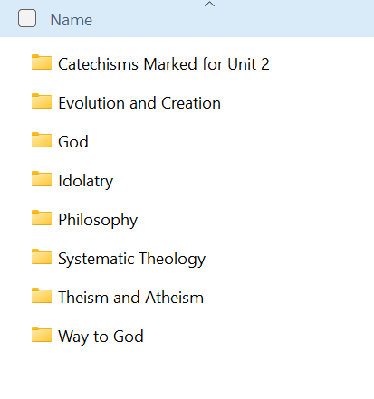

11. Essential Reading Material

Please read the essential marked documents listed below for UNIT TWO. A link to these was sent out to your email when you received your course material. Only read the documents and chapters relevant to this unit:

Catechism of the Catholic Church - Essential Read.pdf

Code of Canon Law 1983 - Essential Read.pdf

The Catechism of the Council of Trent Essential Read.pdf

Catholic Bible Dictionary Essential Read.pdf

These texts are suggested reading only:

Atheism.docx

The COSMOLOGICAL ARGUMENT.docx

Criticisms on Origin of Species by Huxley.pdf

Origin of LIFE.docx

The following marked texts and folder can be read as well to further improve your understanding of the overall subject area. Only read the areas suitable for this unit. They are accessed by the link sent to you with your original course material or by the folder sent to you in your unit’s course package:

Dictionary of Dogmatic Theology - Parente et al Essential Read.pdf

A Concise Encyclopedia of the Philosophy of Religion Essential Read.pdf

The marked “Catechism” folder

12. Unit 2 Exam
The exam for unit 2 is provided with the course material. You can print it out and write your answers on the space provided or you can type directly onto the Word document.

EXAM Unit 2.docx.

Good Luck!

Back to Table of Contents

