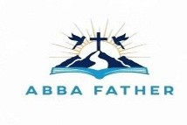
ABBA FATHER

Correspondence Course

Additional Reading Material Available for Unit 9
of Certificate II in Theological Studies

All these folders and titles (e-books) are available to the student upon request via email up to 1 folder and 5 titles at a time, unlimited lend.

Main Folders:

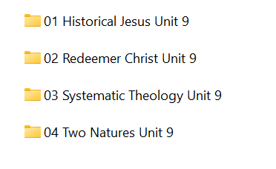

- Historical Jesus folder contains these:

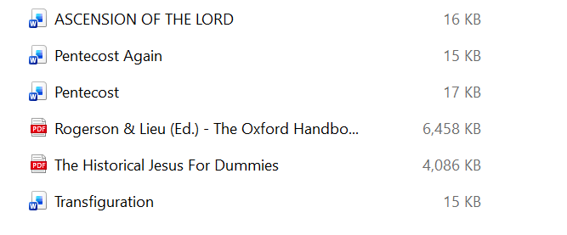

- Redeemer Christ folder contains many good e-books:

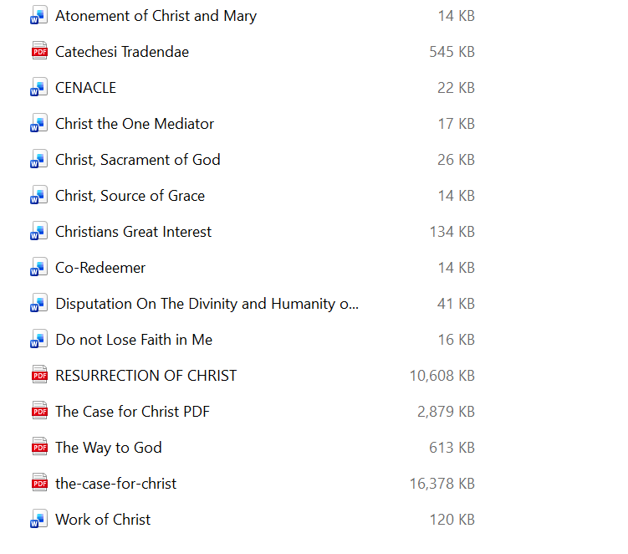

- Systematic Theology contains 2 volumes and an article:

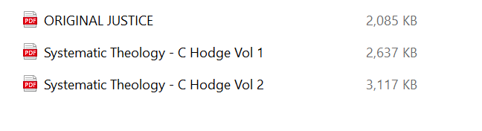

- Two Natures folder contains 4 articles:

