Additional Reading Material Available for Unit 17
of Certificate III in Theological Studies

All these folders and titles (e-books) are available to the student upon request via email up to 1 folder and 5 titles at a time, unlimited lend.
Main Folders:
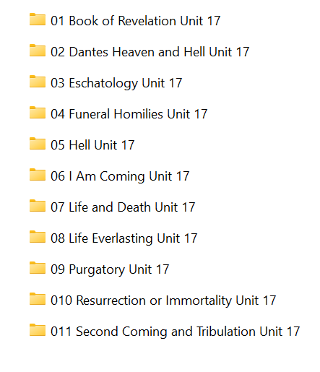
- Book of Revelation folder has these e-books:
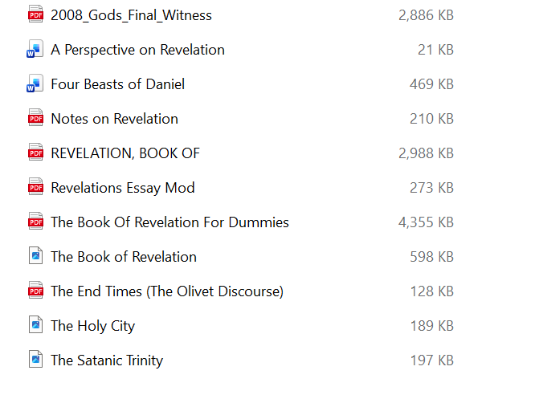

- Dante’s Heaven and Hell folder contains 4 e-books:

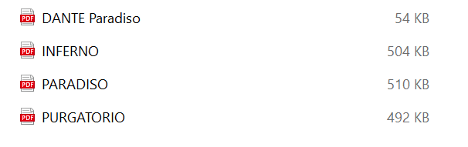

- Eschatology folder has these e-books:

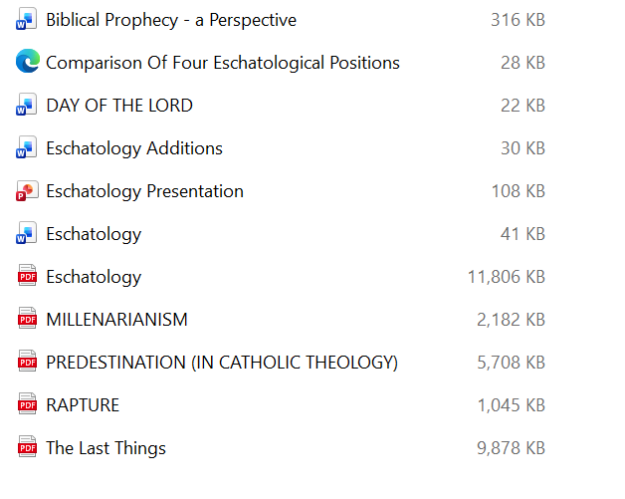

- Funeral Homilies folder has these 5 articles:

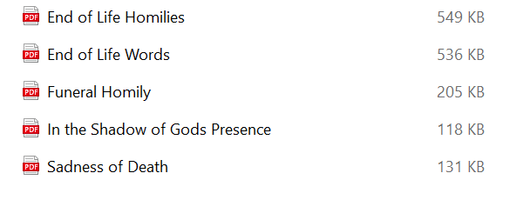

- Hell folder has these:

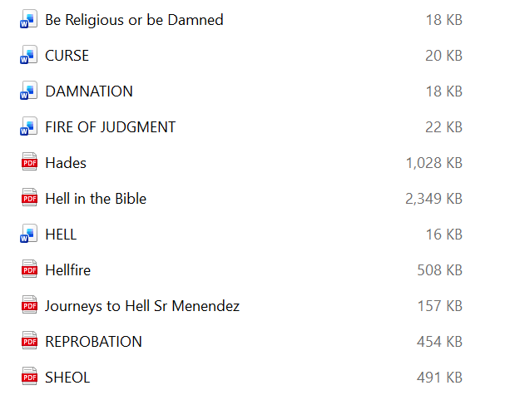

- ‘I Am Coming’ folder has these 4 volumes:

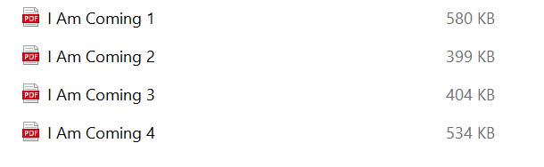

- Life and Death folder has 14 e-books:

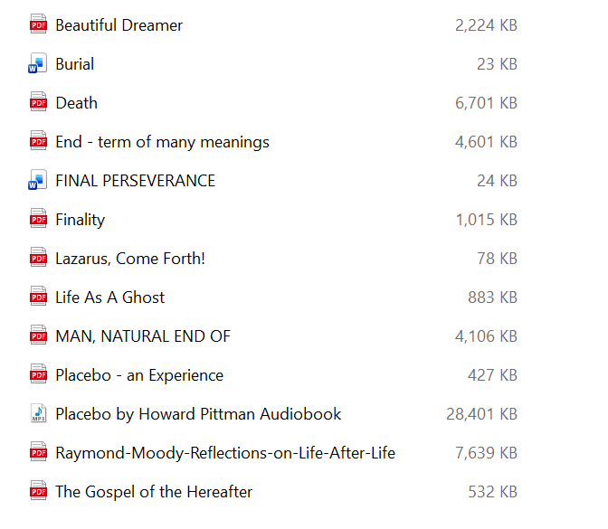

- Life Everlasting folder contains these works:

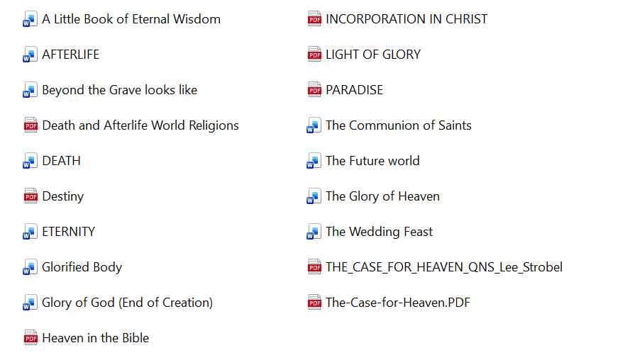

- Purgatory folder has these:

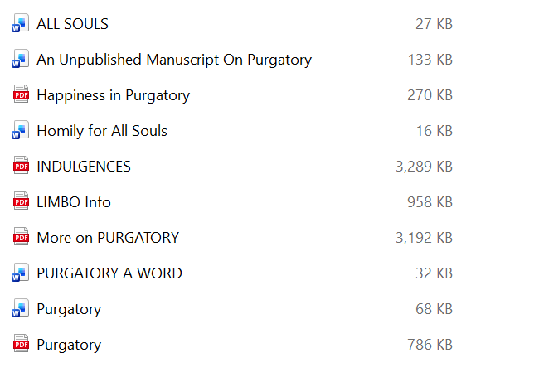

- Resurrection or Immortality folder has these e-books:

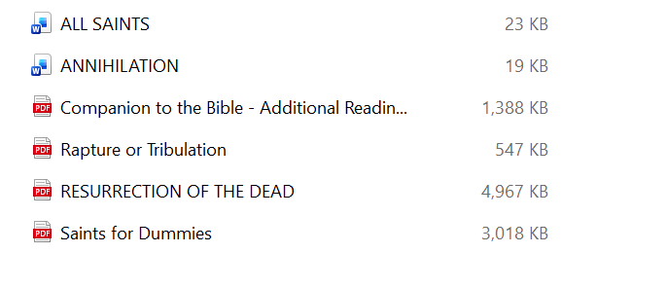

- Second Coming and Tribulation folder has:

