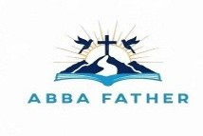
ABBA FATHER

Correspondence Course

Additional Reading Material Available for Unit 2
of Certificate II in Theological Studies

All these folders and titles (e-books) are available to the student upon request via email up to 1 folder and 5 titles at a time, unlimited lend.

Main Folders:

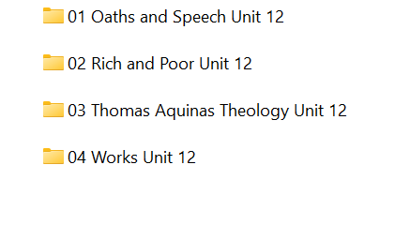

- Oaths and Speech

- Rich and Poor

- Thomas Aquinas Theology

- Works

