Additional Reading Material Available for Unit 18
of Certificate III in Theological Studies

All these folders and titles (e-books) are available to the student upon request via email up to 1 folder and 5 titles at a time, unlimited lend.

Main Folders:
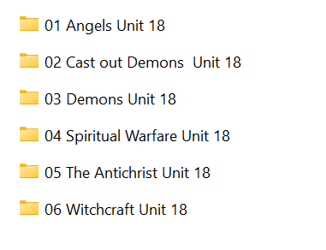

- Angels folder contains these e-books:

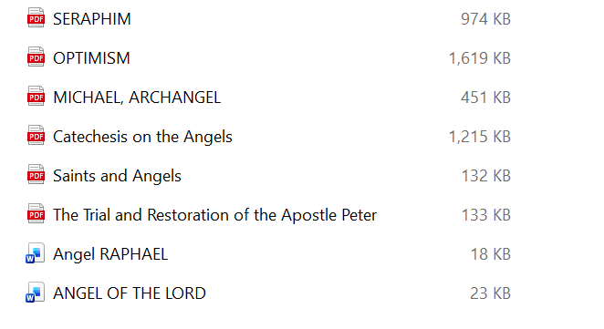

- Cast Out Demons folder has these articles:

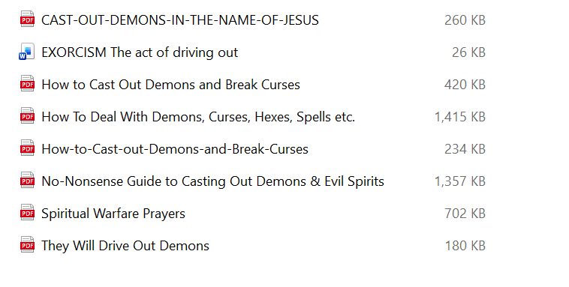

- Demons folder has these e-books:

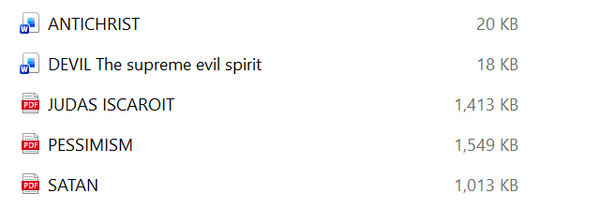

- Spiritual Warfare has these 3 e-books:
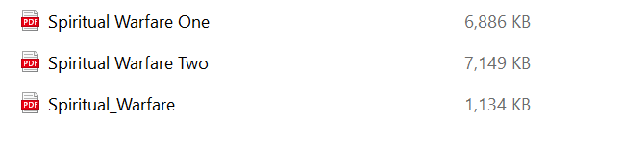

- The Antichrist folder has these:

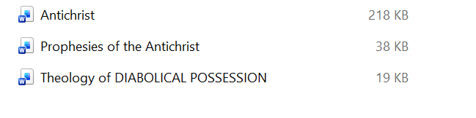

- Witchcraft folder contains 8 e-books:

