Additional Reading Material Available for Unit 16
of Certificate III in Theological Studies

All these folders and titles (e-books) are available to the student upon request via email up to 1 folder and 5 titles at a time, unlimited lend.

Main Folders:
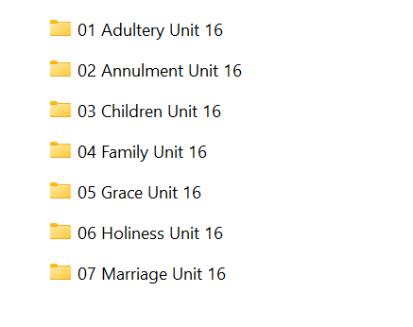

- Adultery folder:

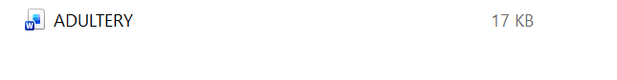
- Annulment folder has:
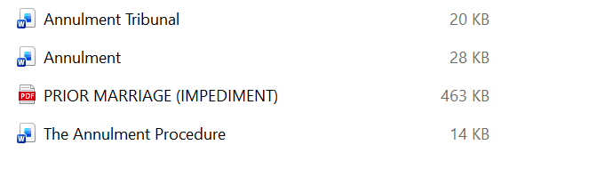

- Children folder has:
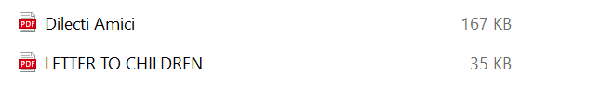

- Family folder contains 7 e-books:

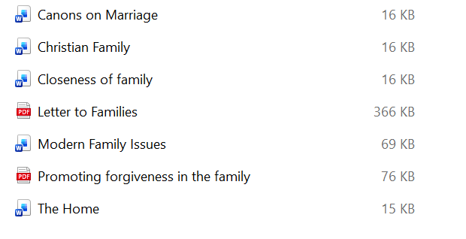

- Grace has 4 articles as e-books:

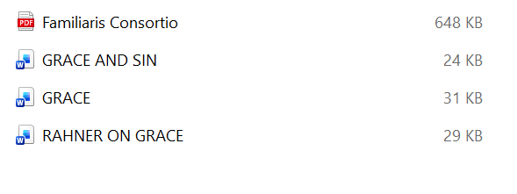

- Holiness has:

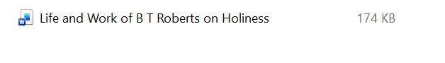

- Marriage folder has these e-books:

