Additional Reading Material Available for Unit 5
of Certificate II in Theological Studies

All these folders and titles (e-books) are available to the student upon request via email up to 1 folder and 5 titles at a time, unlimited lend.

Main Folders:

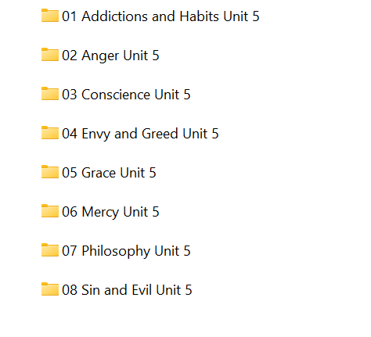

- ‘Addictions and Habits’ has these e-books:

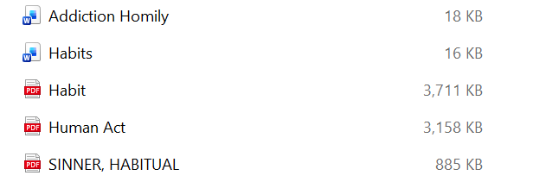
- ‘Anger’ contains the following titles:

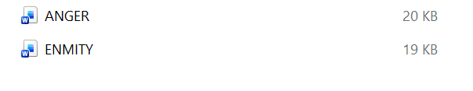

- ‘Conscience’ folder has these 11 articles:

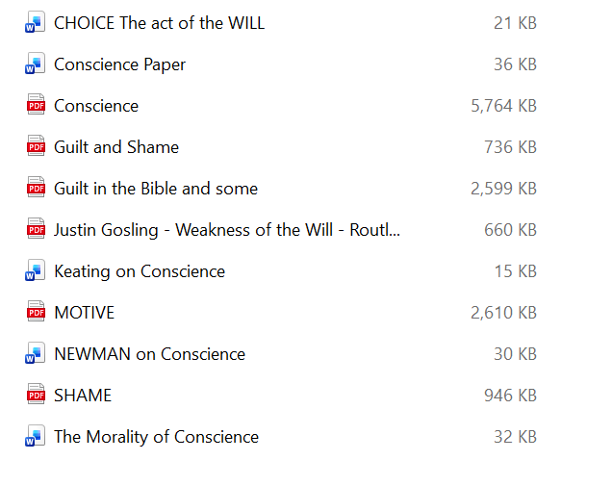
- ‘Envy and Greed’ has these:

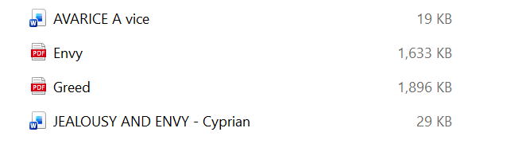

- ‘Grace’ contains these titles:

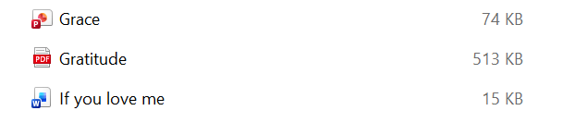

- ‘Mercy’ has these titles:

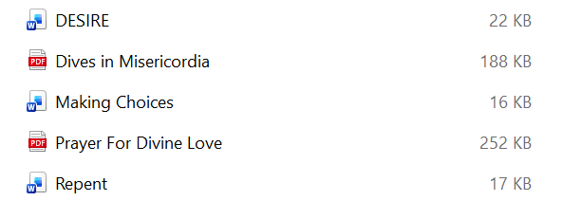

- ‘Philosophy’ folder contains this e-book for borrowing:

- ‘Sin and Evil’ folder has many good e-books:

